School of Computer Science and Statistics

MycroForest – Exploring the use of a microworld to teach about economic viability of climate aware forest management.

*Gayathri Girish Nair*

Supervisor: Brendan Tangney

Co-supervisor: Silvia Caldararu

August 2024

A Thesis submitted in partial fulfilment

of the requirements for the degree of

*Master of Science in Computer Science*

**Declaration**

I, the undersigned, declare that this work has not previously been submitted as an exercise for a degree at this, or any other University, and that unless otherwise stated, is my own work.

The use made of AI tools in work described here, including the preparation of the document itself, is outlined in Appendices 8.4, as per the School guidelines. If relevant, use made of AI is also described in the body of the document.

GAYATHRI GIRISH NAIR August 16, 2024

**Acknowledgements**

This project would not have been possible without the expert guidance of Dr. Brendan Tangney, the project supervisor. He was extremely patient and always available with valuable advice that helped centre focus on most important tasks. When next steps were unclear, he has always stepped in with a vision and provided direction. His observations stemming from a critical review of project artifacts (presentations, idea documents, User Interface (UI) mock-ups, working application versions, final report drafts) have undoubtedly improved quality of this project. Overall, Dr. Tangney’s advice has led this project to evolve from an initial broad idea into a nuanced useful venture that produced a practical teaching tool. His inputs at the Bridge2College learning session wherein the proposed teaching tool was evaluated, encouraged critical thinking, and enhanced the educational value of the tool for learners.

Dr. Silvia Cadararu, co-supervisor, and expert in plant growth under climate change, was instrumental to this project's success. She reviewed drafts of the conceptual model and related documentation, helping determine necessary parameters and relationships, and validated model simplifications. The knowledge and timely correctional advice she shared upon careful review of project artefacts, played a key role in ensuring that this project could be completed on time, as discovering that information through research alone, would certainly not have been feasible for the author who has limited knowledge in the vast domain of botany, forest management, the carbon cycle, and climate change. Dr. Caldararu also shared thoughts on aspects of the teaching tool other than the simulation model like its UI which led to significant improvement of User Experience (UX). Lastly, her presence at the Bridge2College program and active participation in the discussion and introductory sessions left learners with a deeper understanding of the role of forests in the fight against climate change and effects of forest management on it.

For her feedback that helped improve the educational value of the proposed teaching tool as well as great fulfilment of her role as lead educator at the Bridge2College learning session, the author of this work would like to extend sincere thanks to Dr. Jennifer Murphy whose introduction of the tool to educators and responses to their queries contributed to them finding the experience fruitful and enjoyable. This author also extends thanks to other tutors – Holly, Sam, and Huge, who supported learners at the tool evaluation session and shared feedback about the application.

Last but certainly not the least, this project would not have been possible without the continuous support from Girish Kumar Nair and Krishna Priya, parents of the author, who also tested and shared feedback about the tool. The author also thanks friends, Kim Nolle, Noêl Mathis, and Akash Garg for both their feedback regarding the tool and their role in helping get through the year with a smile and great memories despite hectic and stressful academic commitments.

**Abstract**

Since industrialization, CO2 levels in the atmosphere has risen at an unnaturally fast pace due to anthropogenic activity. Today, forests absorb 30% of global annual emissions [1] and are integral to combating climate change. They are also, however, fragile. So, forest management education is important. This is especially true for 15 to 24 year-olds as they are decision makers of tomorrow who will inherit the planet and the challenge of rapid climate change. The Cities and Climate Change Project by the Intergovernmental Panel on Climate Change (IPCC) suggests that individuals in this age group have a strong sense of accountability, and are open to change [2]; thereby making climate change education very important for them.

Several tools exist [3-7] to inform about ideas related to climate change/forests. Many are scientifically accurate decision-making aidsaimed at experts or adults. Others are more abstract yet informative educational games. Few among these, target youth. Many, tackle several problems at once, which while informative, can be distracting or overwhelming. Effective education depends on learner engagement. Education technology tools based on microworlds have been successful at achieving this [8-11].

MycroForest is a web-based microworld designed to teach young adults about forest management and CO2 levels. Learners act as forest owners, creating management plans for planting or felling trees, with consequences reflected in forest composition, atmospheric CO2 levels, and virtual wealth. Challenges of increasing complexity, such as maximizing income, carbon capture, or both and more, can be set. The tool includes a hybrid tree growth – carbon cycle simulation model, UI components, and input variables. Key challenges included realistic simulation design, user-friendly interface design, and web development using NextJS, D3.js, Tailwind, and other technologies.

The proposed teaching tool was evaluated at a 2 hour learning session with 10 Transition Year (TY) students on the [TAP Bridge2College Programme](https://www.tcd.ie/trinityaccess/schools/secondary/bridge-to-college/) at Trinity College Dublin (TCD). Feedback was also obtained from educators at the event. Overall, response is largely positive with students finding it “informative”, “fun”, and “simple to use”. Educators reported active student engagement and fulfilment of learning objectives with the lead educator stating that she would be happy to “utilize MycroForest as a learning tool again”. The domain expert at the event was impressed with how students discovered existing real-world forest management strategies like clear-felling and thinning using the tool with no prior knowledge about them or instructions from educators.

Overall, MycroForest is a web based teaching tool using which, learners role-play as a forest owner and execute their own forest management plans while striving to meet challenges set around learning scenarios to help them understand the importance and difficulty of Sustainable Forest Management (SFM) in a constructivist fashion.

**Table of Contents**

1 Introduction 7

1.1 Motivation 7

1.2 Goal 9

1.3 Ethics 10

1.4 Document Structure 10

2 Background 11

2.1 Forest Management 11

2.2 Education Technology 13

2.3 Simulation Design 15

2.3.1 Agent Based Simulation (ABS) 15

2.3.2 Discrete Event Simulation (DES) 17

2.3.3 Hybrid Simulation 18

2.3.4 Object Oriented Design 19

2.3.5 Time Advance 20

2.4 Human Computer Interaction 20

2.5 Related Work 22

2.6 Summary 30

3 Design 31

3.1 Scope 31

3.2 Pedagogical Approach 35

3.3 UI & HCI Design 38

3.3.1 App Pages 38

3.3.2 HCI Principles 47

3.3.3 Data Visualization 49

3.4 System Architecture 53

3.4.1 Simulation Model 54

3.4.2 Input Variables 70

3.4.3 UI Components 71

3.5 Detailed Technical Design 72

3.5.1 Tech Stack & Technical Architecture 72

3.5.2 Avoiding Bad Software Design 75

3.5.3 Code Re-Design 76

3.5.4 Simulation Model Classes 79

3.6 Summary 86

4 Implementation 87

4.1 Development Methodology 87

4.2 Project Timeline 88

4.3 Challenges Faced 94

4.4 Summary 98

5 Testing and Evaluation 99

5.1 Pilot Testing 99

5.2 Bridge2College 101

5.3 Usability Evaluation 102

5.3.1 System Usability Scale (SUS) 103

5.3.2 Post-Study Usability Questionnaire (PSSUQ) 103

5.3.3 Adopted Questionnaire 103

5.4 User and Educator Feedback 105

5.5 Findings 108

5.6 Development Success 112

5.7 Summary 113

6 Conclusion 114

6.1 Recap 114

6.2 Limitations 116

6.3 Future Work 118

6.4 Personal Reflection 119

7 Bibliography 120

8 Appendices 129

8.1 MycroForest 129

8.2 GitHub 129

8.3 Survey Instruments Used 129

8.4 Use of GenAI in this Work 129

8.5 4 Pillars of Object Oriented Design 131

8.6 Landing Page – Click Through Introduction Dialogues 132

8.7 CO2 Concentration Scale Background 133

8.8 Input Variable Descriptions 133

8.9 Simulation Model Class Diagram 136

8.10 MycroForest – Initial Broad Ideas 137

8.11 PSSUQ Template 137

8.12 Used Questionnaire 137

8.13 Student Feedback - Bridge2College Learning Session 138

8.14 Project Timeline 138

8.15 Object Oriented Programming in JavaScript 138

8.16 User Guide Video – B2C Learning Session 139

# Introduction

This chapter documents project motivation, goals, and ethical compliance.

## Motivation

Currently, we are amidst a climate emergency caused primarily due to heavy dependence on fossil fuels which shows no sign of significant decline. There are multiple reasons for our global collective failure to reduce carbon emissions including economic, geo-political, psychological, and sociological factors [12]. Climate change threatens almost all life on Earth, given rising temperatures, ocean acidification, desertification, and frequent extreme weather. This negatively impacts society by leading to forced human migration, increased mortality, and possibly increased tension between societal factions at varying developmental stages [13]. Such environmental and socio-economic effects also disrupt key industries like agriculture [13], as productivity suffers [12]. Since now an existential threat to humanity, it has been recognized that timely mitigation of rapid climate change demands global transformative reform at a fundamental level across technological, economic, and social factors that underpin direct drivers like fossil fuel usage. This was an important message at the UN Climate Change Conference COP26 in Nov 2021. Large scale drastic yet necessary changes, however, are unlikely to happen via government efforts alone. It requires a shift in collective mindset and understanding between stakeholders and key decision makers [12]. This is why, correct education targeted at key demographics like the youth is crucial to combating climate change.

In 2018, the Cities and Climate Change Project by the Intergovernmental Panel on Climate Change (IPCC) involved 99 youths (individuals aged 15 to 24) across diverse geographic and socio-economic backgrounds that collaborated with each other first digitally and then in person to produce the International Youth White Paper on Climate Change: Education and Cities. This project showed that the youth, to varying degrees, are aware of climate change, inequalities regarding responsibility/accountability of global warming and the importance of individual action. Feelings that they reported on the matter include fear, despair, guilt, shame, urgency, sadness, helplessness, and most promisingly, hope. This suggests that young individuals who will soon comprise key decision makers tasked with solving the challenge of climate change, are indeed, eager to do something about it. [2] Thus, MycroForest aims to inform more members of this age bracket about the link between forest management and climate change.

So far, worldwide responses to government policies that combat climate change have been lukewarm at best despite several climate negotiations. There is a need to reinforce urgency. It is important to realize that, given the difficult to model, non-linear, and dynamic nature of Earth’s climate, unexpected catastrophic changes catching us off guard is a real risk despite best climate modelling efforts. As it stands, global average temperature is predicted to rise to between 2.1 °C and 3.9 °C by the end of the century which is expected to trigger several planetary tipping points from beyond which, restoration of natural systems become extremely difficult if not impossible [12, 14].

A carbon sink absorbs more carbon than it releases, helping reduce atmospheric Carbon Dioxide (CO2), an important greenhouse gas (GHG) [13], and mitigate global warming [15]. Enhancing or creating carbon sinks is one of 3 key strategies to combating climate change, alongside reducing GHG emissions and modifying Earth's energy balance. Past efforts to lower emissions have been largely ineffective, and geo-engineering solutions have often been impractical or risky [12]. Thus, focusing on carbon sinks, particularly forests, is a practical approach. Forests, which cover nearly 4 billion hectares and absorb about 30% of global CO2 emissions [16], are crucial carbon sinks [17, 18]. However, they are fragile; deforestation can turn forests into carbon sources that release more CO2 than they absorb [18]. This is because although forest regrowth absorbs carbon quickly, deforestation results in a greater loss of sequestered carbon due to biological processes like heterotrophic activity and burning of biomass by humans [16, 19]. Also, human CO2 emissions exceed what new growth can absorb. Therefore, alongside planting trees, preserving existing forests is essential to addressing climate change [17].

This is supported by results of a detailed study by A. Daigneault et. al. in 2022 which modelled 81 future socioeconomic and climate policy scenarios to assess future forest climate mitigation pathways between years 2015 and 2105. In 95% of these scenarios, projections led to increase in global forest carbon stocks under afforestation, shifting harvest patterns, and intensification of forest management. Further, the study found timber prices to increase across all projected scenarios and that expanding forest area an rising timber prices had a greater effect on increasing carbon stocks than volume of wood harvested. This hints at it likely being possible to maintain economic viability of forests while promoting carbon sequestration through forest management strategies and alternate means of income generation [18].

Thus, teaching about the link between forest management and atmospheric CO2 levels while also allowing learners to explore economic viability of forests through timber harvesting and other forest income streams is a great way to promote awareness about the need to conserve forests, harvest responsibly, and discover new ways to sustainably earn from them. This also encourages learners to think about the financial motive, a key indirect influencer of deforestation, which in turn, is a direct driver of climate change. The MycroForest teaching tool as presented in this work, strives to do this.

C. Karsgaard and D. Davidson, in their work about youth perspectives and Climate Change Education, highlight some existing teaching approach aspects that requires strengthening. They stress the need to move away from the abstract “save the planet” idea to more concrete examples of how this might look like practically, to inspire action [2]. To this end, MycroForest presents SFM as a specific way to combat climate change. Furthermore, while existing education concentrates on scientific reasons around the "what" and "how" of climate change; social, political, cultural, and economic reasons that define "why" is often overlooked [2]. By allowing learners to investigate earning potential of a forest, MycroForest garners attention onto the underlying economic “why” that drives deforestation and by extension, climate change.

Increased engagement and attention w.r.t the subject matter is linked to deeper understanding. Resulting mindfulness often leads to learners making a conscious effort to resolve mental conflict that stems from discrepancies between existing and new notions of a concept, culminating in mental accommodation of novel ideas and improved assimilation of existing knowledge [20]. Further, teaching methods that promote problem-based, reflective, and inquiry-based learning, have shown to strengthen persistence of learned ideas and enthusiasm towards learning [11]. A microworld is an interactive environment anchored on the theory of constructivism as first proposed by Jean Piaget [21] that facilitates long lasting and deep learning through “learning by doing or making” [22]. Microworlds may be digital or physical, but the former makes is more widely or easily accessible [2]. Thus, MycroForest is a web-based teaching tool that incorporates a microworld comprising a simple forest model that learners can interact with through making their own forest management plans and decisions.

In summary, the need to effectively educate the next generation about use of forests as carbon sinks being one practical part of the solution to the pressing issue of rapid climate change while encouraging them to think about economic viability of sustainable forest management, serves as prime motivation for this project.

## Goal

The goal of this project is to build a microworld to inform 15 to 24 year old learners about the relationship between forest management decisions and atmospheric CO2 concentration. In addition to the opportunity to earn income from timber sales, the tool shall also simulate effects of considering other streams of income from forests in an attempt to draw attention to the idea of conscientious commerce which is one of many principles encouraged as part of ensuring a sustainable future [23]. The resulting web application should be user-friendly with built-in help and support for gradual complexity reveal wherein features are hidden and unveiled in stages, allowing learners to master simpler features first to ensure a low entry threshold [9]. The tool should also incorporate a sufficiently realistic simulation of forest growth and the carbon cycle, based on observed natural phenomena and Earth measurements [4].

To promote self-regulated learning**,** the tool should be engaging and facilitate constructivist learning by allowing users to draft their own forest management plans [20]. They should be able to play the role of a private forest owner, making decisions on tree chopping and planting over multiple years. Further, they should have at least 3 income-earning options from the forest. The app should also allow users to adjust CO2 emissions from fossil fuels and observe long-term effects of their decisions.

Hybridizing a microworld with simulation and gaming elements is known to create effective and engaging learning environments. To boost motivation and self-regulated learning, the tool should embrace game-like features such as goal setting and performance monitoring. Learners should be able to set targets (e.g. max CO2 level, min income), with feedback indicating whether or not these are met [20].

Further, exploratory learning is most effective when guided by some structure [9]. So, MycroForest should allow formulation of challenges using the tool that increase the likelihood of specific learning outcomes. For example, one challenge can have learners try to maximize income from forests and another have them try to minimize CO2 concentration. A third challenge can then, combine both goals to effectively teach about inherent trade-offs.

Research also shows that learners perform best with graphical feedback supported by limited text instead of just textual feedback [24]. So, MycroForest should prioritize graphical feedback with short explanatory help at hand. E.g., use of dynamic informative icons to reflect land content changes over time could be very user friendly. Forest management actions and income streams should be adjustable via a Graphical User Interface (GUI), and CO2 concentration could be displayed on a color-coded scale indicating expected quality of human life considering climate change effects.

Finally, this project aims to evaluate MycroForest in terms of UX, learning experience, and attitude towards climate change by having TY students use it in a learning session and share feedback. Educator opinions should also be collected and assessed to gauge utility of this application as a teaching tool.

## Ethics

The tool was used by (N = 10) TY students as part of the [TAP Bridge2College Programme](https://www.tcd.ie/trinityaccess/schools/secondary/bridge-to-college/) at TCD. Ethical approval for researching different aspects of the Bridge2College programme had been granted by the School of Computer Science & Statistics.

## Document Structure

Section 1 introduces this project, underlying motivation, and goals. Section 2 discusses related research areas and other similar tools. Section 3 explains design decisions, Section 4 describes the implementation approach and Section 5 presents tool evaluation methodology and results. Section 6 concludes with a condensed project review.

# Background

This chapter reviews similar tools and existing work in forest management, simulation design, education technology, and Human Computer Interaction (HCI). It also states how research influenced key design decisions related to MycroForest, the teaching tool developed in this project. Section 3 shall describe MycroForest in greater detail.

## Forest Management

Forest management refers to human intervention in forests driven by economic, social, or environmental principles to meet goals like species and resource conservation or protection and maintenance or boosting of forest productivity. Common management actions include felling trees, planting trees, fertilization, building infrastructure (e.g. roads to improve accessibility, irrigation facilities, etc.), administering pesticides or weedicides, culling invasive species, etc [25]. Ecosystem Services (ESs) here, refer to resources or services that a forest grants. ESs may be *provisioning* (e.g. source of resources like wood/timber, food, water), *regulatory* (e.g. climate regulation, water purification, pollination, etc.), *cultural* (e.g. catering towards spiritual beliefs, provision of spaces for recreational activities, etc.), and/or *supporting* services (e.g. carbon sequestration, soil formation, nutrient cycling, etc. which comprise mechanisms that drive other systems crucial for life). Timber sales is the primary source of income from a forest [25]. Thus, given the economic viability and climate change premise of MycroForest, ESs of primary interest are carbon sequestration and timber provisioning.

Planting and felling trees are crucial forest management actions directly linked to timber production [25]. Hence, they are action options for learners in MycroForest. In forestry, management plans are often scheduled per **rotation period**, the time between subsequent plot scale timber harvests. *Clear-felling*, the practice of removing all trees at once, usually at the start or end of a rotation, is a simple forest management strategy. *Thinning*, involving selective tree chopping during a rotation to promote competitive growth, sustained yield, etc. is another [26]. Rotation length is an important choice in a forest management plan [27] because it greatly affects various ESs, especially carbon sequestration. In 2023, E. Z. Baskent and J. Kaspar studied effects of varying rotation lengths on ESs in Turkey's Bürücek forest. Using the ETÇAP DSS model, they found that shorter rotations increased harvest frequency, boosting immediate wood production and economic returns but reducing long-term tree volume and carbon sequestration. Longer rotations typically enhanced carbon sequestration. However, limited felling at longer intervals could increase net carbon storage due to Harvested Wood Products (HWPs) preserving carbon as long as consequent emissions due to deforestation could be compensated by new growth and CO2 uptake by remaining vegetation [28]. That is, felling few trees at medium to long rotations, primarily for non-burning purposes, could result in lower net GHG emissions compared to natural decay. Baskent and Kaspar observed that some rotation lengths led to better carbon storage than shorter or longer ones such that they expect there to be a forest specific “optimal rotation length for carbon–neutral conditions” [26]. Thus, rotation length is a key input in MycroForest.

Forest management often aims to increase timber production [27] for economic gain, leading to unsustainable deforestation, which contributes to about 20% of all GHG emissions [29]. Wood is either burned for energy or transformed into long-lasting products. Some consider *energy substitution* (e.g. burning wood instead of fossil fuels) and *product substitution* (e.g. replacing concrete with wood) as climate-friendly due to pound for pound lower GHG emissions [28]. However, others argue that forest loss and its diminishing carbon "sink" status cannot be offset by such substitution [30]. The high demand for wood and its role as a primary income source creates a trade-off between forest production and carbon sequestration objectives in forest management plans [25]. MycroForest highlights this trade-off and tries to educate learners about the growing need to compromise on profits and invest in truly climate friendly practices to avoid impossible living conditions due to climate change.

A large portion of forests are private or community owned with many of them being small to medium sized [25] such that owners rely on them for all or a portion of their income for livelihood [24]. As long as funding for ESs like carbon sequestration remains inadequate and unreliable, as is largely the case today [24, 31], it is unrealistic to expect forest owners to completely refrain from felling trees. But given the risk of irresponsible exploitation of such forests leading to significant aggravation of the climate crisis, it is crucial that they be managed sustainably. Thus, it is imperative that ideas like Climate Smart Forestry (CSF) which advocates reduction or removal of GHG emissions while maintaining or increasing productivity of forests and quality of their services, be adopted widely to slow down climate change [28]. Diversifying means of income from forests is one way to lower the motivation to fell trees for timber. A popular way to earn from forests include selling of Non Timber Forest Products (NTFPs) like honey, fruit, mushrooms, medicinal herbs, etc [24]. Yet another way is to make forests available to the public for recreational use and charge for amenities and/or experiences [32]. MycroForest provides the option to activate these two other income streams to teach learners about the possibility of earning form forests in ways other than wood sales and accompanying challenges.

Ultimately, “no management” is considered as the best forest management strategy involving preservation of existing old forests and stopping all deforestation (legal and illegal). Reforestation (establishing a forest on land that once held one) and appropriate afforestation (transforming suitable unforested land into healthy native forest ecosystems) further improves carbon storage. William Moomaw, lead author of 5 IPCC reports, refers to this strategy as “proforestation” [27, 29-31]. MycroForest, through 5 challenges that learners tackle, tries to educate about the need for proforestation.

## Education Technology

Education technology (EduTech) refers to software (SW) designed to facilitate learning, both directly as does e-books, mobile learning apps (e.g. [Duolingo](https://www.duolingo.com/), [Khan Academy](https://www.khanacademy.org/)), microworlds, and educational games, as well as indirectly like assessment tools (e.g. [Kahoot](https://kahoot.com/), [Google Forms](https://www.google.com/forms/about/)), learning management systems (e.g. [Blackboard](https://www.blackboard.com/), [Canvas](https://www.instructure.com/canvas), [Moodle](https://moodle.org/)), knowledge organization tools (e.g. [Evernote](https://evernote.com/), [Notion](https://www.notion.so/), [Mendeley](https://www.mendeley.com/)), synchronous collaboration tools (e.g. [Zoom](https://zoom.us/), [MS Teams](https://www.microsoft.com/en-ie/microsoft-teams/log-in)) etc [33]. Depending on design, EduTech can be empowering or constraining [34]. When engaging, they have been shown to improve learning depth and persistence [11].

Engagement can be defined as active participation with learning tools, subjects, peers, or faculty, and may also be measured based on time, effort, or energy invested [33]. It enhances learning by fostering mindfulness, which promotes conscious effort and development of personally meaningful knowledge. John Dewey, whose ideas inspired constructionism, argued that knowledge is valuable only when personally meaningful [20, 35].

Constructionism is rooted in "learning by making" and promotes self-regulated learning (SRL) by encouraging learners to build their own solutions. It is based on the idea that new understanding is built upon existing knowledge, called constructivism [10]. A microworld here, is a teaching tool based on constructionism which provides a simplified interactive model of some real-world system or idea with objects to think with (OTTW) at its heart [22]. OTTW are constructs that learners manipulate to elicit microworld responses as part of exploratory activities leading to knowledge building [8, 10]. A child’s sandbox is a natural microworld where sand and tools (bucket, shovel, etc.) are OTTW and playing with them promotes an intuitive understanding of density and volumes [20]. Logo, Boxer, and SimCalc are early digital microworlds used to teach math/physics [36]. Given advancements in technology (Object Oriented Programming (OOP) languages, improved graphics, web apps) and superior ability of microworlds to model interdependent cause-effect chains common in human and natural systems like economics, disease progression, plant growth, effects of climate change, etc. they are useful in domains beyond just mathematics and physics [36-38].

Facilitating SRL, wherein learners manage their own learning is central to microworlds. As per Rieber in 1996, self-regulated learners are *intrinsically motivated* (they find the activity rewarding or enjoyable), *metacognitively active* (they engage in planning and/or goal-setting), and *behaviourally active* (they tweak the environment to suit own learning styles) [20]. These characteristics fulfil the 3 widely accepted areas of student engagement (affective, cognitive, behavioural) [33] thereby underscoring how SRL promotes engagement.

Piagetian Learning Theory (PLT) by Jean Piaget whose ideas inspired the proponent of microworlds, Seymour Papert, and the Flow Theory of Optimal Experience (FTOE) by Mihaly Csikszentmihalyi are 2 popular frameworks that define conditions for SRL [20]. **PLT** accredits learning to (i) resolution of *epistemic* *conflicts* between existing mental models and contradicting learning experiences/observations noticed via deliberate assessment/attempts to understand through (ii) *self-reflection*. Conflicts are resolved either via assimilation as learners understand and place experiences within existing mental models or through accommodationwherein they tweak, rebuild, or expand existing mental models to incorporate new ideas via (iii) *self-regulation* [20]. “Flow state” commonly refers to deep engagement that promotes psychological growth and thereby, benefits learning. **FTOE** defines 8 activity characteristics that together, induce such heightened focus [20]. Gamers frequently report flow state. **Gamification** of a microworld which may be achieved by structuring learning activities around *challenges* as proposed w.r.t MycroForest, could, thus, improve engagement [9, 20, 39].

Many a time, microworlds like MycroForest, that try to teach about real-world/natural systems comprise a simulation model. To maintain learner engagement, simulation-as-microworld learning tools should follow the “match the user principle” such that ideas presented “expand when the learner is ready” so as not to overwhelm. Such *model progression* is incorporated into MycroForest via challenges proposed. It is also necessary to ensure that such tools entail good UX to avoid learner frustration [9, 20, 38]. MycroForest is designed to grant good UX. Rieber and colleagues in 2005, investigated how different content representations influence learning from simulations, games, and microworlds [9]. Table 1 summarizes key observations from this work.

|  |  |  |  |
| --- | --- | --- | --- |
| **Simulation** | Graphical feedback with short multimedia explanations leads to better student understanding than graphical or textual feedback alone. | Most students learn from microworlds only when exploration is part of a structured, carefully designed learning activity. | **Microworld** |
| Learners consistently reported lesser frustration when feedback was graphical rather than textual. |
| Explanations are most effective when provided intermittently. Tutorials solely before or after learning activities are less effective because they separate explanation from experience. | Students who discussed content with peers or educators showed increased learning. | **Game** |
| Instructional support is best provided during the simulation as opposed to earlier because the latter leads to formation of hypotheses that are hard to change even when evidence suggests otherwise. | Children favored these 3 game characteristics in a study of student-designed games: (i) storyline quality, (ii) competition, and (iii) appropriate challenge. |
| Students benefit significantly from simulations that build complexity in stages, allowing time to grasp simpler concepts before progressing to more complex ones. |

Table 1. Observations regarding use of simulations, microworlds, and games as educational tools. [9]

Simulations, microworlds, and games are all useful as interactive educational tools, but combining elements from each, can optimize learning experiences. While simulations visualize complex systems well, the mental model that learners develop can be difficult to evaluate for correctness. In tools like MycroForest, which includes a simulation, integrating a microworld approach is beneficial since microworlds produce tangible external artifacts in the form of learner creations that are representative of the their internal mental model [9].

Overall, research suggests that hybridization of microworlds with simulation and gaming elements produce very effective/engaging learning environments [9, 10, 20, 40].

## Simulation Design

To ensure that forest management plans in MycroForest yield similar carbon flow outcomes as in the real world, the virtual forest must simulate tree growth and the carbon cycle with sufficient realism. A “simulation” here, refers to a “model” (system representation) that can be updated based on simulated conditions to mimic real-world behaviour [41]. Thus, every simulation comprises a conceptual model of some target system. Biological processes like forest growth, carbon storage, nutrient cycling, etc. are often simulated because their complexity, long timeframes, and life support role, makes experimenting with these systems in the real-world difficult without disrupting critical mechanisms [42]. Of the many simulation paradigms, w.r.t natural systems, Agent Based Simulation (ABS) and Discrete Event Simulation (DES) are popular.

### Agent Based Simulation (ABS)

ABS leverages an Agent Based Model (ABM). ABMs represent a system using independent agents with their own memory and rules, that interact with each other and the environment [43].

In biological, ecosystem, and climate modelling, ABMs are popular [43] because such target systems are often composed of discrete entities that independently interact with a shared environment or each other to accomplish individual goals resulting in composite emergent behaviour [43, 44]. Also, ABMs impose no restrictions regarding no. of attributes or rules per agent which makes them apt for modelling complex systems like forests/ecosystems [45]. Furthermore, research suggests that students using EduTech with ABS outperform others due to better understanding of cause-effect relationships curtesy the "agent perspective" helping learners grasp the idea of individual contributions in a shared environment leading to emergent behaviour [40]. Thus, MycroForest models tree growth and carbon capture using ABS where trees are agents operating in an environment comprising land and multiple carbon reservoirs.

ABMs support varying levels of abstraction as can readily be observed w.r.t plant growth. In population level ABMs, agents may be individual plants with the ABM capturing forest level behaviour. Individual level ABMs are more nuanced wherein specific plant modules like structural components(e.g. leaves, roots) or more abstract constituents (e.g. carbonate pools) may be agents [45] such that the ABM models growth of a single plant. MycroForest aims to teach about forest level changes under different management plans and not plant biology or growth. Thus, the constituent ABM is a population level one with the forest being a population of tree agents.

Underlying assumptions that influence key mechanisms like tree volume increase or reproduction pattern, can also vary both in approach and level of detail [45]. Following 2 examples of slightly different plant growth ABMs built on empirical and mechanistic approaches respectively, demonstrate this [45].

* **JABOWA** [45, 46]**:** The JABOWA model, an early ABM in plant ecology, simulates forest growth in response to canopy cover changes via sub-routines modelled using *empirical equations* based on simplifying assumptions. E.g. annual growth rate is modelled as $δ\left(D^{2}H\right)=R×LA×\left(1-\frac{DH}{D_{max}×H_{max}}\right)$ where tree agent attributes $D$ is Diameter at Breast Height (DBH), $H$ is tree height, $D_{max}$ is maximum DBH, $H_{max}$ is maximum height, and $LA$ is leaf area. R is a constant, and $δ$ indicates volume change. This equation captures growth being proportional to sunlight received ($R×LA$) and it being inversely proportional to maintenance energy $\left(1-\frac{DH}{D_{max}×H_{max}}\right)$. Tree volume $(D^{2}H)$ is simplified and assumed to be akin to that of a cylinder $(πr^{2}h)$. Another assumption is that other growth conditions are optimal. The JABOWA ABM modelled just 9 tree characteristics (species, age, size, spatial location, growth rate, mortality, shade tolerance, reproduction, competitive ability) and 7 environmental characteristics (canopy gaps, light availability, spatial location, environmental stress, aging, altitude). It successfully reproduced ecosystem behaviours such as competition, succession, and vegetation changes at different elevations. This shows that complex systems can be simulated in useful detail with some complexity abstracted away through *simplifying assumptions*.
* **PLATHO** [45, 47]**:** PLATHO is a population-level ABM that simulates plant growth to understand resource allocation through sub-models of processes like photosynthesis, water uptake, and biomass growth. It updates plant and environmental states to meet resource demands (nitrogen, carbon, water, etc.) at different plant organs. Assumptions such as “potential allocation to defensive compounds is inversely correlated to maximal growth rate” and “tree volume ≈ cylinder volume” simplify the model. Prioritization is guided by assumptions like “photosynthesis is less affected by nitrogen deficiency than growth.” Given high target system complexity, models like PLATHO incorporate equations, e.g., total carbohydrate demand $:{ D}_{pot}=r_{max}×W_{1}×Δt{×f}_{T}×f_{Ph}$ where, $r_{max}$ is maximum growth rate, $W_{1}$ is amount of living structural biomass, $Δt$ is the time step, $f_{T}$ is a factor $∈[$ 0, 1] that is a function of air temperature, and $f_{Ph}$ is a factor $∈[$ 0, 1] that is a function of phenological stage of the plant based on seasonal growth. The PLATHO model tested various hypotheses and predicted responses to different conditions. It accurately reproduced observations like effects of nitrogen fertilization on biomass gain, validated by comparing simulated and measured apple tree data. Even discrepancies like overestimating effect of CO2 on spruce needle compounds, led to further investigation, revealing importance of plant acclimatization to increased CO2 and enhancing understanding.

*Mechanistic modelling* involves representing some primary system based entirely on knowledge of its underlying structural elements and functional mechanisms. Mathematical equations may or may not be used. Algorithms or functions based on informed assumptions are key drivers of simulation. In *empirical modelling*, systems are represented using high level mathematical expressions based solely on statistical relationships in measured data. The latter is useful when outputs or attribute data of a target system is available, but knowledge about its structure or working is limited [41].

Distinction between JABOWA and PLATHO lies mainly in level of mechanistic detail. JABOWA models plant growth at a higher level with expressions incorporating tree attributes like height, diameter, and leaf area, but not modelling processes like photosynthesis, respiration, and water uptake. Thus, it swaps sub-models in PLATHO for parameters in an equation whose values are data driven. This makes JABOWA more empirical than PLATHO which is more mechanistic due to sub-models representing biochemical processes, which also makes PLATHO more realistic/detailed than JABOWA.

With complex target systems as is botany or ecology, there is often a need to intentionally limit level of detail modelled for computational feasibility or to reflect specific simulation purposes. Also, knowledge about underlying mechanisms is likely incomplete. In such situations, distinction between the 2 modelling approaches get blurred. For example, although more so than JABOWA, PLATHO is still not entirely mechanistic. It has embedded empirical modelling elements such as use of mathematical expressions to simplify sub-model processes formulated based on observed data in addition to knowledge about the target system’s underlying mechanics. Similarly, JABOWA also makes a few mechanistic assumptions to decide on what attributes are to be included in expressions and what modelling characteristics to consider when promoting emergence of appropriately realistic behaviour.

Thus, biology, ecology, and climate change related simulations can require hybrid ABMs combining mechanistic and empirical elements to meet unique needs [41]. Therefore, the ABS within MycroForest models key processes like tree growth and reproduction using algorithms and high-level mathematical expressions incorporating tree and environmental attributes like species, age, size, spatial location, growth rate, environmental stress and aging inspired from JABOWA based on certain mechanistic, informed assumptions or rules inspired from PLATHO about underlying mechanisms and structure of the system like the relationship between height and diameter of trees, coniferous trees generally being more long lived than deciduous ones, and so on. This approach including informed simplifying assumptions, creates a realistic yet computationally feasible model.

### Discrete Event Simulation (DES)

Discrete Event Simulation (DES) is a popular modelling paradigm, especially suited for process flows [48]. It breaks down continuous system behaviour into an ordered sequence of discrete events/processes [43] that makes it possible to simulate slow systems like forest growth in a shorter-than-real time frame, given that time between events is not simulated and a single event can represent multiple state changes [49]. This ability of DES to hasten slow, real-world processes in simulation is deemed beneficial in forestry related simulation wherein real-time modelling of forest management plan execution is often infeasible due to slow natural timelines [48].

All DEMs comprise entities and a priority queue that manages events [49]. Running a DEM typically involves 3 iterative steps [50]: (i) Execution of *calendar* (a.k.a. schedule, plan, priority queue) *events*. (ii) Execution of activities or *processes* comprising each event which may or may not include stochastic elements or probabilistic execution durations with uncertainty often modelled using a probability distribution. (iii) Entity attribute, system state, and statistics updates in response to executed processes.

A use case wherein DES is most popular, is decision making or strategy comparison because human decisions can easily be incorporated as events added to the simulation queue. This accounts for forestry applications of DES that compare management/harvesting strategies, assess various facility layouts, and analyse logistics approaches [48]. E.g. Westlund et al. developed an optimization-simulation framework to evaluate wood supply chain performance under varying weather conditions. Their approach combined an optimization model for generating harvest schedules with a DES model for simulating delivery under different weather scenarios [51]. Thus, MycroForest incorporates a DES to handle execution of forest management actions created by learners.

The idea of entities generating events comprising a set of instructions to be executed at planned times is very practical w.r.t software implementation. DES is compatible with OOP because model entities can be implemented as objects with properties capturing entity attributes and methods defining event processes [49].

Furthermore, simulations are built to serve 2 purposes: (i) To analyse/understand some phenomenon/system, or (ii) to provide a training environment that teaches about it. The simulation in MycroForest caters to purpose (ii). There is evidence of DES being beneficial w.r.t teaching tools as its structure makes it easy to incorporate learner decisions into the existing event schedule [48, 52].

MycroForest aims to allow learners to create and explore effects of different forest management strategies over 300 years on a virtual forest. This presents an ideal use case for DES w.r.t scheduling and execution of management actions as events. It is compatible with the OOP approach used to code the MycroForest simulation model.

### Hybrid Simulation

DES is ideal for modelling discrete human decisions or actions over time, while ABS excels at capturing individual agent interactions and emergent behaviour. Thus, for simulating plant growth and carbon capture resulting in forest-level patterns from independent tree – environment interactions, ABS is appropriate. DES is more suitable for simulation of discrete user generated actions. Therefore, MycroForest adopts a Hybrid Simulation (HS) approach with ABS to model tree growth and DES to manage timely execution of learner generated forest management actions. HS incorporating elements of more than one simulation paradigm is not uncommon. The combination of ABS + DES is considered to be most effective in “any situation which includes resources that must perform activities as well as human interactions where individual behaviours alter how these activities proceed” [53]. This reinforces suitability of ABS + DES for MycroForest.

HS is sought after for complexity management because in addition to supporting abstraction of system components, it also allows problem or system breakdown into smaller parts such that the simulation paradigm most suited to each part may be employed. This helps control accuracy – complexity or performance trade-offs. [54, 55]

A key challenge with HS is compatibility or integration of constituent simulation paradigms. Ensuring interoperability between elements from different simulation approaches can be difficult [54, 55]. To this end, in addition to ABS and DES, MycroForest adhered to a general, Object Oriented (OO) design to simulate remaining system mechanisms. This OO design ties DES and ABS together because it is compatible with DES as previously discussed, as well as with ABS as agents may be objects and agent types, classes [53].

### Object Oriented Design

The Object-Oriented (OO) software design pattern views systems as collections of interacting *objects* with their own data and functions. The definition of an object is known as a *class*. Object-Oriented Simulation (OOS) applies this concept to modelling, naturally representing many real-world systems [56]. For example, a cell can be modelled using objects representing its components (nucleus, mitochondria, etc.). More abstract concepts like gravity can also be treated as an object. MycroForest adopts OO design because it naturally mirrors real-world hierarchies (e.g. MycroForest defines an Environment class containing a Land object which in turn contains several Tree objects) while keeping code modular, concise, reusable, and flexible. Please find examples of the 4 pillars of OO design (Abstraction, Polymorphism, Inheritance, Encapsulation) in MycroForest’s code at Appendices 8.5.

Furthermore, OOS simplifies object communication through function calls and variable access, reducing computational overhead compared to message passing or event-based methods. This flexibility facilitates integration with other simulation paradigms [56].

All simulations require time synchronization, which can be challenging with HS [56]. MycroForest addresses this via a Simulation class that coordinates all processes by triggering a time step update that gets propagated through nested entities, advancing all simulated objects in time.

### Time Advance

A time advance mechanism here, refers to how progress of time is modelled within the simulation. There are generally 2 ways to implement this [53].

1. **Time Step:** Simulation advances in predefined fixed time steps or intervals (Δt), updating all variables at each step. This is common in ABS.
2. **Next Event:** Rooted in the event worldview of DES, time advances based on event occurrences and not fixed intervals.

MycroForest uses the Time Step method with Δt = 1 year, allowing users to scrub through a timeline GUI to view the world state at any simulated year. This enhances understanding of cause-effect relationships by enabling replayability. Further, fixed, predictable time steps make it easier to measure decision impacts and plan management actions [53]. Actions like tree felling and planting, is typically planned in years because trees can live from 50 to 3000 years, with the oldest living tree, a Great Basin Bristlecone Pine, estimated to be at least 5000 years old [57].

A disadvantage of the time step method is that it limits the simulation's progression rate to $1/Δt$, making it impossible to step through faster [53]. In MycroForest, because plant growth varies significantly across time, it is challenging to choose a $Δt$ value. Behaviour can differ greatly depending on whether $Δt$ is 1 month, 1 season, 1 year, or 1 decade. To minimize the influence of $Δt$ on model behavior, it is common to set Δt to be very small such that changes are smoothened [53]. However, this is impractical for MycroForest due to long tree lifespans. A $Δt$ of 1 day would make simulations over 300 years too slow. Simulating 200 to 300 years is necessary to observe long-term forest management effects, as significant changes in carbon levels occur over centuries. Real-world forest management actions are often planned in rotations of 5 to 150 years [26]. Thus, $Δt$ of 1 year was chosen for MycroForest to align with real-world planning, visualize significant changes in tree growth, and cover a long enough timeframe to observe carbon level changes, while keeping simulation time manageable.

## Human Computer Interaction

Human Computer Interaction (HCI) is the discipline concerning design and implementation of interfaces between human users and computer systems that ensure realization of user goals through appropriate system responses with good usability-functionality balance to maximize human-machine communication where usability is a measure of a system's capability for efficient and appropriate task fulfilment [58, 59].

HCI may be uni-modal (single input channel) or multi-modal (multiple input channels). Possible input channels include facial/body movement detection (vision based), voice recognition (audio based) or keyboards/mouse interaction (sensor based). While multi-modal interfaces offer potentially richer experiences, they often require specialized technology (e.g. infrared cameras, haptic devices, etc.) and can be distracting, especially for young learners [59]. MycroForest opts for a simple uni-modal interface using familiar mouse and keyboard interactions for accessibility and ease of use.

HCI can also be grouped as active (user-initiated) or passive (system-initiated). Active HCI involves direct and deliberate interaction between users and systems in a command – action event flow wherein systems respond only upon user initiated action (e.g. sending an email). Passive HCI on the other hand respond to detected non-physical or indirect environmental or user generated queues (e.g. “Hey Siri” voice activation) [60]. MycroForest presents an active HCI. This allows for experiential learning and increased user control, both of which contribute towards a good learning experience [39].

The HCI discipline is, however, fragmented with no single universally acknowledged set of principles to guide HCI theory application. Instead, there are several good perspectives with some like Norman's model from 1988 being more practical than others such as Nemirovsky's Audience Participation Model from 2003 [58]. Its intuitiveness makes Norman's Model particularly popular. This model splits the HCI experience into 7 steps organized such that (i) to (iv) comprise an “execution” component and (v) to (vii) comprise the other “evaluation” component. Undesirable HCI is attributed to the “gulf of execution” and the “gulf of evaluation” which define misalignment between “task language” (user's conceptual understanding and possible actions to achieve goals) and “core language” (system's internal processes, responses, and information presentation to users). Other researchers like Abowd and Beale in 1991 extended Norman’s ideas by defining UI as a bridge connecting the languages. They state 4 key mappings between task and core languages that the UI must ensure is strong. These are (i) Articulation (user maps their goals to actions), (ii) Performance (system interprets user actions correctly and makes appropriate state changes in response), (iii) Presentation (system presents updated state), and (iv) Observation (users updates mental model or understanding based on presented changes) [61].

A challenge with Norman’s Model, even with Abowd and Beale’s UI extension, is that from a developer's perspective, it can still seem abstract as it states broad desired characteristics and not specific implementable features. Thus, it may be advantageous to follow practical guidelines like Jacob Nielsen's usability heuristics, a set of 10 rules to avoid common interface design problems [58]. Furthermore, to address lack of consensus on a single set of best principles, V. Hinze-Hoare in 2007 conducted a survey of HCI literature and assigned scores to key principles weighted based on proportion of overall citations received. This revealed 8 good HCI principles in decreasing order of weightage: (i) Recoverability (ii) Familiarity (iii) Consistency (iv) Substitutivity (v) Task Migratability (vi) Synthesisability (vii) Predictability (viii) Perceptual Ergonomics. [58]. The first three were most significant and agrees with Nielsen’s principles.

Thus, the UI of MycroForest strives to facilitate Norman’s interaction experience while trying to follow Jacob Nielsen's usability heuristics to strengthen the mapping between the user’s understanding of the system and the system’s responses to the user.

## Related Work

Multiple existing interactive tools [3-7, 62-66] model forests in the context of growth, climate change, and/or forest management. Broadly, they are either decision making aids for experts like working foresters, or teaching tools. 5 such tools are explored here.

#### **Tool 1 – SimForest** (Educational Simulation) [64]

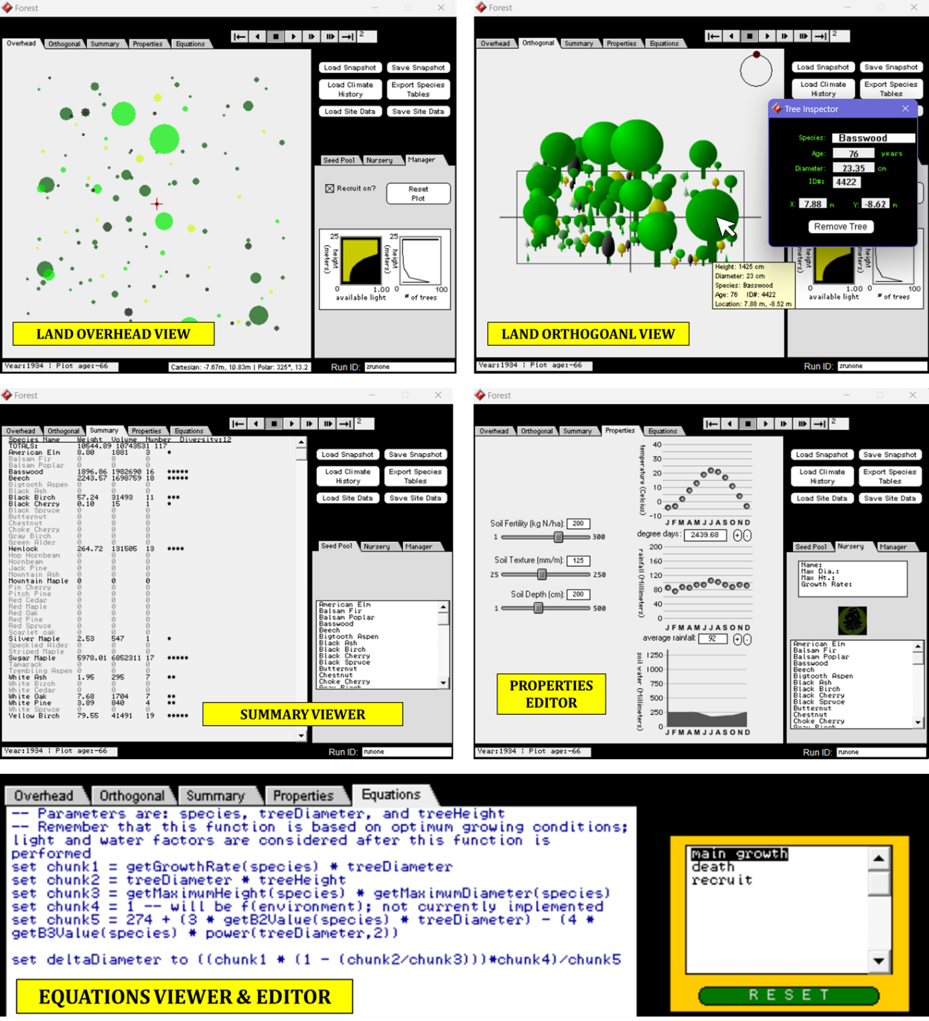

Figure 1. SimForest UI.

[SimForest](http://simforest.hampshire.edu/index.html) is a Java-based software for inquiry-based learning that simulates forest growth under various environmental conditions (soil fertility, texture, depth, water, temperature, rainfall). The forest can grow naturally, or learners can plant trees from a selection of 30 species. Users can play/pause the simulation and move forwards or backwards in time at different speeds, with both overhead and orthogonal views available. Clicking on a tree shows its properties (species, age, diameter, ID, position) and allows for deletion. Learners can edit tree properties and environmental conditions. A summary tab displays weight, volume, and number of trees per species, and an equations tab shows editable growth, death, and reproduction mechanisms. Further, the tool comes in 2 versions based on learner control over simulation variables. The black box model limits access, while the glass box model allows learners to edit nearly all parameters and equations. The glass box model also enables tree cutting and core sample analysis. The tool also allows saving and reloading of world snapshots.

|  |  |
| --- | --- |
| **Pros** | **Cons** |
| Rich set of manipulatable controls. | Does not consider CO2 levels. |
| General forest growth simulation. Multiple learning scenarios may be developed. |
| Clean user-friendly UI. |
| Facilitates inquiry-based constructivist learning comprising multiple iterative inquiry cycles with steps (i) ask question or form hypothesis, (ii) plan to answer or test hypothesis (iii) note observations, (iv) analyze data gathered, (v) communicate learnings. | Only available on PC. Needs download/set up. OS, Java, or Swing related compatibility issues possible. |
| Can be adapted to teach a range of age groups and expertise levels (school grade 4 all the way up to university graduate students and forestry professionals). |
| Allows moving through times at various speeds. | Does not consider economic value of forests. |
| Good data visualization. |
| Allows multi-level control (high-level or black box, as well as low-level or glass box). |

Table 2. SimForest - Pros and cons.

SimForest's detailed simulation model is based on allometric equations. MycroForest assumes most growth conditions modelled by SimForest as ideal, focusing on just carbon availability. SimForest emphasizes tree or environment parameter editing, not forest management. In contrast, MycroForest allows creation of land management plans involving actions like chopping and planting trees, while not permitting unrealistic actions like editing species, age, or height of grown trees. Like SimForest, MycroForest allows system state to be saved and reloaded for easy sharing of world settings and reproduction of past results. MycroForest also has timeline controls as in SimForest, enabling forwards/backwards motion in time and playing/pausing of the simulation.

#### **Tool 2 – Foster Forest** (Decision Support Simulation) [3]

Foster Forest embraces the Companion Modelling (ComMod) approach. It is a simulation adapted to be a Role Playing Game (RPG) aimed at experts like forest managers, community forest federation members, etc. 5 participants, a mayor, public forester, protected area manager, and 2 private landowners make social, economic, and ecological decisions to manage ES availability. A facilitator is also required to computerise participant decisions and must be a Foster Forest expert who can adapt source code to implement creative strategies. All participant roles manage budget and avoid negative impacts of ecological factors like overgrazing. Some roles have more exclusive objectives (e.g. mayor maintains water quality and upholds aesthetic value of forests, public forester focuses on timber harvests, protected area manager promotes old growth conservation and shares information about carbon storage).

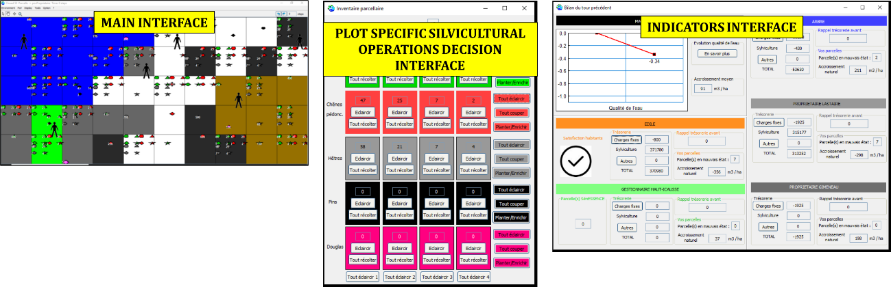

Figure 2. Foster Forest UI – The main interface displays the 50 land plots simulated. Different views (owner view, eligibility for conservation plan view, etc.) can be selected to be overlayed on these plots. The above main interface image shows the ownership view coded per participant. The indicators interface displays overall and participant specific ecological and land parameters.

The simulation is built using the [CORMAS](http://cormas.cirad.fr/indexeng.htm) platform upon an Agent Based Model (ABM) composed of spatial (land plots owned by participants), semi-autonomous (participant roles), and physical entities (trees). The participatory experience comprises 5 steps starting with a pre-simulation questionnaire that asks about climate change views, followed by a user-guide briefing session before the main activity with multiple rounds is conducted. The session ends with a post-simulation questionnaire and collective debriefing session.

The simulation progresses in 10-year timesteps comprising 2 periods. During the action period, the facilitator shares climate projections, timber, and carbon prices. Players then discuss and present forest management strategies involving tree planting or removal, hunting, trading plots, and execution of sustainability efforts like old growth protection. In the next computerised update phase, the facilitator inputs player decisions into the tool, which simulates forest growth, calculates successive ABM entity states, and updates values like participant income or expenses and changes in social or ecological parameters (e.g. carbon storage, soil fertility, etc.). The facilitator concludes this phase by providing an overview of new parameter values and climate changes.

|  |  |
| --- | --- |
| **Pros** | **Cons** |
| Participants enjoyed the ComMod wherein decisions followed group discussions. | Participants must be familiar with the domain. Not for the lay man. |
| Participants found the UI too mathematical and hard to relate to. |
| Tool requires extensive introductory training and user guides. |
| Tool is realistic with a well-designed ABM. | Participants cannot interact with the tool directly. They rely on a facilitator. |
| Participants appreciated being able to test strategies in a risk-free environment. | Tool use instructional material (2 usage videos, 6 booklets one for each role + facilitator) provided was overwhelming for some participants. Thus, learning curve is very high. |
| Tool is very flexible and supports a rich variety of scenarios. Participants can come up with creative strategies not severely limited by tool capabilities. | This tool requires an elaborate set up with 2 projectors and a facilitator. It was built using software that needs to be downloaded and installed along with associated user guide materials. This makes this tool less accessible. |

Table 3. Foster Forest – Pros and cons.

Design decisions in MycroForest inspired by Foster Forest include the following.

* Using an ABM approach for forest growth and carbon flow.
* Implementing carbon reservoirs like Foster Forest’s plot carbon storage.
* Tracking participant income and expenses related to forest management actions.
* Featuring more than one tree species with varying growth rates and wood prices.
* Implementing younger trees to be more sensitive to environmental factors.
* Allowing only mature trees to reproduce, with natural regeneration needing nearby mature trees.
* Incorporating tool use and debriefing sessions for effective pedagogy.
* Conducting group activities wherein learners collaboratively design management plans, inspired by the ComMod approach.

The ABM in MycroForest is simpler than in Foster Forest, omitting details like soil fertility and tree competition due to project scope constraints, primarily time. This simpler model effectively links forest management practices with atmospheric CO2 levels, making it suitable for educational purposes w.r.t getting young learners to think about the role of forests in mitigating rapid climate change. Unlike Foster Forest, MycroForest is a web application, making it more accessible with minimal setup. Its user-friendly, aesthetically pleasing design includes easily digestible guidance. MycroForest is also a microworld accessible to non-experts and young users, requiring only a standard browser, a desktop or laptop, and a stable internet connection.

#### **Tool 3 – MineSet** (Educational Game) [4, 63]

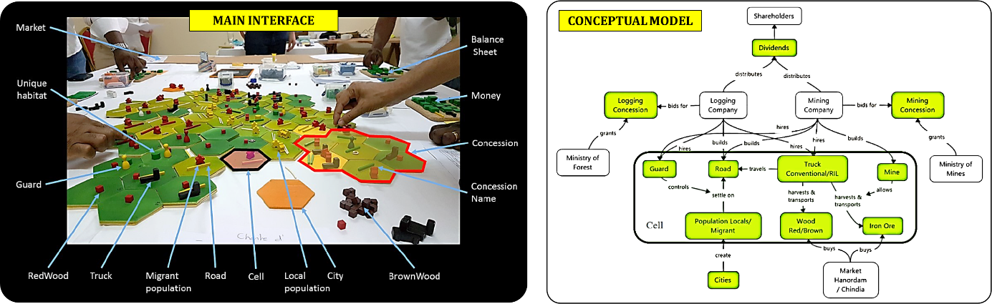

Figure 3. MineSet interface (left) and conceptual model (right). [4]

MineSet is a role-playing board game aimed at a broad audience including various forest stakeholders such as local communities, NGOs, protected area managers, companies, and governments. Players act as CEOs of logging or mining companies and interact with markets, the government, and NGOs to develop land use strategies effects of which are measured in terms of forest cover, biodiversity, and volumes traded. The underlying model captures main drivers of land use change in central African forests (demographics, economical, governance, technological, cultural) via simple rules [4]. In 2023, P. O. Waeber et al. tested the game online with Forestry graduate students via Zoom, noting high engagement, effective learning, and development of realistic strategies. Participants indicated a need for a fully digital version of this game or similar ones as widely accessible and transformative learning tools [63].

|  |  |
| --- | --- |
| **Pros** | **Cons** |
| ComMod. | Allegorical model is less scientifically accurate. |
| Engaging and immersive. |
| Models a rich variety of land use change drivers. | Significant set up required. |
| Implements model progression to slowly reveal game complexity. | No explicit mention of climate change. |
| Caters to a wide audience, particularly forest stakeholders. However, non-expert audiences can also enjoy and learn from it. | The physical nature of the game requires in-person attendance. This makes it less widely accessible unless online collaborative tools (like zoom, google meet, etc.) are incorporated and a third-party coordinate and communicates all player moves. This is tedious. |
| The physical mine set board game is a more holistic visceral experience that is more likely to be remembered given close in-person interaction with peers and physical interaction with game pieces. |

Table 4. Mine Set – Pros and cons.

Like Mine Set, MycroForest prioritizes capturing causal links between system components over producing accurate real-life outcomes. This focus suits learning tools aimed at understanding management activities and environmental impacts rather than plant growth or carbon transformations. A simpler model makes the tool faster and more user-friendly. MineSet uses indicators such as landscape composition and species diversity, with a maximum value approach to categorize changes into mentally trackable categories. MycroForest mirrors this approach with range-limiting and color-coded categories for atmospheric CO2 levels and biodiversity scores, enhancing the impact and clarity of these indicators. The idea that “learning begins when the game is over”, is central to teaching tools like MycroForest and Mine Set where focus is on encouraging discussion around sustainable resource management. After playing the game Mine Set participants reported learning about (i) the system, (ii) themselves, and (iii) peers, thanks in large part to frequent group discussions. This reinforces the decision to have students use MycroForest in groups and interleave challenges with discussion sessions.

#### **Tool 4 – About That Forest** (Educational Game) [5]

[About That Forest](https://games4sustainability.org/gamepedia/about-that-forest/) is a multiplayer RPG where learners, as forest dwellers, draft, and vote on policies for tree harvesting or non-timber product sales. Players can also plant trees and monitor other players. Poor forest health leads to floods affecting the entire community. The game is available on mobile devices, browsers, and PC.

|  |  |
| --- | --- |
| **Pros** | **Cons** |
| Underlying code allows for easily modifiable settings. | Underlying model and research not openly available. |
| ComMod. |
| Engaging. |
| Competition in addition to cooperation. |
| Multiple economic drivers of exploitation. | Atmospheric CO2 levels is not a modelled indicator. |
| Widely accessible. |
| Appeals to a wide age group and range of starting knowledge levels. |

Table 5. About That Forest – Pros and cons.

This tool highlights economic drivers behind forest exploitation and the "tragedy of the commons," here, representing profit-driven decisions leading to resource overuse and ecosystem collapse. MycroForest, like About That Forest, focuses on economic viability of forest management, and includes non-timber products as secondary means of revenue. MycroForest’s click-through introduction on the landing page is inspired from About That Forest’s text based introduction. Furthermore, About That Forest presents land as a grid with each cell possibly containing a tree whose icon changes to reflect its growth over time. This makes for a simple and informative display of land composition change. MycroForest thus, also adopts this visualization approach. Both About That Forest and MycroForest have one main indicator of climate change, which is less distracting. Unlike About That Forest wherein this indicator is “floods”, in MycroForest, it is atmospheric CO2 levels since this is more suited to drawing attention to role of forests as carbon sinks.

#### **Tool 5 – Forest Kids** (Educational Game) [6]

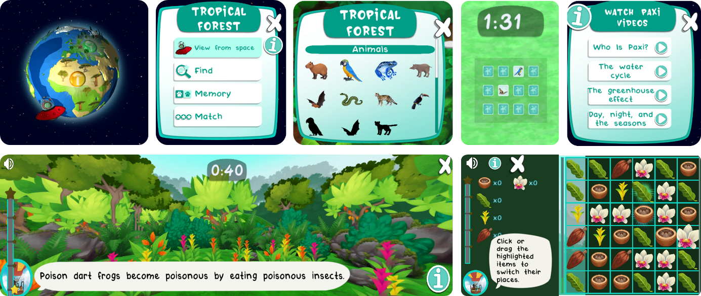

Figure 4. Forest Kids UI elements.

[Forest Kids](https://www.esa.int/Education/Forest_Kids_game_on_biodiversity_now_available) is a Unity 3D-based educational game for young children available on mobile (Android, iOS) and the web. Players explore 4 forest types (boreal, tropical, temperate, arid) with a team of digital children and an alien, learning about flora, fauna, and forest ESs. The game has timed mini games (picture matching, match 3, and spot the plant/animal) that earn points and add species to the player's collection, motivating continued exploration. It includes fun facts and lessons on the water cycle, greenhouse effect, days, and seasons. Interaction is primarily point-and-click/drag, with no planning or constructionist elements. The game is more explanatory than experiential.

|  |  |
| --- | --- |
| **Pros** | **Cons** |
| Age appropriate for children. | No learning through making. |
| Visually very attractive. | Facts presented during matching and memory games are random and lack connection. This can make them hard to learn. |
| Great user experience with smooth interactions. |
| Motivating mini games. | Games are very engaging. The timing element adds a sense of urgency. As pointed out in [9] , games that are very competitive or engaging, often with a scoring system, especially in the absence of constructionist mechanisms, can significantly affect learning negatively. Users tend to enter a "twitch" mode where they are hyper focused on improving score and learning suffers. This is a real threat here. Personally, when trying the memory game, I, this author, soon found myself ignoring presented facts and more focused on memorizing tile symbols to get matches right before the timer runs out to score maximum points. |
| Very informative and covers different topics related to forest biodiversity and Earth's climate. |
| In-app help is well placed and provided in small, easy to absorb chunks. |
| Text in the game is supported by audio readouts to make it easier to absorb for children. |
| Facts are repeated from time to time but not too frequently. This may promote information persistence in memory. |

Table 6. Forest Kids – Pros and cons.

A key lesson from this tool is that gaming elements in educational tools should not distract learners. Unlike Forest Kids, MycroForest has no score or point system. Instead, competition is introduced by having students work in teams and compare strategies, aiming for the lowest CO2 level, highest income, etc. This approach ties the competitive activity back to forest management, reducing the chance of learners entering the gamer’s "twitch" mode. Like Forest Kids, MycroForest is age-appropriate for young adults and features custom artwork to enhance aesthetic appeal and improve UX.

#### **Discussion**

One key aspect that most above tools have in common is that they provide a low-risk environment within which to experiment with management strategies. This is the primary reason why simulation, microworlds, and games are suitable for forest management exercises. Learning through trial and error in the real world is not practical as key ecosystem services may be harmed. Another driver for prevalence of simulations in forestry is associated speed up of natural and ecological processes which makes it possible to appreciate the true gravity of the consequences of decisions made over time. These qualities make tools like MycroForest attractive for educational purposes.

All examined forest management related tools (Foster Forest, Mine Set, About That Forest) include timber harvesting as a primary income steam. MycroForest follows suit.

Another important lesson from reviewed tools is that good UX and a pleasing UI are crucial for user engagement. Thus, MycroForest adheres to HCI best practices.

Table 7 compares aforementioned tools (table columns) against each other w.r.t certain qualities (table rows). MycroForest, the resulting product of this work, has been added to this table to gauge if it possesses all following qualities originally deemed desirable.

* **Realistic:** Models the real world sufficiently well such that environment responses to forest management actions mirror real world observations.
* **Engaging:** Users find it engaging.
* **Easily Accessible:** Is widely accessible with minimal set up required.
* **For Youth:** Youth understand and use it with ease. They find it informative.
* **Team:** Facilitates decision-making that is satisfying to do collaboratively.
* **Solo:** Provides a rewarding experience for individual learners.
* **Focused Aim:** Does not try to do too many things at once. Focuses on few specific key ideas (e.g. forest management actions and atmospheric CO2 levels, forest management actions and economic gains/losses).
* **Forest Management:** Allows learners to make forest management decisions.
* **Forest As Carbon Sink:** Highlight role of forests as important carbon sinks.
* **Financial Motive:** Draws attention to financial motives that drive forest exploitation.
* **Low Entry Threshold:** Fairly easy to start using without getting overwhelmed.
* **Easy To Use UI:** Has good UX and a simple, easily navigable, not frustrating UI.
* **Sufficient Built-In Help:** Contains user-friendly, comprehensive, built-in user guides.

|  |  |  |  |  |  |  |
| --- | --- | --- | --- | --- | --- | --- |
| INFORMATIVE **TOOL** → **QUALITY** ↓ | *FOSTER FOREST* | *MINE SET* | *ABOUT  THAT FOREST* | *FOREST KIDS* | *SIMFOREST* | *MYCROFOREST* |
| *REALISTIC* | ⚫ | ⚫ | ⚫ | ⚫ | ⚫ | ⚫ |
| *ENGAGING* | ⚫ | ⚫ | ⚫ | ⚫ | ⚫ | ⚫ |
| *EASILY ACCESSIBLE* | ⚫ | ⚫ | ⚫ | ⚫ | ⚫ | ⚫ |
| *FOR YOUTH* | ⚫ | ⚫ | ⚫ | ⚫ | ⚫ | ⚫ |
| *TEAM* | ⚫ | ⚫ | ⚫ | ⚫ | ⚫ | ⚫ |
| *SOLO* | ⚫ | ⚫ | ⚫ | ⚫ | ⚫ | ⚫ |
| *FOCUSED AIM* | ⚫ | ⚫ | ⚫ | ⚫ | ⚫ | ⚫ |
| *FOREST MANAGEMENT* | ⚫ | ⚫ | ⚫ | ⚫ | ⚫ | ⚫ |
| *FOREST AS CARBON SINK* | ⚫ | ⚫ | ⚫ | ⚫ | ⚫ | ⚫ |
| *FINANCIAL MOTIVE* | ⚫ | ⚫ | ⚫ | ⚫ | ⚫ | ⚫ |
| *LOW ENTRY THRESHOLD* | ⚫ | ⚫ | ⚫ | ⚫ | ⚫ | ⚫ |
| *EASY TO USE UI* | ⚫ | ⚫ | ⚫ | ⚫ | ⚫ | ⚫ |
| *SUFFICIENT BUILT IN HELP* | ⚫ | ⚫ | ⚫ | ⚫ | ⚫ | ⚫ |

Table 7. Comparison of closely revied tools against each other and MycroForest in context of desirable qualities. (⚫ = completely satisfies, ⚫ = fails to satisfy, ⚫ =satisfies with caveats)

Many apps are scientifically accurate or realistic regarding plant growth models. This is true for decision-making aids like Foster Forest aimed at experts and simple explanatory tools like Forest Kids. MycroForest, however, uses a simplified conceptual model, assuming ideal growing conditions except for CO2 and generalizing plant species to coniferous or deciduous. This simplification is acceptable as MycroForest focuses on teaching about causal links between forest management and atmospheric carbon levels. Other tools like Mine Set, About That Forest, and SimForest also abstract plant growth details to emphasize broader behaviours or interactions. Of these, SimForest is likely the most detailed, considering more environmental factors like temperature, light availability, soil depth, and water capacity.

MycroForeset and SimForest do not have a multi-player mode or support sign-up/log-in. However, learning activities can be structured such that groups of students make decisions using these tools thereby making ComMod still possible.

FosterForest requires added hardware, a facilitator, and special software downloads. Mine Set is a physical board game that needs setup and is best played in person. SimForest requires downloading and installing, and is prone to system compatibility issues. Therefore, compared to web-based or mobile applications like About That Forest and MycroForest, tools like FosterForest, Mine Set, and SimForest are less accessible.

Overall, MycroForest meets all intended criteria w.r.t this project. It is a sufficiently realistic, engaging, and accessible web-based teaching tool aimed at the youth. Although there is no multiplayer mode, both team and solo learning activities can be structured around it. Unlike many tools that try to do multiple things at once, MycroForest focuses exclusively on forest management, its effect on atmospheric CO2, and impact of financial motives. This app is built to be easy to get started and use with ample built-in help.

## Summary

Research for this project involved reviewing fields like forest management, education technology, simulation design, and human computer interaction, as well as analysis of 5 interactive tools with similar elements as MycroForest, the proposed teaching tool.

Key forest ecosystem services and management strategies were analysed, recognizing carbon sequestration and timber provisioning as crucial for MycroForest, which aims to educate about economic viability of climate-conscious forest management. The tool includes tree planting and felling as key actions affecting both timber production and CO2 levels, thereby influencing carbon sequestration. Rotation period was identified as a critical decision factor in forest management within MycroForest. While halting deforestation and promoting afforestation and reforestation are essential to combat climate change, forest owners often depend on forest income. MycroForest offers alternative income streams and presents challenges to inform about the importance of proforestation and reduced resource usage w.r.t slowing down rapid climate change.

Exploring education technology showed that microworlds are effective teaching tools due to their support for self-regulated learning rooted in constructionism, which promotes deep, persistent, and engaging learning. MycroForest, a simulation-as-microworld, incorporates gaming concepts and offers target setting, model progression, and challenges at various difficulty levels. This blend of simulation, microworld, and game elements has been linked to enhanced usability and learning effectiveness.

MycroForest needs to model tree growth, the carbon cycle, and effect forest management plans created by learners. So, different simulation paradigms were studied. A hybrid simulation approach was adopted. MycroForest uses ABS to model tree growth and carbon transfer with 1 year time step time advancement while DES is used to incorporate forest management decisions taken by learners. Ensuring interoperability between different simulation approaches is difficult. MycroForest manages this through adoption of object oriented design which also upkeeps software quality.

Research suggests that good human computer interaction is key to effective education. To this end, MycroForest presents an active, unimodal, and thereby less distracting, pleasing UI that tries to incorporate best practices based on known good HCI principles like Norman’s model and Jacob Nielsen's usability heuristics.

Examining 5 similar tools informed the design of features in MycroForest, like timeline controls, forest representation, and climate change indicators. It also suggested elements to avoid, like distracting gamification, unrealistic updates, and a steep learning curve. The result is a realistic, engaging, and accessible web-based tool that offers a rewarding individual or group learning experience focused on forest management, atmospheric CO2, and underlying financial motivations, tailored for young adults.

# Design

This chapter describes project scope, pedagogical approach adopted, current UI, application of HCI best practices, system architecture, and technical details.

## Scope

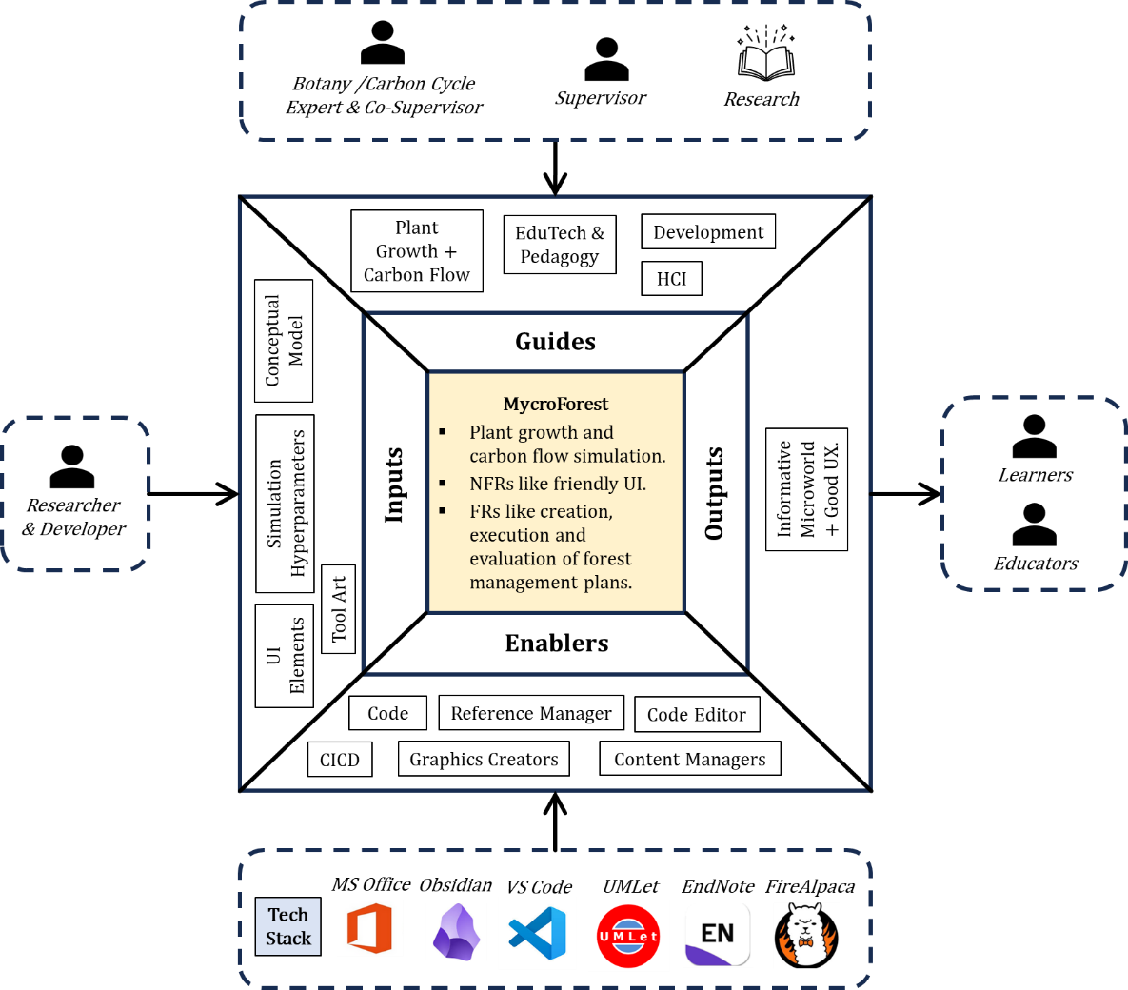

Figure 5. Scope diagram [67] with core focus in the middle.

**Deliverable Name:** MycroForest.

**Project Justification:** Project objectives are as follows.

* Research EduTech, simulations/microworlds, forest management, and climate change to develop a user-friendly tool that informs youth about the role of forests as carbon sinks and economic factors driving resource exploitation through SRL.
* Evaluate the tool w.r.t educational value, learner engagement, and usability based on feedback from students and faculty who use it at the Bridge2College program.

**Scope Statement:** MycroForest is designed for learners to explore climate-aware forest management by creating and executing their own management plans and analysing its impact on a virtual forest environment. It will not model biochemical processes like photosynthesis but will illustrate realistic cause-and-effect relationships between management actions and carbon levels as is sufficient for the associated educational purpose. Users will have limited access to plant growth or environmental parameters, focusing instead, on management actions like planting/harvesting.

* **In Scope:** MycroForest provides a virtual forest that evolves based on a hybrid simulation model where learners can create, execute, and analyse management plans and means of income generation via non-timber products or visitor permits. The UI shall adhere to HCI and data visualization best practices.
* **Out of Scope:** Due to time constraints and the interdisciplinary nature of the project, forest growth and carbon flow models are simplified and not biochemically accurate. They focus on variables affecting the carbon cycle using high-level averages from real-world data and assume other conditions to be ideal (e.g. factors like sunlight, temperature, and soil nutrients are not explicitly modelled since do not directly influence the simplified carbon cycle). Since the primary focus is forest management, learners may only update model hyperparameters via management plans and cannot alter values like max tree height, soil carbon release rate, etc. directly. These values are pre-defined based on research and expert opinions from Dr. Silvia Caldararu.

**FRs & NFRs:** Below are functional and non-functional requirements prioritised using the MoSCoW scale wherein priority categorization = Must > Should > Could > Would [68].

|  |  |  |
| --- | --- | --- |
| ***#*** | ***FUNCTIONAL REQUIREMENT (FR)*** | ***PRIORITY*** |
| 1 | System shall allow creation, editing, and deletion of forest management plan actions. | MUST |
| 1.1 | System shall enable users to make following decisions regarding each forest management action: (i) Action type = Plant / Fell. (ii) Tree type affected = Age, Species. (iii) No. of trees affected. (iv) Action execution time. (v) Whether this action is to repeat or not. | MUST |
| 1.2 | As the simulation steps through each timestep, system shall try to execute every planned action for that step. | MUST |
| 1.3 | System shall allow users to define the harvest rotation period (1 rotation = ? no. of years) | SHOULD |
| 1.4 | System shall provide feedback about action execution status (full/partial success, failed). | SHOULD |
| 1.5 | System shall allow saving and reloading of a forest management plan along with system state. | SHOULD |
| 2 | System shall allow the user to navigate through time using a timeline. | MUST |
| 2.1 | System shall facilitate a play/pause button that allows the user to view the state of the forest at each point in time as an animation. | MUST |
| 2.2 | User may skip to any point in the timeline. | SHOULD |
| 2.3 | User may move through time one step at a time. | COULD |
| 3 | System shall display concentration of CO2 in air in a color-coded manner where colors stand for expected quality of human life at that CO2 level. | MUST |
| 4 | System shall allow users to earn income from the forest. | SHOULD |
| 4.1 | Successful execution of fell actions result in gaining income via the timber income stream. | MUST |
| 4.2 | Users may activate the non-timber forest products income stream. | SHOULD |
| 4.3 | Users may activate the Forest Recreation income stream. | SHOULD |
| 5 | Forest management actions and/or maintaining other income streams shall cost some money. | MUST |
| 6 | System shall display in-world wealth of the user. | MUST |
| 6.1 | System shall display overall income and expenses. | MUST |
| 6.2 | System shall display per year income and expenses. | SHOULD |
| 6.3 | System shall display income per rotation and expenses. | SHOULD |
| 6.4 | System shall allow users to view income and expenses breakup among different income streams. | COULD |
| 7 | System shall include built-in help. | MUST |
| 7.1 | System shall present short extracts of component relevant help. | MUST |
| 7.2 | System shall have a help page with all user guide materials on it. | SHOULD |
| 8 | System shall display land content. | MUST |
| 8.1 | System shall display presence/absence of trees on land. | MUST |
| 8.2 | System shall display biodiversity score and class related to the land. | SHOULD |
| 8.3 | System shall allow users to hover over a tree on land and view its species and age. | WOULD |
| 9 | System shall allow users to edit amount of Carbon emitted due to burning of fossil fuels. | MUST |
| 10 | System shall allow users to set CO2 and income targets. | SHOULD |
| 10 | System shall allow users to set target CO2 concentration and display whether this target is met (CO2 level <= CO2 target) throughout the simulation. | SHOULD |
| 10 | System shall allow users to set target per rotation income and display whether this target is met (income this rotation >= per rotation income target) throughout the simulation. | SHOULD |
| 11 | System shall allow users to sign-up and log-in to persist information. | WOULD |

Table 8. MycroForest - Functional Requirements (FRs)

|  |  |  |
| --- | --- | --- |
| ***#*** | ***NON-FUNCTIONAL REQUIREMENT (NFR)*** | ***PRIORITY*** |
| 1 | The tool shall be valuable to both individual and groups of learners. | MUST |
| 2 | The tool shall provide good UX. | MUST |
| 2.1 | The tool shall be easy to use. | MUST |
| 2.2 | The tool shall respond quickly enough and present information effectively enough to minimize learner frustration. | SHOULD |
| 2.3 | The tool shall adhere to good HCI and data visualization practices (e.g. Norman's model, etc.). | MUST |
| 3 | Learners shall find learning activities using the tool valuable. | MUST |
| 4 | The tool shall be a web application with wide accessibility needing minimal set up. It should work well on at least Firefox, Chrome, Edge, Brave, and Opera browsers on modern PCs/laptops. | MUST |
| 5 | The tool shall subject all user inputs to sanitization checks prior to performing internal parameter updates to avoid erroneous or malicious input corrupting data. | MUST |
| 6 | The tool shall be suitable for youth (15 - 25 year old individuals). | MUST |
| 7 | The tool shall highlight the role of forests as important carbon sinks as well as draw attention to the underlying financial motives that drive exploitation of forests. | MUST |
| 8 | The tool shall not overwhelm learners and instead present user guide related information as short extracts with supporting images. Features of the tool shall also be introduced few at a time, gradually over multiple challenges. | SHOULD |
| 9 | The tool shall make available, sufficient amounts of easily findable built-in help. | SHOULD |
| 10 | Learners shall find the learning experience using the tool enjoyable. | COULD |
| 11 | The tool shall try to provide an optimal level of challenge for learners by allowing multiple challenges of varying difficulty levels to be formulated using the tool. | COULD |
| 12 | Gamification elements in the tool and associated learning activities shall motivate learners without distracting them. | WOULD |

Table 9. MycroForest - Non Functional Requirements (NFRs)

#### **Key People & Technologies**

The project team included a researcher/developer (author), Dr. Brendan Tangney – a Computer Science professor at TCD specialized in Educational Technology as supervisor, and Dr. Silvia Caldararu – a Botany, Climate Change, as well as Carbon Cycle expert as co-supervisor. Key tools used were [MS Word](https://www.microsoft.com/en-ie/microsoft-365/word), [MS Excel](https://www.microsoft.com/en/microsoft-365/excel?market=af), [MS PowerPoint](https://www.microsoft.com/en-ie/microsoft-365/powerpoint), [Obsidian](https://obsidian.md/), [FireAlpaca](https://firealpaca.com/), [VS Code](https://code.visualstudio.com/), [UMLet](https://www.umlet.com/), and [EndNote](https://endnote.com/). MS Word was used for this writeup, MS Excel for organizing tables and spreadsheets, and MS PowerPoint for creation of figures. Obsidian helped manage interlinked personal files, UMLet enabled UML diagram creation, FireAlpaca was used for creating artwork for MycroForest, EndNote managed research references, and Visual Studio Code served as code editor.

#### **Working With Domain Experts**

Throughout this project, the author has worked in close association with two domain experts, Dr. Brendan Tangney (supervisor) and Dr. Silvia Caldararu (co-supervisor).

Dr. Tangney, an expert in Education Technology reviewed UI and learning activity designs to ensure an engaging and appropriately challenging experience for young adults. Periodic meetings with him allowed discussion of project artifacts as part of the Agile workflow’s analysis phase. He was always available at times of need and skilfully identified whenever research/development was off-track as well as advised refocusing on priorities. Below are few specific examples of his valuable contributions.

* Initially the option to add management actions within a rotation period was excluded, assuming it to be too complex/confusing. However, Dr. Tangney suggested that allowing management actions, during intermediate years would be both interesting and intuitive for learners. This was recognized and implemented. It later led to learners discovering the management strategy of thinning for themselves.
* He noted an inconsistency in an early version of the application where both the total bank balance and money-related target were labelled as "funds." This violated Jacob Nielson’s Usability Heuristics rule (iv) and could cause confusion. Thus, the UI was edited by renaming the income target setter and bank balance more distinctly.
* During Bridge2College learning session discussions, Dr. Tangney put forth critical questions like “Do you think forestry is good?” which encouraged learners to think more deeply about the subject and reflect on learnings from the tool better.
* Dr. Tangney recommended designing challenges that allow learners to use target-setting features to compete in groups. This inspired the idea of having student teams compete to achieve higher income targets or lower CO2 levels. Based on healthy enthusiasm observed at student discussions, this made the activity more enjoyable.

Dr. Caldararu is an expert in plant growth and how both plants/forests affect the climate as well as how the climate affects them. She carefully reviewed the plant growth and carbon flow model to ensure sound simulation design and reflection of reality. She also shared feedback regarding the UI. Below are few specific examples of her contribution.

* The initial carbon flow model excluded soil carbon, focusing only on air, vegetation, and fossil fuels. Dr. Caldararu recommended including soil, emphasizing its critical role in regulating atmospheric carbon levels.
* She also recommended exploring different wood uses which affects amount of carbon released. This led to incorporating harvested wood use for energy production versus as lumber, thereby considering how HWPs can lock away carbon and increase net carbon sequestration if not burned and new growth replaced felled trees.
* Initially, hunting/fishing was another income stream. Dr. Caldararu advised that this may take away from the SFM learning outcome, as this income stream is often abused causing forest biodiversity loss, adversely affecting forest resilience. Thus, it was decided not to present hunting/fishing as a climate-friendly income source.
* Dr. Caldararu suggested implementing a “developer mode” to track key variables like “carbon absorbed”, “tree life stage”, etc. such that it may be saved and visualized for fault diagnosis. This feature was implemented. Individual tree data (stress, carbon absorbed, life stage, etc.) and environment data (carbon per reservoir, atmospheric CO2 concentration, etc.) can be recorded and saved as CSV files to later be visualized using Python libraries like pandas, NumPy, and matplotlib. This made error detection faster. Figure 6 shows screenshots of this dev mode, including activation in the utils.js file, data saving using the button on the timeline, and data visualization.

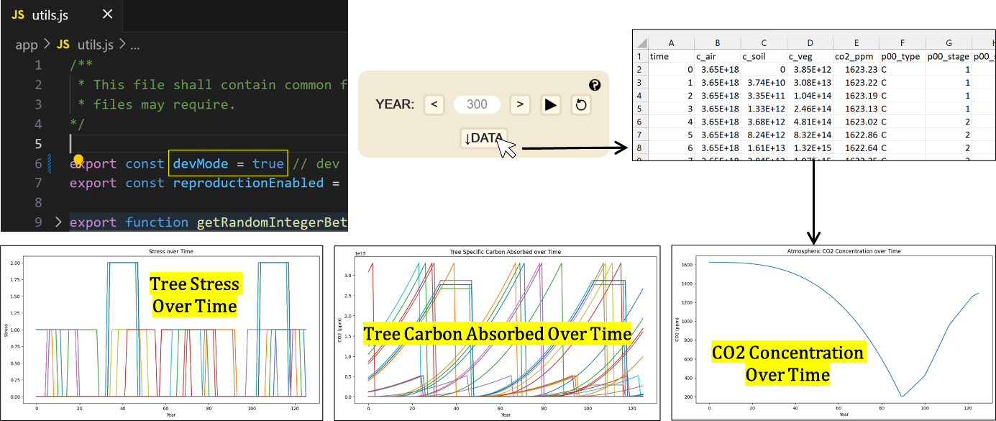

Figure 6. Dev mode.

## Pedagogical Approach

As discussed in section 2.2, hybridization of microworlds, simulations, and game theory in EduTech improves learning. Microworlds present many ways to interact with and manipulate model parameters. Exploration of a microworld providing timely and appropriate types of feedback is an absorbing experience. Ability to build virtual constructs in the microworld invokes a sense of control. Gamification through target setting, multiple challenges, and model progression keeps learners appropriately stimulated. Finally, a narrative can add fantasy/role-play which frees learners of other worries and self-consciousness. Thus, skilful hybridization leads to learning environments that agree with frameworks like FTOE and therefore, likely better caters towards SRL than does any approach (simulation, microworld, game) on its own.

All microworlds contain interactive OTTW. They support learning by allowing variable manipulation or facilitating outcome exploration. By this definition, each panel on the world and planner page in MycroForest is an OTTW. The planner page includes OTTW for forest plan and income stream management, while the world page features panels for target setting, time navigation, and fossil fuel usage. All other panels on the world page are also OTTW due to their role in graphically reflecting internal state changes.

Table 10 below, summarizes main EduTech ideas from section 2.2. Following paragraphs explain how MycroForest design elements and intended learning activity tries to adhere to identified pedagogy best practices w.r.t a gamified simulation-as-microworld.

|  |  |
| --- | --- |
| **Piagetian Learning Theory (PLT)** | **Good Practices (GP)** |
| (i) Epistemic conflict. | (i) Structure learning activities around challenges for gamification. |
| (ii) Self-reflection. | (ii) Multiple challenges with varying difficulty improves likelihood of learners finding an optimal difficulty level. |
| (iii) Self-regulation. | (iii) Model progression is beneficial. |
| **Flow Theory (FTOE)** | (iv) Good UX is key to avoiding learner frustration. |
| (i) Optimized challenge level. | (v) Graphical feedback accompanied by short, embedded multimedia explanations boosts understanding and reduces frustration. |
| (ii) Holds attention. |
| (iii) Clear goals. | (vi) Guidance during interaction with the tool improves learning. |
| (iv) Clear feedback. | (vii) Learners should explore the microworld within context of a structured activity to ensure learning. |
| (v) Absorbing experience. |
| (vi) Sense of control. | (viii) Topic related discussions boost understanding. |
| (vii) Frees learner of self-consciousness. | (ix) Students find a storyline, an important motivator and construct using which to mentally relate to the tool. |
| (viii) Hastened sense of time. |

Table 10. Pedagogy best practices.

Land plot content icons are updated per simulation timestep with a 100 millisecond delay, reflecting changes w.r.t time and planned forest management actions. Action execution status appears colour coded in the plan viewer as well as planner. The money panel gets updated with virtual money earned or spent. Colours and a number get updated to reflect atmospheric CO2 concentration changes. Green or red colour indicates achieved or failed status of targets respectively. Finally, text box entries turn red to indicate erroneous input. Feedback within MycroForest is primarily graphical. Both a dedicated help page and short multimedia (text + image) user guide material easily accessible by clicking  symbols associated with every world/planner page panel is also available. These features cater towards GP (v), PLT (ii), and FTOE (ii, iv, vi).

Further, Good UX is essential to prevent frustration (GP (iv)) that impedes learning. HCI best practices from Norman’s Model, Task-Core Language Mapping, and Jacob Nielsen's Usability Heuristics was applied alongside data visualization knowledge to enhance usability. Simplifying assumptions w.r.t the simulation model also helped ensure fast and smooth UX.

This teaching tool is intended to be used by students in the presence of an educator as mid-activity guidance promotes correct learning. The learning activity can also be split into short parts, each having a slightly different goal/theme with group discussions held in-between so that learners may interact with tutors and peers, which also allows tutors to ensure correctness of learner mental models. This activity structure aligns with GP (vii, viii), PLT (ii, iii), and FTOE (ii, iv, v). Furthermore, learners may compete in teams to develop forest management strategies that meet specific goals which can later be analysed and discussed amongst all and the facilitator. This can be motivating and enjoyable, thereby satisfying GP (i) and FTOE (ii, v, viii). Also, MycroForest allows learners to set maximum air CO2 concentration and minimum rotation income targets with colours green or red indicating success or failure respectively. This facilitates self-evaluation or monitoring and thus, aligns with FTOE (i, iii, iv, vi) and PLT (ii).

Ensuring learning from microworlds requires structure. This can be achieved by presenting challenges with specific goals, which guides the thought process and adds gamification to maintain motivation. MycroForest includes 5 challenges with increasing difficulty. The interface displays only those UI elements, controls, and use guide material essential for each challenge, hiding others to aid model progression. This approach aligns with GP (i, ii, iii, vii), FTOE (i, ii), and PLT (i). Table 11 summarizes implemented challenges. To switch between them, facilitators are to press Ctrl + Alt + 1, 2, 3, 4, or 5.

|  |  |  |  |  |
| --- | --- | --- | --- | --- |
|  | **Goal** | **Active Features** | **Possible Learnings** | **Expected Learner Activity** |
| **Challenge 1** | Maximize income from the forest. | Timeline Land Money Viewer Plan Viewer Planner Timber Income Stream | # Timber is a profitable resource. This motivates deforestation. # Generally, forest management activities are performed in rounds. | # Plan to chop as many trees as possible. # Note down income. # Edit plan.  # Try changing rotation period. # Coniferous trees are more profitable. Try planting only coniferous trees. |
| **Challenge 2** | Keep atmospheric CO2 concentration at as desirable a value as possible. | Challenge 1 Features + CO2 Target Setter + CO2 Scale - Money Viewer | # Forests sequester carbon.  # Mature/older trees are imperative to keeping atmospheric CO2 concentration low.  # Mature trees absorb more carbon as they grow. But older trees store more CO2.  # Chopping bigger old trees releases more CO2 at once than chopping smaller young ones.  # Clear felling is a bad strategy.  # Thinning is a better idea. # Best strategy is no management. | # Activate CO2 target. # Try best plan from challenge 1. Note highest CO2 concentration figure across 300 years. # Set a slightly lower concentration value as target. # Tweak management plan. # Try to hit lower CO2 target. # Repeat last 3 steps. |
| **Challenge 3** | Maximize income while trying to keep CO2 concentration ideal. | Challenge 2 Features + Money Viewer | # It is impossible to keep CO2 levels in a safe range without lowering profit margins. | # Set CO2 and income targets. # Tweak plan and see if targets are achieved.  # Report lowest CO2 + highest Income combination achieved. |
| **Challenge 4** | How long before fossil fuel usage leads to critical CO2 levels (red)? How to delay this? | Challenge 3 Features + Fossil Fuel Usage Panel + Carbon Distribution Panel + Biodiversity Score & Land Class | # Only way to improve CO2 concentration in the air is to significantly cut down fossil fuel emissions. No silver bullets. # There is more carbon trapped within earth as fossil fuels than there is in the air and vegetation. | # Set fossil fuel emissions to current global level of 10 GtC. Count years before CO2 level is critical and the entire forest dies. # Tweak plans to see if strategy can keep carbon levels in check. # Realize that this is not possible. Only way to reduce atmospheric CO2 concentration is to reduce emissions. |
| **Challenge 5** | How helpful is diversifying income from forests? | Challenge 4 Features + NTFP Income Stream + Recreation Income Stream | # Other income streams are not as profitable or reliable as timber.  # There is a need for more ways to earn from a forest without felling trees. # Income streams like forest recreation requires building infrastructure and thus large initial investment. | # Activate other income streams. # Compare per year, per rotation, and overall income and expenses of these other streams with that of the default timber stream. |

Table 11. Learning activity challenges implemented in MycroForest.

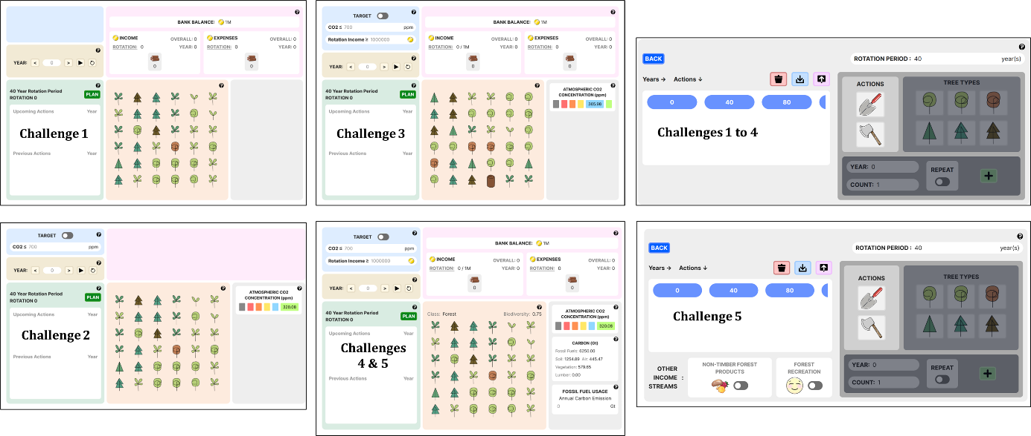

Figure 7. UI gradual feature reveal over 5 challenges.

Implementing problem-based, reflective, and inquiry-based learning via supportive class climate, peer interactions, and teacher-learner relationships enhances retention of learned values and information [11]. MycroForest supports these conditions with target setting, immediate feedback, and challenges coupled with discussion opportunities.

Lastly, research suggests that young learners appreciate a good story/premise for the learning activity (GP (ix), FTOE (vii)). Hence, the landing page incorporates an interactive exercise to spark interest followed by a quick click-through introduction that welcomes the learner with a narrative, setting the scene for the activities to follow.

## UI & HCI Design

This section explains the UI of MycroForest and reasoning that underpins its design.

### App Pages

MycroForest comprises 4 web pages. Following passages explain what each page looks like, possible interactions, and its purpose.

#### **Landing Page**

This is the first page that the learner sees. It displays the name of the application, its icon, text summarizing the premise of this app that reads “Economically Viable Climate Aware Forest Management”, and instructions on how to proceed which reads “Press Enter”. This content is hidden by a dark veil and is revealed upon mouse hover with the cursor acting like a torch. This little exercise serves to pique the interest of learners and drop a hint as to the nature of the application being that it demands active participation. Upon pressing the “Enter” key on the keyboard, the dark veil disappears, content gets updated, and text that reads “Hi” with a prompt urging the user to click it, replaces the app icon. Towards the bottom of the screen, two words “Help” and “Word” also appear. Hovering over these, reveal navigation instructions that inform the learner that they must press the “H” and “W” keys to navigate to the “Help” and “World” page respectively.

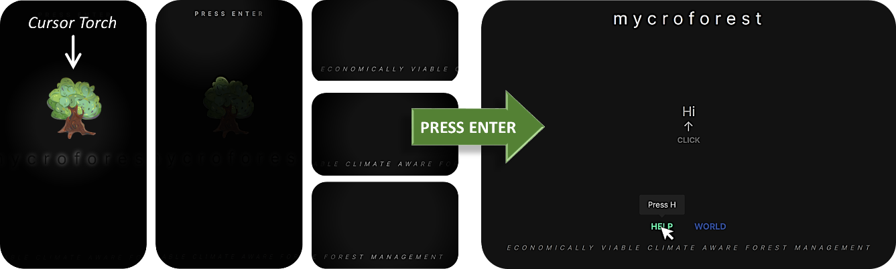

Figure 8. Landing page. Left: Interactive mouse cursor torch reveal content. Right: Introductory content that is revealed upon pressing the "Enter" key.

Clicking on “Hi” begins a dialogue which progressively introduces the learner to the app. The first time a user starts this click-through session, they must complete it. Attempting to move to other pages mid-way, causes a message to appear – “Your enthusiasm is much appreciated, but I’m not done yet. Please continue clicking. I promise this won’t take long”. When the learner clicks on the text, it fades to reveal the next dialogue until the last one is reached. Each dialogue serves a purpose. E.g. the dialogue “The forest is healthy and fairly large. I’d say it’s a good size for a first time forest owner like yourself.” suggests to the learner that they will be assuming the role of a forest owner.

Please find the full dialogue and the purpose it serves, in Appendices 8.6.

#### **Help Page**

Pressing “H” on the keyboard reveals the help page with an interactive graph whose nodes correspond to components in the microworld. Double clicking a node opens a pop-up window with text and images describing that component and how to interact with it. Each leaf shaped node may be dragged such that others follow in a fluid motion. This adds an element of such that learners might stay and explore topics.

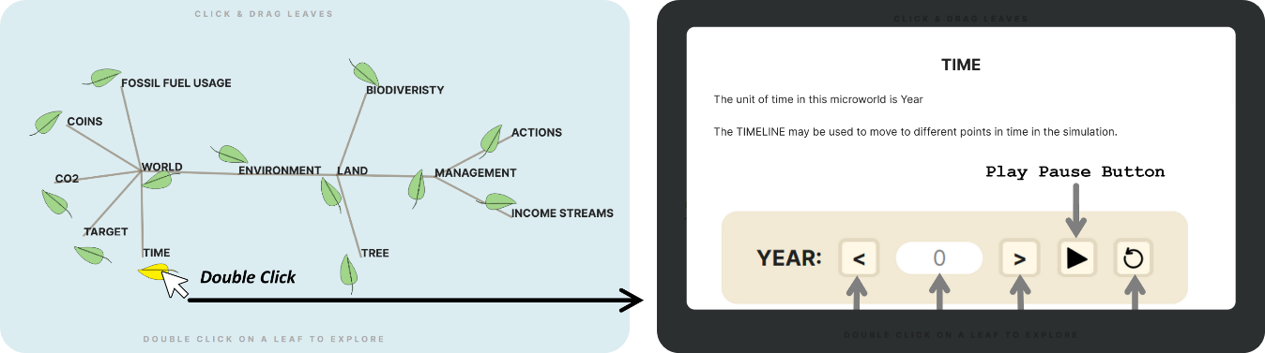

Figure 9. Help page with interactive graph. Double clicking a leaf node reveals pop-up text and graphics explaining significance and use of associated microworld component.

#### **World Page**

Pressing “W” on the keyboard takes the learner to the main Graphical User Interface (GUI) of the application. This is where users are expected to spend most of their time.

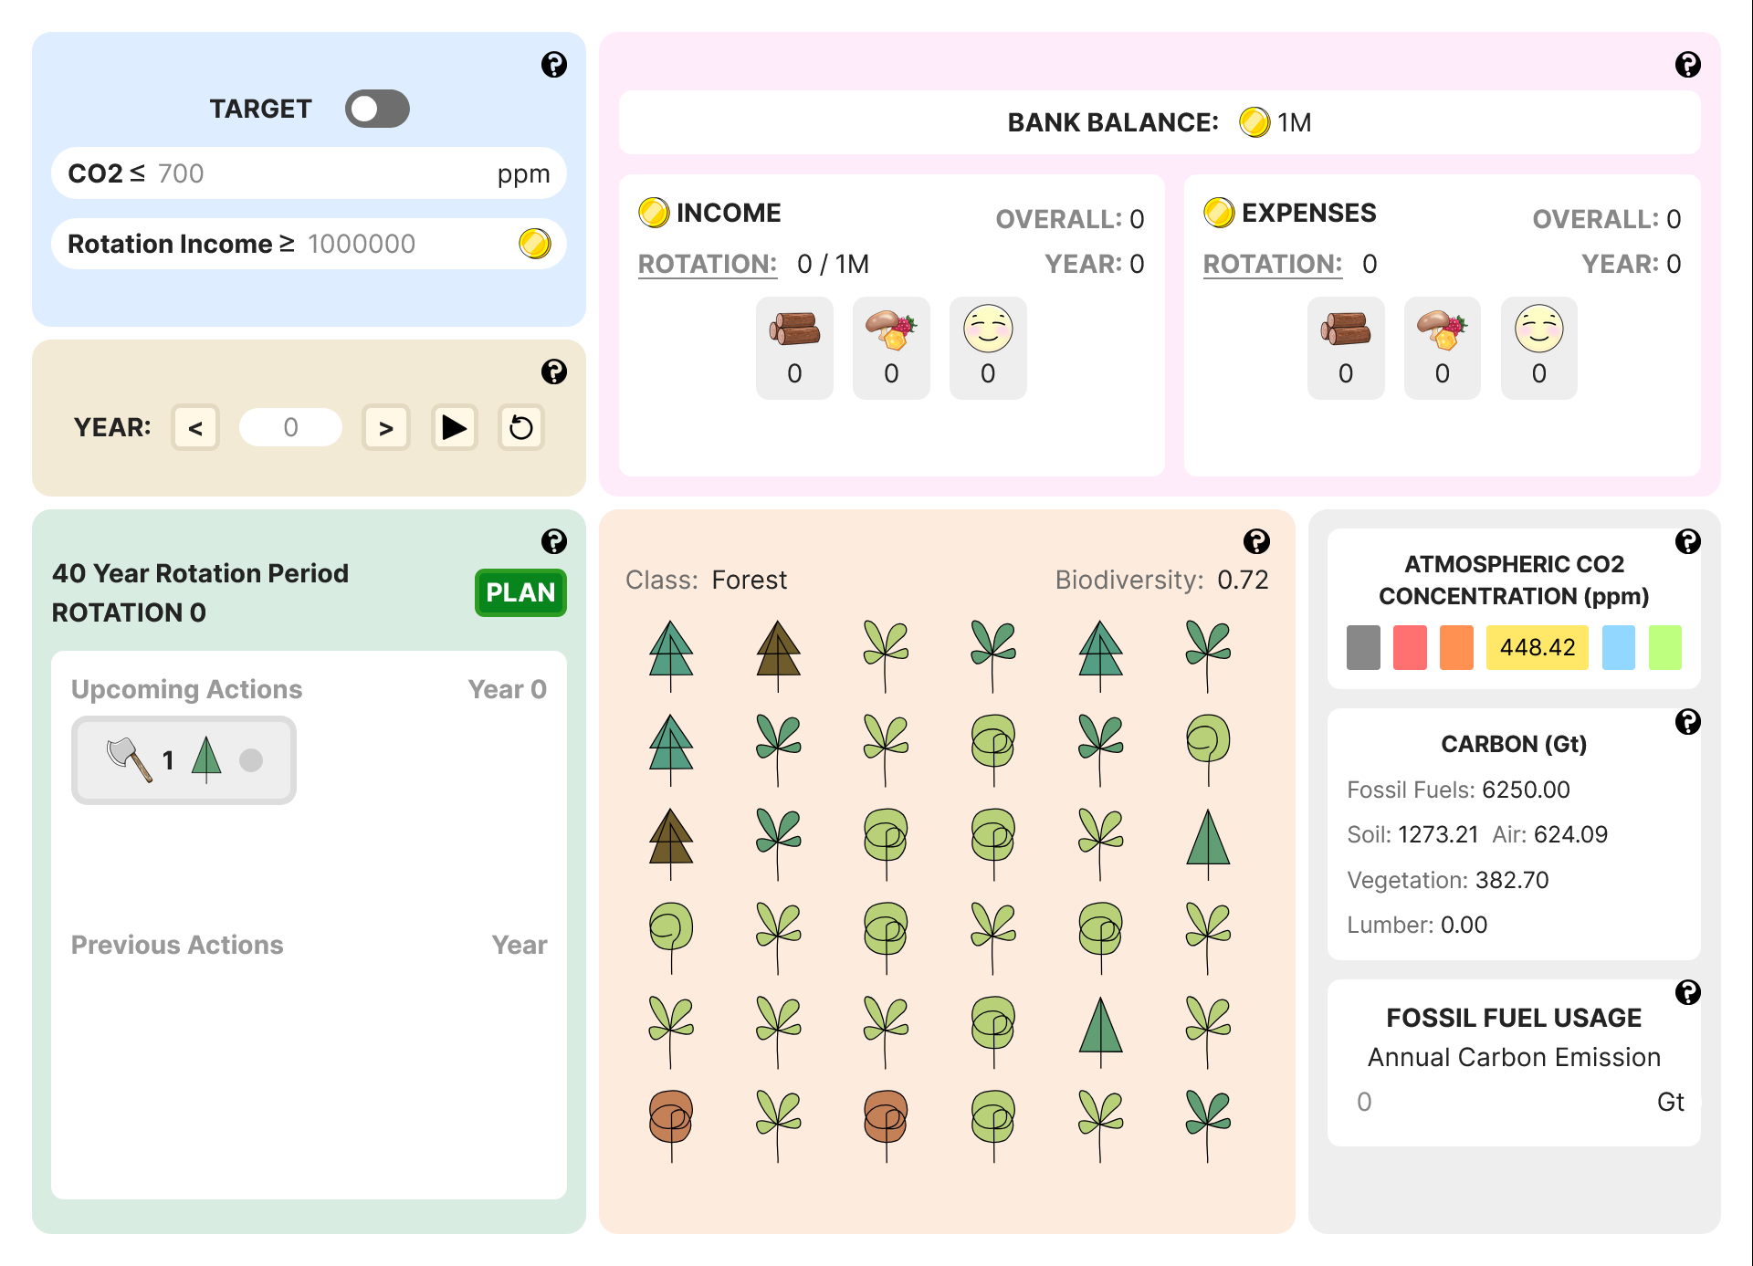

Figure 10. World page. This is the tool's main GUI.

Following paragraphs explain each UI element using parts of text and graphics displayed to learners when they click on the  icon in the tool or read about it in the Help page.

*Land Plot*

The land has 36 spots arranged in a 6 x 6 grid, each of which may either contain a tree or be empty. Hovering over land content reveals its type at the bottom of the plot.

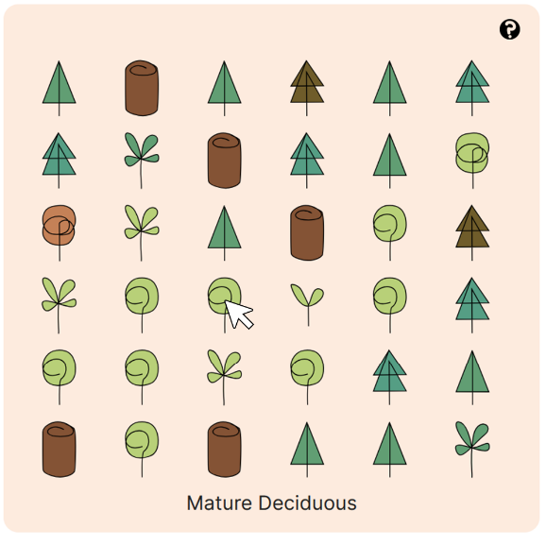

Figure 11. Land plot with mouse over interaction.

*Timeline*

The TIMLINE may be used to move to different years in the simulation.

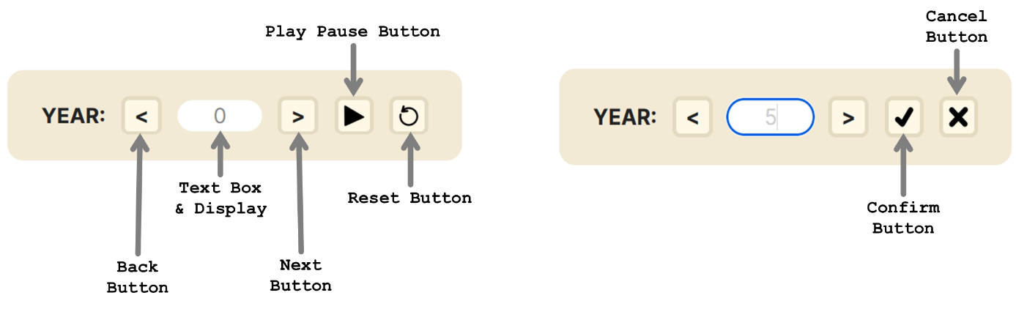

Figure 12. Timeline controls.

Clicking the PLAY BUTTON runs the simulation. The number displayed changes to reflect each new timestep. Once clicked, the play button changes to a PAUSE BUTTON. Clicking the pause button halts the simulation and it changes back into the play button. The RESET BUTTON may be clicked to go back to year 0. The BACK and NEXT buttons may be clicked to navigate to one year before or after the current simulated year.

In the TEXTBOX, learners may type in any year within simulation range (0 to 300 years) and the microworld jumps to it. Upon entering some input, the play/pause and reset buttons change to a CONFIRM BUTTON and CANCEL BUTTON. Clicking the confirm button applies the year change and cancel prevents this. If input is invalid (not an integer in the allowed range) then the input box turns red to indicate this and the change will not be applied even upon confirmation.

*Plan Viewer*

The PLAN VIEWER panel displays planned actions, the current rotation number and set rotation period. Once a plan has been drafted using the planner that can be accessed by clicking on the PLAN button, actions that were most recently processed along with the corresponding year is displayed under Previous Actions. Similarly, actions to be processed next along with the corresponding year, are displayed under Upcoming Actions. These action tags are horizontally scrollable if there are more of them than can fit within the view frame.

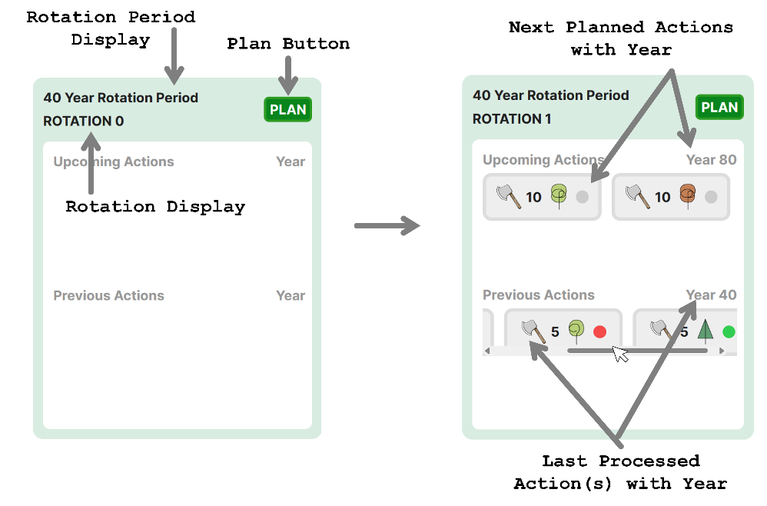

Figure 13. Plan viewer interactions.

*Money Viewer*

The MONEY NIEWER PANEL displays bank balance, income, and expenses. BANK BALANCE is the total amount of coins that the learner has at any given point in the simulation. Coins are the currency of this microworld. INCOME refers to no. of coins earned. Overall income is how much the learner has earned so far in the simulation, yearly income is how much they have earned this year alone, and rotation income is how much they have earned in this rotation. EXPENSES refer to coins the learner has spent overall, this year, and this rotation.

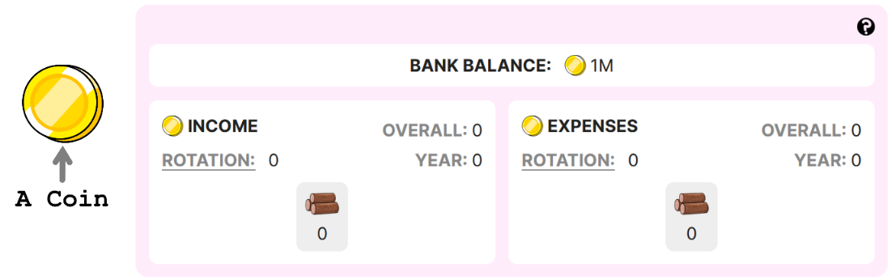

Figure 14. Money panel overview.

By default, it is income/expense per rotation that is visible below the icon representing type of income stream. Learners may click on 'OVERALL', 'YEAR' or 'ROTATION' to update this. Hovering over the icon reveals the name of the income stream.

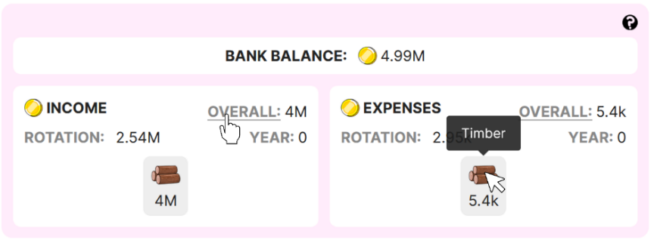

Figure 15. Money panel interaction.

When there are multiple sources of income, a breakup of income and expenses per stream is displayed using a colour coded proportion bar. Hovering over each colour displays the income stream and its contribution.

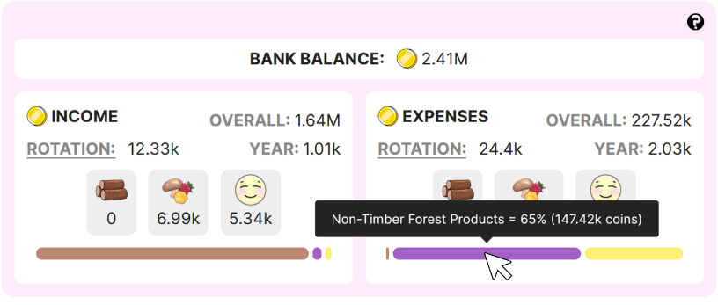

Figure 16. Income stream breakup.

*CO2 Scale*

Natural processes like respiration and human activities such as burning wood or fossil fuels release carbon into the atmosphere, mainly as CO2. In the microworld, CO2 concentration is displayed on an easy-to-read scale, with each band labelled to indicate expected quality of life at that CO2 level upon considering climate change. Current CO2 levels during the simulation are shown in the ATMOSPHERIC CO2 CONCENTRATION panel. Hovering over each tile reveals band range and associated quality of life label.

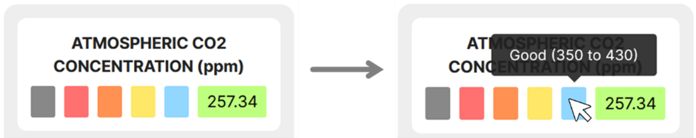

Figure 17. CO2 concentration display panel.

*Targets*

Learners may set targets. The TARGET panel displays and facilitates this.

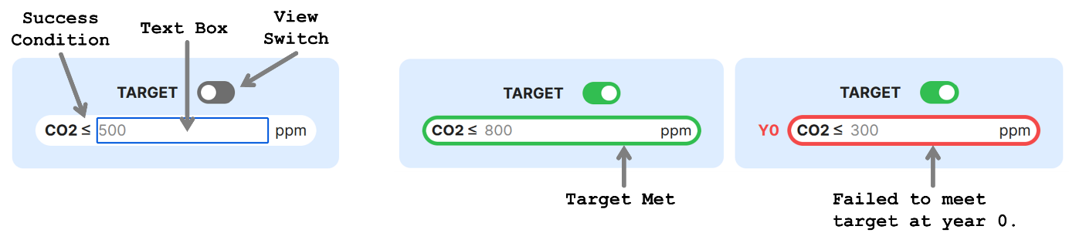

Figure 18. Target panel interaction.

Learners can set maximum CO2 concentration in the TEXTBOX, below which levels must not drop. The VIEW switch can be toggled ON/OFF. When ON, the target panel shows whether target is met, with a green border for success and a red border for failure. The first year of failure is also displayed (e.g., Y2 for Year 2). Similarly, target income can be set, indicating minimum income per rotation. If target is not met, the rotation where the failure first occurred is displayed with the notation "R" followed by rotation number.

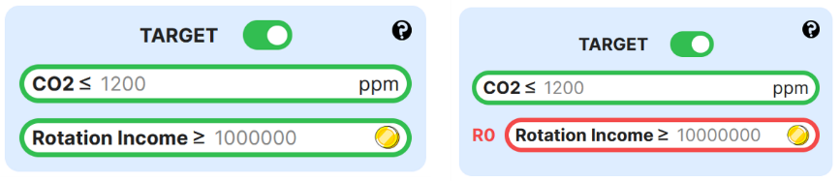

Figure 19. Income target met and failed display.

*Fossil Fuel Usage*

The FOSSIL FUEL EMISSIONS panel both displays and allows learners to set amount of carbon released into the atmosphere annually due to humans burning fossil fuels. By, default, this is 0 GtC but, can be changed by typing any positive whole number.

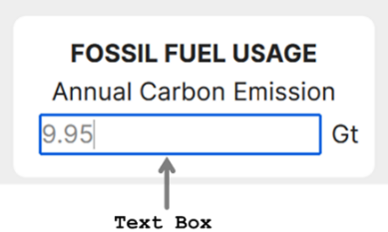

Figure 20. Fossil fuel emissions panel.

*Carbon Composition Display*

The carbon panel displays exact amount of carbon in each reservoir throughout the simulation. There are 5 carbon reservoirs. Amount of carbon is expressed in Gigatonnes (Gt) of carbon (1 Gt = ${10}^{12}$ kgs).

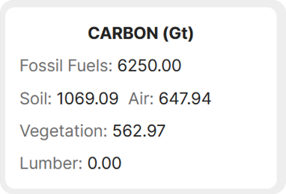

Figure 21. Carbon distribution panel.

#### **Planner Page**

The world page contains a “PLAN” button leading to the planner page. The MANAGEMENT ACTION PLANNER here, allows forest management plan creation involving planting or felling trees and activation of other income streams. The “BACK” button returns the learner to the world page.

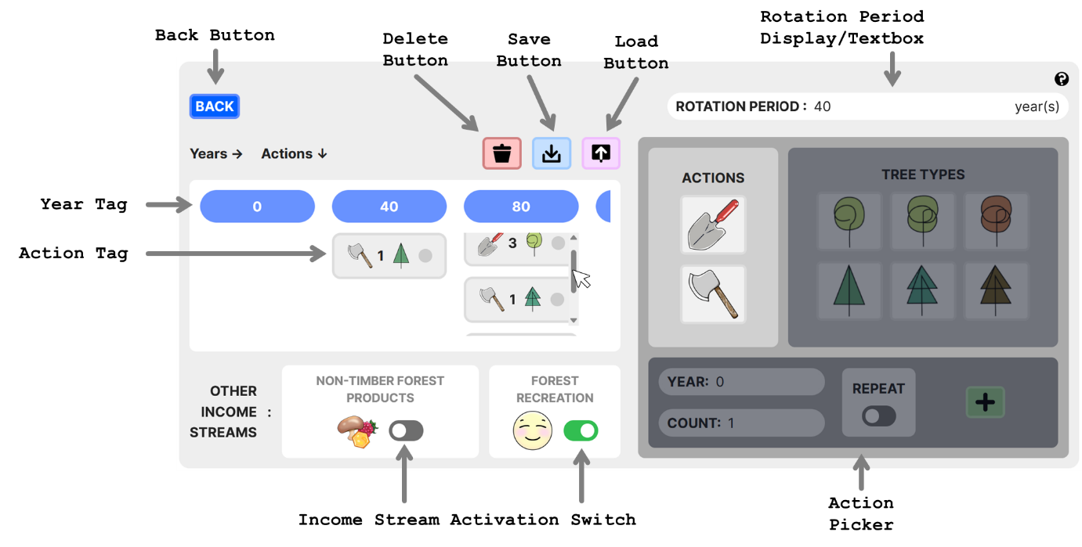

Figure 22. Planner page that contains a GUI that facilitates forest management plan creation.

There are 2 possible management actions: (i) **Felling:** Only mature, old growth, or senescent trees may be felled. Depending on size of the tree, it can cost up to 3000 coins to fell it. Income fetched from the felled tree will depend on its wood density and size. Nevertheless, felling a tree always generates some income from timber sales. (ii) **Planting**: Irrespective of tree life stage chosen from action picker, planted trees start out as seedlings. Planting incurs a fixed cost of 277 coins.

To add actions, first, action type must be selected. Then, tree type (species and age) and finally, maximum no. of trees to be affected and the year when this action is to be executed. If invalid numbers are entered into text boxes, that change is not applied and text turns red. If REPEAT switch is on, picked action will be performed every rotation starting that planned year. Finally, the ADD BUTTON adds a new action tag to the plan.

Rotation period can be set by changing the value within the ROTATION PERIOD TEXT BOX. Invalid entries (integers ≤ 0, integers ≥ max no. of simulated years = 300, negative numbers, floating point numbers, input containing characters other than numbers) is highlighted in red and will not lead to rotation period value update.

Blue year tags represent years at the beginning of each rotation as per set rotation period. The view frame is horizontally scrollable. ACTION TAGS added using the ACTION PICKER will appear under their corresponding year tags such that under each year tag, they are vertically scrollable in case of view frame overflow. Clicking an action tag, selects it. Clicking a selected tag, deselects it. Multiple tags may be selected at once. Selected actions can be deleted by clicking the DELETE BUTTON. Double clicking this button deletes all planned actions. Clicking the SAVE BUTTON saves current system state along with learner decisions. The UPLOAD BUTTON allows saved state loading.

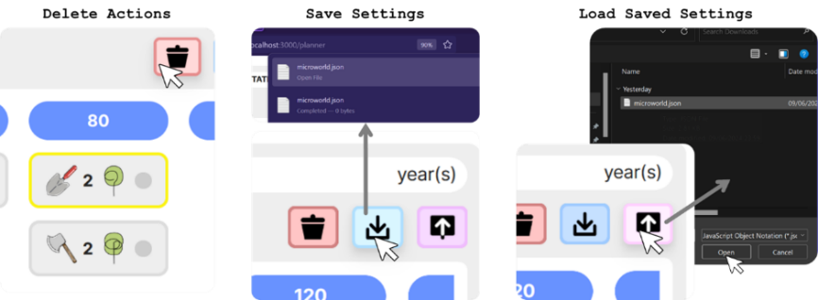

Figure 23. Management action planner. Delete actions and save or load plans interaction.

If the learner chooses to add an action for a year that falls within a rotation and not at the beginning of one, then such years appear in red to indicate this.

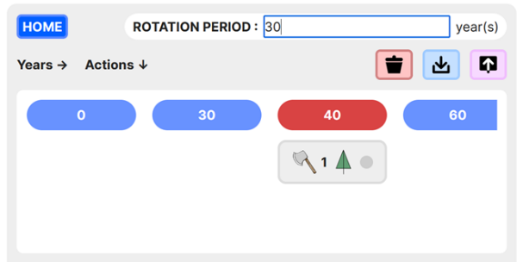

Figure 24. Within rotation action coloration difference.

Action tags display information about corresponding actions and their execution. If an action was successful for all planned no. of trees, then status is green. If it was only possible to execute it for a fraction of originally specified no. of trees, then status is yellow. A red status indicates that the action could not be executed at all. Actions may not get executed for some trees if the specified tree type does not exist on land at the planned moment, or if there are insufficient coins to fund the action.

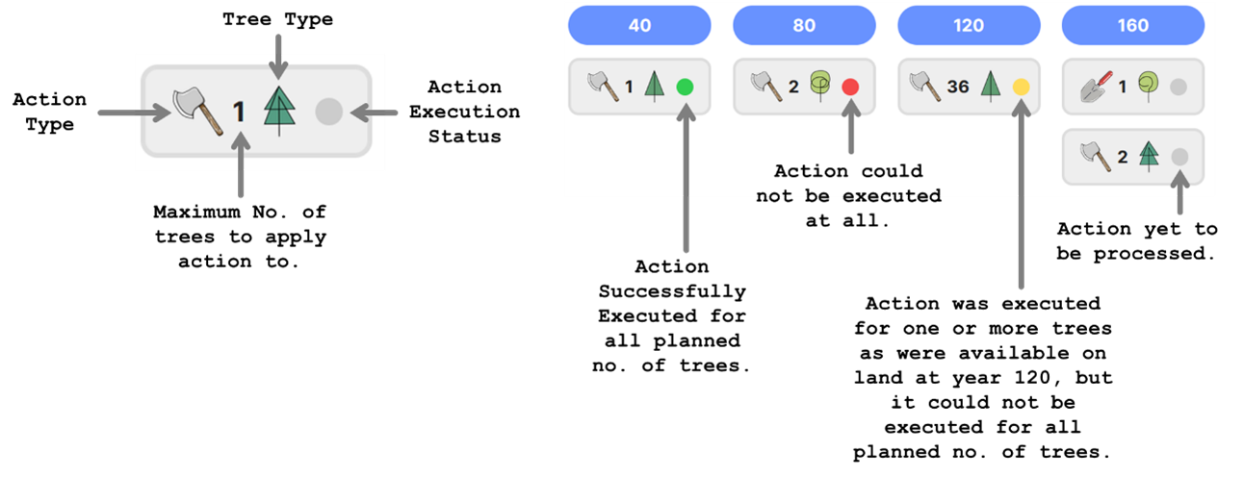

Figure 25. Significance of action tags.

Income can be generated via the TIMBER INCOME STREAM by selling wood from felled trees. When the fell action is successful, harvested timber is sold and gets used. Learners may also harvest and sell other forest resources like honey, mushrooms, and berries through the NTFP INCOME STREAM or open the forest up for public recreational use and earn through visitor permit/ticket sales via the RECREATION INCOME STREAM. Switching on the corresponding switch activates each income stream.

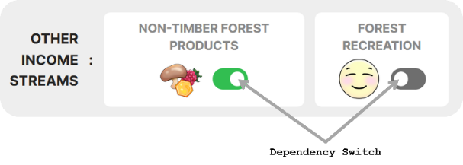

Figure 26. Other active and inactive income streams.

### HCI Principles

Table 12 summarises HCI principles that MycroForest has tried to adhere to.

|  |  |  |
| --- | --- | --- |
| ***Norman's Model*** | ***Task-Core Language Mapping*** | ***Jacob Nielsen's Usability Heuristics*** |
| (i) Goal establishment. | (i) *Articulation –* User maps their goals to actions. | (i) Use simple language without irrelevant information. |
| (ii) Intention formation. | (ii) Speak the user's language. |
| (iii) Action sequence specification. | (ii) *Performance –* System interprets user actions correctly and responds appropriately. | (iii) Minimize memory load. |
| (iv) Maintain consistency. |
| (iv) Action execution. | (v) Provide timely and apt feedback. |
| (v) System state perception. | (iii) *Presentation –* System presents updated state. | (vi) Clearly mark exits. |
| (vi) System state interpretation. | (vii) Incorporate shortcuts for expert users. |
| (iv) *Observation –* Users update mental model based on presented changes. | (viii) Display good error messages. |
| (vii) System state evaluation. | (ix) Design to prevent errors. |
| (x) Ensure help is readily available. |

Table 12. HCI principles summary.

**Norman’s Model & Task - Core Language Mapping:** *ARTICULATION →* MycroForest incorporates Norman’s Model. It allows CO2 and income ***goal*** setting. Learning activity challenges, guide learner ***intentions***. Users interact through forest management plan development. The management action planner offers an action picker and plan viewer, facilitating easy creation, viewing and editing of plans. This aligns with Norman’s Model ***principle (iii)***. Further, MycroForest allows learners to trigger ***action execution*** and step through plans easily using the timeline’s play, pause and step buttons. *PERFORMANCE + PRESENTATION →* Land plot, money viewer, CO2 panel, carbon panel and targets panel all reflect **system state** changes after each timestep so that users may ***perceive*** all relevant plan consequences. MycroForest strives to make cause-effect interpretation easy. *OBSERVATION →* Thus, an option to pause and replay the simulation or jump to specific points in time is provided to help investigate plan effects on the virtual forest. Furter, starting forests and plans may be saved/reloaded. Action execution status is also presented. Land content change is graphically displayed and animated as the simulation runs to facilitate change detection. All these factors hope to support ***learner interpretation*** of the system. Lastly, target and CO2 panels use colour to indicate condition idealness, helping learners ***evaluate*** system state.

**Jacob Nielsen's Usability Heuristics:** Data visualization and feedback on the main pages (world/planner page) in MycroForest, is primarily graphical with minimal text to maintain focus and reduce cognitive load. Learners only encounter paragraphs of text within the user guide, accessible via either  icons or the help page. ***Language*** of text is kept ***simple*** for easy comprehension by youth. Icons depict ***familiar***, largely unambiguous items (e.g. axe = fell a tee, chopped logs = timber, plus = add, bin = delete, etc.). Stylized tree icons encode information like species and life stage. Simple, commonplace, interactive elements (buttons, text boxes, switches, scrollbars, hover, click, double-click, keypress) are likely familiar to most learners. The planner page plan viewer displays world page actions, and action execution status on the world page gets reflected on the planner page, improving decision consequence monitoring/evaluation. World settings (plan, targets, initial forest composition, active income streams, management actions) can be saved and reloaded. Learners can thus worry less about keeping plans in ***memory*** and focus on interpreting results. All terms in MycroForest mean the same thing on every page. Display language (graphics and text) is kept ***consistent***. The tool provides immediate ***feedback*** upon time update and action execution. State changes are immediately reflected on the UI. Users can reset the simulation anytime, delete entire plans/individual actions, reload a saved world, or simply refresh the browser to get a fresh starting forest and default settings. This facilitates ***undoing*** of mistakes or starting afresh. No shortcuts are implemented. ***Erroneous*** text box inputs are met with text turning red or a red border indicating this. Further, there are measures in place to ***prevent errors***. E.g. it is not possible to load the planner page without having navigated there from the world page. This prevents state corruption. Comprehensive built in ***help*** is available in to inform without overwhelming.

### Data Visualization

**Note:** Below content is based on knowledge from lectures and material put together by Prof. John Dingliana for the CS7DS4/CSU44056 – Data Visualization module undertaken by this author at TCD as part of the MSc. Computer Science (2023 – 24) course.

Centuries of research suggests that sight is the most important human sense [69]. Thus, data visualization is integral to software design. Content presentation greatly influences mental model of a system and rate at which viewers develop the right understanding.

#### **What?**

In MycroForest the simulation model is, the dataset.Dataset typeis temporal as system state changes over time. The model is visible to the learner via displayed system state variables and thus, this is ***what*** is visualized. Different data types benefit from different visualization methods. Broadly, data may be quantitative (number) or categorical (not a number). Quantitative data can be discrete (integers) or continuous (real numbers). Categorical data may be binary (1/0, yes/no, true/false), nominal (not ordered, e.g. red, green, blue), or ordinal (ordered; e.g. small, medium, large). Table 13 identifies key data attributes in MycroForest that are to be visualized and their types.

|  |  |  |  |  |  |
| --- | --- | --- | --- | --- | --- |
| **Data:** | Years | Tree Type | Tree Age | Tree Position | Income |
| **Description:** | Current year in simulation. | Coniferous or deciduous. | Age of the tree. | Tree (x, y) position on land. | Money earned. |
| **Type:** | Quantitative Discrete | Categorical Nominal | Quantitative Discrete | Categorical Nominal | Quantitative Continuous |
|  | | | | | |
| **Data:** | Expenses | Biodiversity | Total Money | CO2 | Carbon |
| **Description:** | Money spent. | How biodiverse is the land? | Bank balance. | Atmospheric CO2 concentration. | Carbon in various reservoirs. |
| **Type:** | Quantitative Continuous | Quantitative Continuous | Quantitative Continuous | Quantitative Continuous | Quantitative Continuous |
|  | | | | | |
| **Data:** | Action Type | Action Tree Affected | Action Year | Action Num Trees Affected | Is Action Successful |
| **Description:** | Fell or plant. | Type and age of the tree targeted by the action. | Year at which the action is to be executed. | The no. of trees that the action is to affect. | Success, partial success, failure. |
| **Type:** | Categorical Nominal | Categorical Nominal | Quantitative Continuous | Quantitative Discrete | Categorical Ordinal |
|  | | | | | |
| **Data:** | Is Action Repeated | Target Values | Is Target Met | Is Income Stream Active | Rotation Period |
| **Description:** | Whether this action is to be repeated periodically. | Set CO2 or income target. | Whether target is met. | Whether an income stream is active. | Set rotation period. |
| **Type:** | Categorical Binary | Quantitative Continuous | Categorical Binary | Categorical Binary | Quantitative Discrete |

Table 13. Visualized data attributes and their types.

#### **Why?**

Data visualizations serve 2 purposes: explanatory or exploratory. Explanatory visualizations convey a known data story, while exploratory visualizations present all data for the viewer to investigate. In MycroForest, since the model is based on informed research and resembles a known system, ***purpose*** of data visualization is ***explanatory***.

Task abstraction is a deeper level of data visualization. It refers to identification of what viewers might do with the data. The actions – targets framework captures this well. Briefly put, this framework considers possible actions that viewers may perform (verbs) on certain target portions or characteristics (nouns) of visualized data. Following are 3 action – target task abstraction examples (actions are blue, targets are magenta).

* Prospective business owners might analyse consumer trends regarding their product and consume information as they discover key customer bases. They may produce own data about striking features in the dataset. E.g. annotating customers by derived age categories might reveal that most of them are millennials.
* Doctors may search a brain scan to look up and confirm shape of the frontal lobe, locate the hippocampus, browse for known neural activation paths, or explore to look for unexpected abnormalities.
* An air crash investigator might query flight data to compare it with data from past crashes to identify similarities. They may summarise instrument readings from normal flights by plotting distributions and extracting extremes like min and max values to see if crash related values are outliers.

Similarly, using MycroForest, learners may produce forest management plans and compare results to discover dependencies between order and choice of management actions and system state trends over time such as changes in forest composition, atmospheric CO2 concentration, forest income, biodiversity score, etc. Learners may explore different strategies as they browse through different settings for rotation period length, activation of income streams and so on, to locate plans that achieve goals like carbon sequestration maximization, income generation maximization, etc. In the process, they learn about challenges and best SFM practices.

#### **How?**

Visualizing data involves selecting suitable encoding channels, which refer to graphical element characteristics. There are 8 channels: position, shape, size, brightness, colour, orientation, texture, and motion. They can be selective (easy to distinguish), associative (support grouping), ordinal (show order), or quantitative (allow quantification). Range of a channel refers to no. of distinct data point types that it supports. Multiple encoding channels can be used in the same visualization. Some combinations, like position + colour, offer better visual separability than others, like using multiple hues of the same colour. Once chosen, encoding channels are incorporated into visualization idioms which are essentially types of graphs (e.g. scatter plot, line plot, pie chart, etc.). Idioms may also show changes, facilitate selection, and exploration. Multiple idioms may be combined through juxtaposing, partitioning, or superimposing. Further, they also handle complexity by incorporating data filtering, aggregation, or embedding. Thus, several design decisions are involved in presenting content such that the visualization “addresses a clear objective” while “avoiding distortion” of data and “handles complexity” well enough to inform without distracting or overwhelming the viewer.

Following paragraphs justify some data visualization choices in MycroForest.

Most data attributes in MycroForest get updated as the simulation runs. This change is captured through animation via the motion encoding channel. Land content icons, action tags, and all numbers (money, CO2, carbon, etc.) get updated per time step.

The **land plot** visualizes Tree Age and Tree Type. Trees can live up to 100 years and remain on land after death until complete decay. To avoid overwhelming the viewer, tree age is grouped into 6 categories, with more precise details revealed upon hovering over a tree icon. Biodiversity score ranges from 0 to 1 and is categorized into “Unforested,” “Plantation,” “Forest,” or “Ecosystem” for better differentiation. Figure 27 shows how both colour and shape were varied to tell different tree type – life stage combinations apart. Dead trees use the same symbol for both species since behaviour after death is same regardless of species. The land grid in MycroForest (6 rows by 6 columns) fits a scatter plot idiom encoding tree positions. Changes over time are animated using the motion channel.

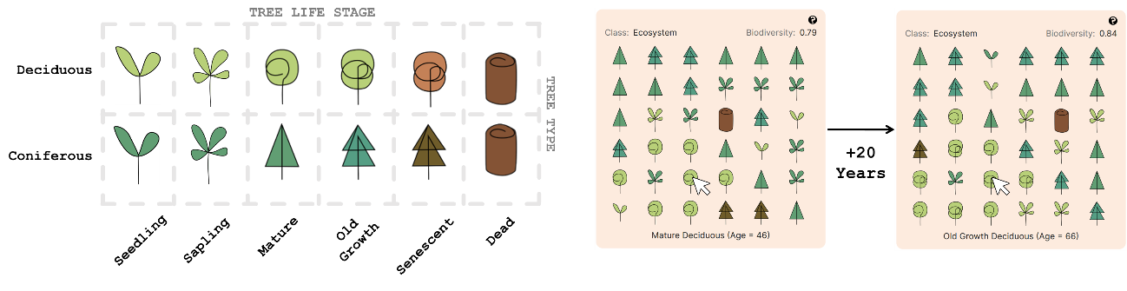

Figure 27. Land plot visualization that leverages colour, shape, position, and motion encoding channels.

The **money viewer** shows Income, Expenses, Total Money, and Is Income Stream Active, with numbers limited to 2 decimal points as greater precision does not add educational value. There are 3 income streams (Timber, NTFP, Recreation) and 2 values (income, expenses) that change over time, creating high data complexity. Total bank balance and overall figures are shown in text, but data is grouped into 3 time-based levels (overall, this year, this rotation) for concise clarity. Only active income stream figures are displayed. A stacked bar chart is used to show stream wise contributed proportion. Hovering over bars reveal details like stream name and specific value of coins. When there is more than 1 active income stream, by default, steam wise split of income/expenses is displayed only for “per rotation income”. Users can view this breakup for any time level by clicking on the heading for that time level. The fact that this time level is clickable is indicated by the text gaining an underline upon hover. The currently selected or last clicked time level’s heading retains that underline even when the mouse pointer is not over it to show that this is the selected level. All these figures get updated per timestep. Thus, the money panel uses position, colour, size (size of each bar in stacked bar plot), and motion encoding channels to organize and display money related data. Aggregation and interactive reveal are leveraged to manage complexity.

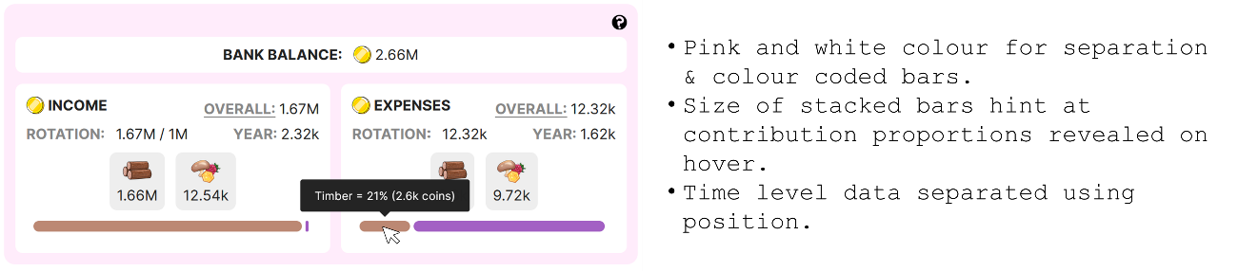

Figure 28. Money panel visualization that leverages colour, size, position, and motion encoding channels.

The **planner** and **plan viewer** visualize forest management plans by learners. Management actions comprise 5 data attributes (Action Type, Action Tree Affected, Action Num Trees Affected, Is Action Successful, Action Year). There are 2400 possible unique actions. Complexity stemming from high dimensionality was reduced as follows.

* Encode 4 action attributes into one symbol, using colour to indicate execution status (red = failed, amber = partially successful, green = successful).
* Only years marking start of a rotation (blue) or ones within a rotation (red) with planned actions are shown in the Planner. Learners see few years at a time and may scroll to view others that overflow the viewer window.
* A yellow outline implies “selected”.
* The plan viewer shows only upcoming/last processed action tags, separated using position (top/bottom). Clicking on the PLAN button opens the planner with details.

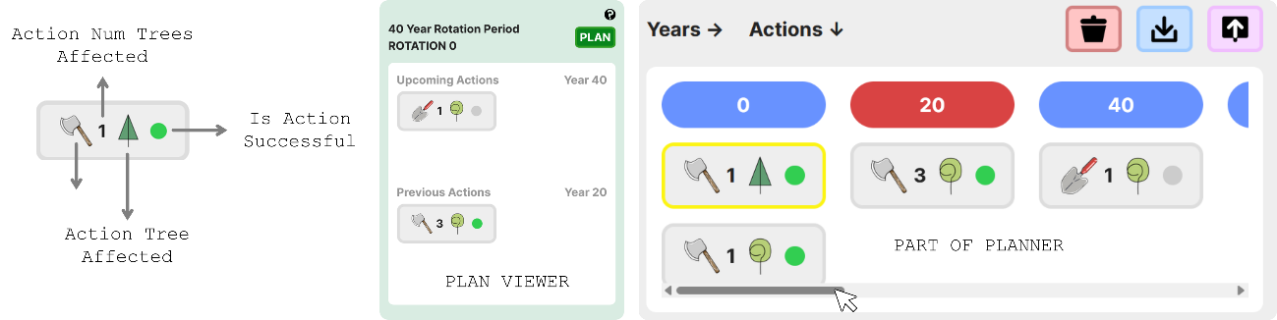

Figure 29. Management plans visualized using position, colour, and motion (content changes over time) channels.

**CO2 concentrations** are continuous and quantitative with a wide range. To enhance interpretability, they were categorized by impact on human life due to climate change, and color-coded. Only current value is displayed as text and updated each timestep. Hovering over a colour reveals its category, saving space by eliminating the need for a legend.

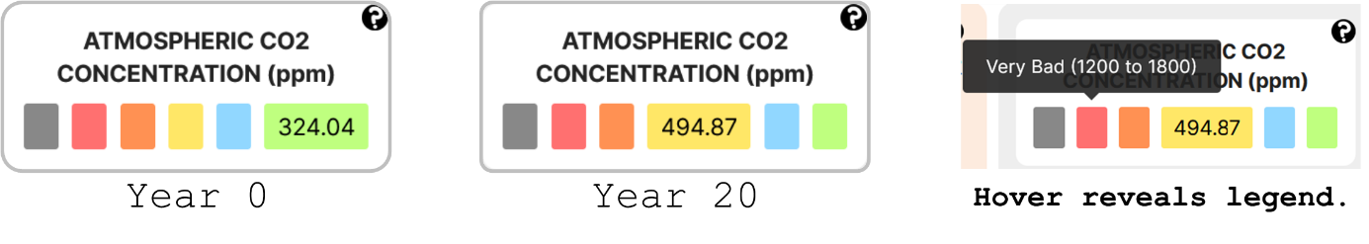

Figure 30. Colour and motion (updates over time) encoding channels used in the CO2 panel.

Another notable display design decision is the use of red and green colours to indicate whether **targets** have been achieved (green) or not (red). Lastly, the decision was made to use a toggleable switch component to capture attributes like “Is Serious Mode”, “Is Income Stream Active” and “Is Action Repeated” whose values, the learner can set. These components are implemented to have a distinctly separate colour and shape in ON and OFF positions which encodes their categorical binary nature well.

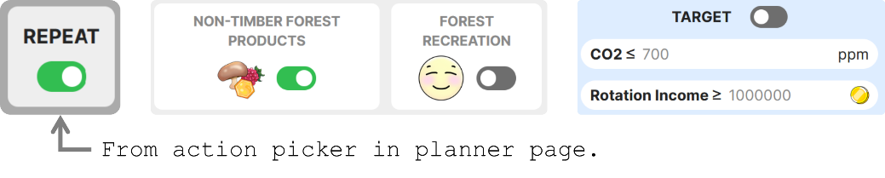

Figure 31. Use of switches.

Overall, encoding channels used were colour, position, size, and motion, with position + colour being the most common combination. This is also evident in the world and planner page; wherein related graphical elements are separated by coloured panels for best visual separability.

## System Architecture

Structurally, MycroForest can be thought of as being composed of a simulation model, UI components, and input variables as shown in Figure 32.

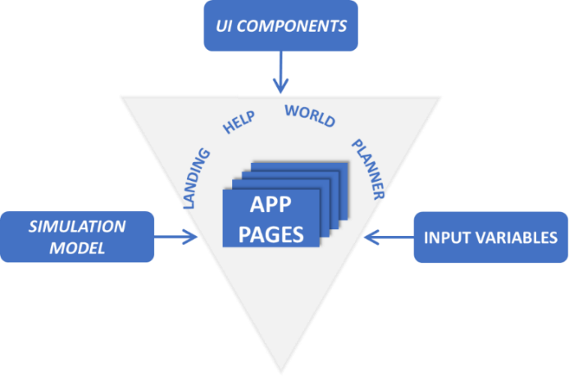

Figure 32. MycroForest application structure.

### Simulation Model

This section outlines the conceptual model behind the simulation and the research that inspired it. Assumptions and abstractions simplify the model for a smoother, more focused learning experience, avoiding slow computation and poor UX. Model parameters are set to realistic values based on research and expert opinion.

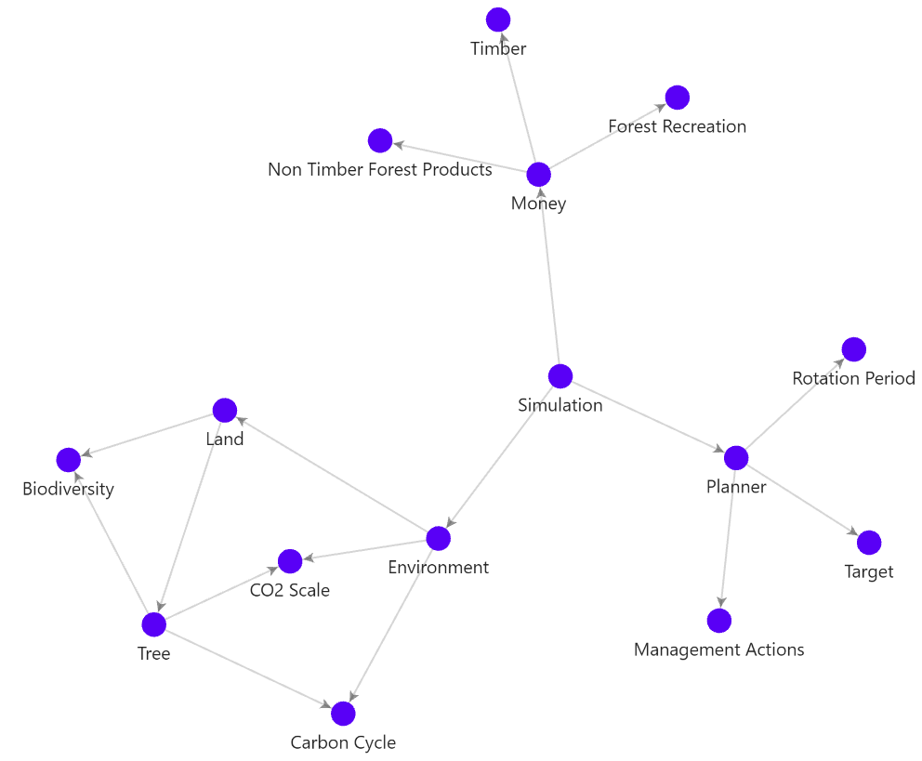

Figure 33. Graph representation of simulation model entities. Click on a node to navigate to its explanation.

Each node in Figure 33 represents a key idea or component as explained below.

#### **Simulation**

Simulation is the master component that manages all others. It coordinates world elements and initializes the microworld which contains an Environment, and a Planner that keeps track of user generated forest management plans. The simulation also triggers state update of all world components, refreshes the UI to reflect changes, and tracks forest resources and Money flow. (*Back To Graph*)

#### **Environment**

The environment comprises the atmosphere, Land, and carbon reservoirs. 5 reservoirs are modelled as follows between which carbon moves in a simplified Carbon Cycle.

1. **Soil**: Soil holds carbon as organic material or minerals [70].
2. **Fossil Fuels**: About 5 to 10,000 gigatonnes (Gt) of carbon in the lithosphere is stored as fossil fuels [70].
3. **Atmosphere:** The mass of the atmosphere is about 5.1e+21g [71]. Given the mass of CO2 (solute) in the air (solution) in grams and the mass of the atmosphere in grams, concentration of CO2 in Parts Per Million (PPM) was computed as $\frac{mass_{CO2}}{mass_{air}}×$ 1e+6 [72, 73]. The CO2 Scale groups air CO2 concentrations into categories based on impact on human quality of life after considering associated climatic conditions.
4. **Vegetation**: Plants sequester carbon dioxide (CO2) from the atmosphere by removing it and storing it in solid or liquid form [74].
5. **Lumber**: This man-made reservoir includes all wood preserved in use (like furniture or construction) rather than burned. Preserving wood significantly slows its breakdown and re-entry into the carbon cycle through natural decay [75, 76].

At the start of simulation, carbon reservoirs must be initialized. Earth's carbon amounts are estimated at 800 GtC in air, 2300 GtC in soil, 550 GtC in vegetation, and 10,000 GtC in fossil fuels [70]. To support plant growth in the microworld, air carbon was scaled down to 500 GtC. Thus, amount in other reservoirs were also scaled to maintain a ratio same as on Earth, ensuring that the simulation is realistic enough for a teaching tool. At first, all carbon in soil and vegetation is assumed to be in air, as the microworld starts with no plants. Plants then capture and store carbon in themselves and the soil as they grow. Table 14 summarizes this carbon distribution. (*Back To Graph*)

|  |  |  |  |  |  |
| --- | --- | --- | --- | --- | --- |
| **Reservoir:** | *Fossil Fuels* | *Soil* | *Air* | *Vegetation* | *Lumber* |
| **Earth GtC:** | 10000 | 2300 | 800 | 550 | 0 |
| **Scaled GtC:** | 6250 | 1437.5 | 500 | 343.75 | 0 |
| **Starting gC:** | 6.25E+18 | 0 | 2.28E+18 | 0 | 0 |

Table 14. Carbon distribution among reservoirs. GtC = Gigatonnes of Carbon and gC = Grams of Carbon.

#### **CO2 Scale**

Atmospheric CO2 concentration is measured in Parts Per Million (ppm), indicating the number of CO2 parts per million parts of air. PPM is a standard concentration measure. It is a measure of proportion, like percentage [73]. In the microworld, CO2 concentration is organized in a labelled and color-coded scale, reflecting expected human quality of life after considering climate change effects. Another such cale classifies photosynthetic efficiency at different CO2 levels.



Figure 34. Quality of human life and photosynthetic efficiency associated with atmospheric CO2 concentration. Please find knowledge that informed design of above scale in Appendices 8.7.

In the CO2 concentration–quality of life scale, levels < 200 ppm or > 1800 ppm are unliveable since photosynthesis struggles < 200 ppm [77] and global warming causes inhospitable climate > 1800 ppm [78]. CO2 levels between 700 and 1200 ppm are considered bad as it nears the tipping point [14, 79]. (*Back To Graph*)

#### **Carbon Cycle**

The carbon cycle refers to movement of the carbon element between its various states and locations on Earth. Most of it is bound to rock in the lithosphere, with the rest found in the ocean, soil, atmosphere, living organisms, and as fossil fuels deep underground. Any location where carbon can be stored in large quantities is called a carbon reservoir. Carbon moves between these reservoirs through the slow and fast carbon cycles [70].

* **Slow Carbon Cycle:** Carbon moves between air, water, and rock slowly over 100 to 200 million years. Air bound carbon dissolves in water and rains down as a weak carbonic acid, slowly reacting with rock to chemically weather them. Ions (calcium, magnesium, carbon, etc.) so released, end up in the ocean via rivers where they are utilized by organisms that transform them into hard material like calcium carbonate that gets deposited as sediment on the ocean floor and is compressed over time to produce rock like limestone. Lastly, volcanic activity returns some carbon from deep inside earth into the atmosphere to complete the cycle [70].
* **Fast Carbon Cycle:** This cycle primarily concerns the biosphere or life on earth and is fast enough to be visible in a human lifetime. Plants and phytoplankton absorb CO2 from the atmosphere and turn it into sugar through photosynthesis, a chemical reaction. When carbohydrates so produced are broken down to for energy either by producers themselves or other organisms that directly/indirectly consume them, CO2 and other carbon compounds are released back into the air through respiration. Carbon in life is also released into the soil and air when dead organisms decay [70].

Undisturbed, both cycles maintain amount of carbon in each reservoir within about the same range over millennia. Burning fossil fuels, quickly moves large quantities of carbon from the slow to fast cycle and disrupts carbon balance. Land use changes and deforestation reduce carbon storage ability of the biosphere and soil, aggravating environmental carbon saturation, causing ocean acidification, global warming, and thus, climate change [70]. MycroForest models key elements of the fast carbon cycle and ignores the slow one as effects of the latter is small within simulated 300 years.

Following paragraphs explain how MycroForest models carbon transfer between the 5 reservoirs considered (air, soil, vegetation, lumber, fossil fuels).

*Tree Growth & Decay*

In MycroForest, vegetation refers to trees. They both absorb and release carbon. This transfer mechanism is slightly different among growth, biomass maintenance, and decay phases of a tree’s existence as follows.

* **Growth**: Plants absorb CO2 from air for photosynthesis, meaning that carbon in plant biomass originates from air. In the microworld, carbon absorbed by a tree each time it grows is computed as the amount of carbon in new growth biomass. Let a tree have grown in volume by $Δ{Volume}_{tree} m^{3}$ with density ${Density}_{tree} g/m^{3}$. Then, the tree’s weight should have increased by $Δ{Mass}_{tree}={Diameter}_{tree}×Δ{Volume}_{tree}$. Of the total weight of a tree, around 50% is dry weight [80]. Thus, $Δ{Mass}_{tree}^{dry}=0.5×Δ{Mass}_{tree}.$ About 47.5% of a tree’s dry weight, is carbon [80]. So, ${Carbon}_{tree}^{absorb}=0.457×Δ{Mass}_{tree}^{dry}.$ This absorbed carbon gets added to total carbon in the vegetation reservoir and subtracted from air such that ${Carbon}_{veg}={Carbon}_{veg}+{Carbon}_{tree}^{absorb}$ and ${Carbon}_{air}={Carbon}_{air}-{Carbon}_{tree}^{absorb}$.
* **Maintenance:** In addition to height and diameter increases, a tree also needs to replace biomass lost due to damage or shedding [46]. Carbon in this replaced biomass is referred to here, as maintenance carbon. Maintenance carbon is subtracted from air and added to soil ( ${Carbon}_{air}={Carbon}_{air}-{Carbon}_{tree}^{maintain}$ and ${Carbon}_{soil}={Carbon}_{soil}+{Carbon}_{tree}^{maintain}$) without vegetation reservoir levels changing because the amount of carbon in biomass lost to soil is assumed to be the same as that absorbed from air to replenish it. Let volume of replaced biomass = 1% of a tree's total volume, $Δ{Volume}_{tree}^{maintain}= 0.01×{Volume}_{tree}$. This proportion of 1% is a number that works well with other microworld settings chosen through trial and error as it was not possible to find real-world figures for this. As before, $Δ{Mass}_{tree}^{maintain}={Density}_{tree}×Δ{Volume}_{tree}^{maintain}$, $Δ{Mass}_{tree}^{maintainDry}=0.5×Δ{Mass}_{tree}^{maintain}$, and ${Carbon}_{tree}^{maintain}=0.475×Δ{Mass}_{tree}^{maintainDry}$.
* **Decay**: As trees decay, carbon stored in them re-enters air and soil from vegetation. If a tree has died and remains on land, about 15% of carbon stored in it is released into air and soil each year [81]. Thus, in the microworld, decayed volume per timestep = 15% of tree volume at time of death. Let annual amount of carbon lost to decay be fixed at ${Carbon}_{tree}^{decay}=0.15×{Carbon}_{tree}^{t}$ where t = time right before tree death. Thus, weight of dead tree lost to decay would be ${Mass}_{tree}^{decay}=\frac{{Carbon}_{tree}^{decay}}{0.475}$ and consequently, volume would be ${Volume}_{tree}^{decay}=\frac{{Mass}_{tree}^{decay}}{{Density}_{tree}}$. Thus, after each year, volume of a dead tree that remains in soil, changes as ${Volume}_{tree}={Volume}_{tree}-{Volume}_{tree}^{decay}$. Of the amount of carbon decayed each year, around 35% ends up in the soil with the rest getting released back into air [82]. So, ${Carbon}_{soil}={Carbon}_{soil}+\left(0.35×{Carbon}_{tree}^{decay}\right)$ and ${Carbon}_{air}={Carbon}_{air}+\left(0.65×{Carbon}_{tree}^{decay}\right)$.

*Soil Release*

Soil naturally releases a portion of stored carbon into air through processes like microorganism respiration. Of the around 2300 Gt of carbon in soil, about 60 Gt is lost annually [70]. Thus, in MycroForest, annual soil release is set to $\frac{60}{2300}×100≈30\%$ of soil carbon, such that ${Carbon}_{soil}^{release}=0.03×{Carbon}_{soil}$ per timestep with ${Carbon}_{soil}={Carbon}_{soil}-{Carbon}_{soil}^{release}$ and ${Carbon}_{air}={Carbon}_{air}+{Carbon}_{soil}^{release}$.

*Timber Usage*

Harvested wood has various uses. It can be burned for heat/power, used in construction, or made into products like paper. Thus, in MycroForest, uses are broadly categorized into “energy” (for burning) or “lumber” (for preservation). About 50% of globally harvested wood is used for energy [83]. Mass of carbon ${Carbon}_{timber}$ is computed from mass of harvested timber multiplied by dry weight % and carbon % as previously seen. Here, ${Carbon}_{timber}^{energy}=0.5×{Carbon}_{timber}$ and ${Carbon}_{timber}^{lumber}=0.5×{Carbon}_{timber}$. It is assumed that all carbon in burned wood re-enters air and that all of it in lumber gets preserved. Thus, harvested wood use adds carbon to both lumber and air reservoirs. ${Carbon}_{lumber}={Carbon}_{lumber}+{Carbon}_{timber}^{lumber}$ and ${Carbon}_{air}={Carbon}_{air}+{Carbon}_{timber}^{energy}$. Timber is obtained when a tree is felled. When chopped, around 25% of the tree (roots = 21.3% [84] + the stump + some foliage) is assumed to remain in soil while the rest is harvested. Thus, ${Carbon}_{timber}=0.475×0.5×{Mass}_{timber}$ where ${Mass}_{timber}=0.75×{Mass}_{harvestedTree}$.

Unlike in the microworld, in reality, all carbon in burned wood does not re-enter the atmosphere (some wood may be turned to ash etc.), but most of it, still does and hence this is a sound assumption. Also, it is assumed that wood used for lumber is preserved responsibly to maximize lifespan such that carbon in it is not released in the simulated timeframe. In reality, carbon stored in HWPs is not as straightforward. Amount of carbon sequestered depends on several factors at wood production, use, and end of life stages. In the production phase, carbon in wood varies depending on tree type. Hardwood from deciduous trees is denser and preferred for durability which often leads to over-harvesting and thereby, more carbon released than preserved. In the use phase, wood products keep some carbon from re-entering the fast carbon cycle until it decays. At this stage, best course of action is to recycle into secondary wood products. Another, less desirable option is to burn it to produce greener energy compared to that produced by burning fossil fuels. These are, however, ideal scenarios. Unfortunately, a lot of harvested wood ends up in landfills before end of life and rot quickly to release CO2 as well as more potent GHGs like methane (CH4). Also, processing of wood using toxic substances like CCA or ACQ to increase lifespan often does more harm than good [75]. Nevertheless, in MycroForest the assumption that lumber carbon does not re-enter the cycle, is sound because if responsibly produced and used, wood can indeed lock away carbon out of the fast carbon cycle for centuries [76].

*Fossil Fuel Usage*

Normally, carbon in fossil fuels enter air very slowly over millennia via the slow carbon cycle. But since the industrial age, humans have burned petroleum based oil, coal, and gas for energy, thereby quickly releasing a large about of carbon from fossil fuels into the environment. In 2023 alone, 36.8 Gt of CO2 $≈$ 10 Gt of carbon was added into the atmosphere this way [70, 85]. In MycroForest, carbon added to air due to fossil fuel usage is modelled as ${Carbon}_{fossilFuels}={Carbon}_{fossilFuels}-{Carbon}_{fossilFuels}^{release}$ and ${Carbon}_{air}={Carbon}_{air}+{Carbon}_{fossilFuels}^{release}$. Learners can edit . (*Back To Graph*)

#### **Land**

Land in MycroForest, represented as a 6 $×6$ grid amounts to a total of 36 spots. Each spot may host 1 live Tree. Here, “36” spots, is an arbitrary choice deemed small enough to be visually tracked yet big enough for management plans to yield varying results. This value can be increased/decreased by editing the LAND_SIZE input variable. Assuming trees are grown in rows with 25 ft between them, 1 acre could support 83 trees ([tree spacing and distance calculator](https://treeplantation.com/tree-spacing-calculator.html)). Thus, 36 trees would occupy 0.43 acres = 1740.15 $m^{2}$. Thus, land in the microworld is assumed to span 1740 $m^{2}$. Although too small to represent a real forest (mean size of private forests in Ireland $≈$ 80,000 $m^{2}$ [86]), given only at most 36 trees, scaling real world forest figures to suit land of size 1740 $m^{2}$ should help map real-world figures to the MycroForest more accurately. Further, land content determines Biodiversity which in turn, influences tree growth rate, ability of trees to recover from stress, and earnings from some income streams.

*Spot Availability*

In the microworld, a tree can only grow if a suitable spot is available, which means: (i) there are no trees in the spot, or (ii) there is just 1 dead tree in the spot such that it has decayed to the point where ${Height}_{tree}^{max}=0.5×Height_{tree}^{max}$. The value of 0.5 is arbitrary, but this rule emulates how in nature, new growth arises from remains of a dead tree while it is still decaying.

*Initialization*

At the start, the simulated world is populated with seedlings based on a predefined species mix: 60% coniferous and 40% deciduous. Initially, 92% of the space is free, with 8% occupied by seedlings—2 coniferous, 1 deciduous, and 33 empty spots. This setup reflects the forest composition in Ireland [87] but may change as the forest evolves. After 200 years, the resulting forest becomes the starting point for players, with initial seedling placement random, allowing for different forests with each browser refresh. Learners can save and reload specific forests. (*Back To Graph*)

#### **Tree**

In MycroForest, trees are categorized as either “deciduous” or “coniferous”, representing a simplified version of Earth's diverse species. Deciduous trees, such as oak and maple, shed leaves in winter or produce fleshy fruits and flowers. Coniferous trees, like cedar and spruce, are evergreen, reproduce via cones, and have needle-like leaves. This classification was chosen over others like “hardwood” and “softwood” because it presents cleanest separation and the latter can be misleading (there exists “hardwood” species with soft wood and vice versa) [88]. Category properties assume values averaged over multiple species and are not therefore based on any single tree / species.

Table 15 lists differences between properties of the 2 species as implemented in MycroForest. Property values are based on certain real world observations: on average, coniferous trees are taller [89, 90], more long lived [91], have softer wood [88, 92], mature slower [93] and reproduce less often [94] compared to deciduous trees.

|  |  |
| --- | --- |
| **Coniferous** | **Deciduous** |
| Maximum height = 70 m. [89] | Maximum height = 40 m. [90] |
| Reproduction interval = 2.5 years. [95] | Reproduction interval = 1 year. |
| Wood density = 6e+5 g/ $m^{3}$ [92] | Wood density = 7e+5 g/ $m^{3}$ [92] |
| Evergreen. Does not shed leaves seasonally. Thus, % of carbon lost and replenished per year in addition to growth (maintenance carbon %) = 1%. [88] | Sheds all leaves in autumn and regrows them in spring. Thus, maintenance carbon is assumed to be = 40%. [88] |
| No. of years spent in each stage of life in increasing order = grows from seedling to sapling after 4 years, matures at age 26, becomes old growth at age 60 and enters the senescent stage at age 90 before dying at age 100. | No. of years spent in each stage of life in increasing order = grows from seedling to sapling after 3 years, matures at age 21, becomes old growth at age 47 and enters the senescent stage at age 70 before dying at age 80. |

Table 15. Difference between coniferous and deciduous trees.

As seedlings, trees of both species have same height = 0.2 m since real data with species wise seedling size differences was not found [96]. Developed tree age groupings as in Figure 35 was based on informed assumptions (aforementioned sources).

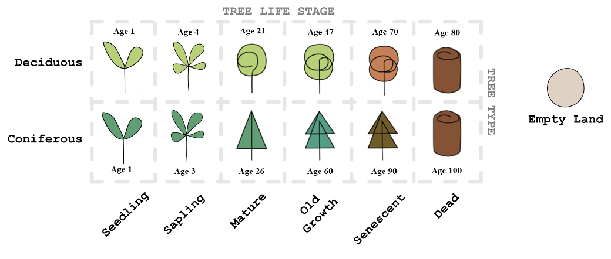

Figure 35. Possible land content with ages.

Trees are modelled to live and die as in the real world. When alive, they grow and can reproduce. After death, they decay until no more mass remains. Also, live trees are under stress due to environmental factors and aging. Increased stress negatively effects growth [97], but certain conditions like high biodiversity can help reduce impact of stress. Trees may recover from environmental stress when conditions are favourable [98]. Following passages explain design of each such key mechanism in MycroForest.

*Stress*

Modelling tree mortality as a consequence of stress as in MycroForest, is a common approach. The growth model in MycroForest incorporates real world observations regarding effects of stress on tree vigour [97, 99]. Growth of trees decline when under environmental stress. Trees under high stress or significant amounts of stress for long periods enter breakdown mode followed by quick death. Plants experience increased stress when resources (CO2, water, heat, etc.) are either too abundant or too scarce. Under favourable conditions, trees recover from stress. The Tree Decline Recovery Seesaw model in [98] captures this tree vigour – stress relationship well.

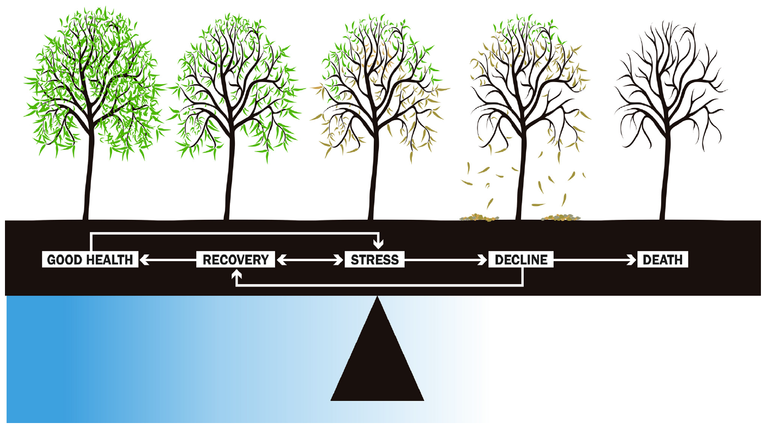

Figure 36. The Tree Decline Recovery Seesaw model illustrating how health of a drought stressed tree shifts between varying stages. Physical changes like leaf re-growth and loss indicates recovery and decline respectively. [98]

In MycroForest, trees have a “stress” property. They die only when $Stress_{tree}≥1$. Living trees are under stress due to environmental conditions (air 𝐶𝑂2 level) and time (age).

$$Stress_{tree}=\min\left(1, Stress_{tree}+Stress_{tree}^{env}\right)$$

$$Stess_{tree}=min⁡(1, Stress_{tree}+Stress_{tree}^{age})$$

In the microworld, only CO2 is explicitly modelled as an environmental stressor due to its strong link with climate change. Realistically, plants face many other stressors like pests, temperature fluctuations, competition, etc [100]. Modelling these is out of scope. This would add complexity without much educational value and thus was omitted. CO2-related stress is calculated based on each tree's tolerance for CO2 availability, with premature trees (seedlings, saplings) being more vulnerable than mature ones.

$$Stress_{tree}^{env}=Factor_{stress}^{co2}$$

$$Factor_{stress}^{co2}= ToleranceMap_{CO2}(LifeStage_{tree}, CO2_{air})$$

Table 16 shows assumed mapping between CO2 availability in the air and stress induced in the tree. This tolerance mapping was developed based on the previously presented CO2 Scale that links atmospheric CO2 concentration to photosynthetic efficiency.

|  |  |  |
| --- | --- | --- |
| **CO2** | | |
| ***Availability (ppm)*** | ***Stress per Year*** | |
| *Premature* | *Mature* |
| < 200 | 1 | 1 |
| < 430 | 0.01 | 0.001 |
| < 700 | 0.0001 | 0.00001 |
| < 1200 | 0 | 0 |
| < 1800 | 0.0005 | 0.00005 |
| >= 1800 | 0.1 | 0.01 |

Table 16. Tolerance of trees to CO2 availability.

Aging stress peaks when a tree hits max age. It increases by $Factor_{stress}^{age}$ = 0.01 every year after a tree enters the senescent stage, capturing old-ager related health decline.

$$IF Age_{tree}=Age_{tree}^{max} THEN Stress_{tree}^{age}=1 ELSE$$

$$IF LifeStage_{tree}="senescent" THEN Stress_{tree}^{age}=Stress_{tree}^{age} +Factor_{stress}^{age}$$

When conditions are favourable, trees recover from past stress. Healthier plants recover faster. Rate of recovery is determined by a $Factor_{stress}^{recover}=0.2$ that was arbitrarily chosen based on the informed assumption that recovery is generally gradual [98].

$$Stress_{tree}=max(0, Stress_{tree}-\left(Factor_{stress}^{recover}×Health_{tree}\right))$$

$$Health_{tree}=(1-Stress_{tree})$$

*Living*

After accounting for stress, if a tree is alive, the following life processes occur.

* **Recovery:** The tree may recover from stress as mentioned previously.
* **Growth**: Tree growth includes both new mass gain and maintenance volume gain. Maintenance volume replenishes biomass lost from natural shedding (self-pruning) or damage. It is computed as an arbitrary fixed % of tree volume, $Volume_{tree}^{maintain}=Volume_{tree}×Factor_{volMaintain}$. This $Factor_{volMaintain}$ is assumed to vary between species as $Factor_{volMaintain}^{deciduous}=0.4$ and $Factor_{volMaintain}^{coniferous}=0.01$ based on knowledge that deciduous trees seasonally shed leaves while coniferous trees lose very little biomass this way. In the real world, tree height is limited by various factors, but diameter typically continues to grow, albeit more slowly after maturation [101, 102]. This ongoing growth, called "secondary growth," [103] is modelled in MycroForest. For simplicity, tree volume is treated as cylindrical. Here, "growth volume," "growth height," and "growth diameter" refer to new growth, while "new volume," "new diameter," and "new height" represents sum of old values plus new growth.

$$Volume_{tree}^{growth}=max⁡(0, Volume_{tree}^{new}-Volume_{tree})$$

$$Volume_{tree}^{new}=π×{\left(\frac{Diameter_{tree}^{new}}{2}\right)}^{2}×Height_{tree}^{new}$$

$$Diameter_{tree}^{new}=min\left(Diameter_{tree}^{max}, Diameter_{tree}+Diameter_{tree}^{growth}\right)$$

$$Height_{tree}^{new}=\min\left(Height_{tree}^{max}, Height_{tree}+Height_{tree}^{growth}\right)$$

$$Diameter_{tree}^{growth}=GrowthRate×Diameter_{tree}^{growthMax}$$

$${Height}_{tree}^{growth}=GrowthRate×{Height}_{tree}^{growthMax}$$

Once the tree reaches maximum height, secondary growth takes place.

$$Diameter_{tree}^{new}=Diameter_{tree}+Diameter_{tree}^{growthSec}$$

$$Diameter_{tree}^{growthSec}=2×\sqrt{\frac{Volume_{tree}^{growthSec}}{π×Height_{tree}}}$$

$$Volume_{tree}^{growthSec}=Volume_{tree}^{growthMax}×Factor_{growth}^{sec}$$

Where the secondary growth factor is assumed to be $Factor_{growth}^{sec}=0.01$ (arbitrarily chosen to model a small amount of secondary growth) and

$$Volume_{tree}^{growthMax}=π×{\left(\frac{Diameter_{tree}^{growthMax}}{2}\right)}^{2}×Height_{tree}^{growthMax}$$

Growth declines under increased stress, but greater biodiversity enhances forest resilience. The biodiversity stress reduction factor $Factor_{stress}^{bRed}$ mitigates negative impact of stress on growth [104].

$$GrowthRate=1-max\left(0, Stress_{tree}-Factor_{stress}^{bRed}\right)$$

Max annual growth height is based on tree age at start of its mature stage and max height. Max growth diameter computed based on max growth height using the relationship $Diameter_{cm}=Height_{m}^{3/2}$ where height is in meters and diameter is in centimetres [105]. Thus, given $Diameter_{m}=\frac{Height_{m}^{3/2}}{100}$, max amount that the tree can grow by under primary growth per timestep can be computed as $Height_{tree}^{growthMax}=\frac{Height_{tree}^{max}}{\begin{aligned}Age at the beginning \\ of "mature" lifestage\end{aligned}}$, $Diameter_{tree}^{growthMax}=\frac{{\left(Height_{tree}^{growthMax}\right)}^{3/2}}{100}$.

All growth volume so gained (maintenance + primary + secondary growth) leads to carbon sequestration as part of the Carbon Cycle as previously discussed.

* **Reproduction**: Trees may reproduce every reproduction interval $RprIvl$ no. of years if there is a free spot adjacent to it and the tree is either mature or old growth with $Stress_{tree}≤Factor_{stress}^{reproduce}$ where it is assumed that $Factor_{stress}^{reproduce}=0.5$.

$$RprIvl^{deciduous}=1 year RprIvl^{coniferous}=2.5 years$$

Most conifers reproduce through cones or wind dispersion, while many deciduous trees produce fruits that attract animals, who then spread the seeds farther from the parent tree. This biotic dispersal often leads to wider seed spread [88]. Thus, deciduous trees may spawn seedlings in 2 more spots, 2 steps away from the parent in addition to immediately adjacent positions as can coniferous trees (Figure 37).

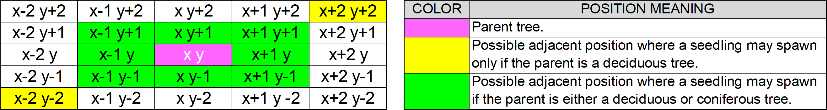

Figure 37. Positions around a parent tree where new seedlings may spawn.

* **Death & Decay**: Naturally over time or when felled, trees die as $Stress_{tree}=1$. Once dead, they decay as mentioned in Carbon Cycle. (*Back To Graph*)

#### **Biodiversity**

Biodiversity refers to variety of life forms in a forest and is a key indicator of its health. Higher biodiversity enhances forest resilience through increased genetic variability, which aids in adaptation, greater tree diversity, reduced risk of complete die-out from species-specific threats, and stronger ecosystem functions like nutrient cycling [106, 107]. Biodiversity figures computed in MycroForest are Score $B$, Category $B_{cat}$, and Stress Reduction Factor $Factor_{stress}^{bRed}$. Mixed forests with trees of varying ages are healthiest. They host rich biodiversity. Even dead wood contributes towards increased biodiversity (fungi, insects, etc) [106-110]. Thus, in MycroForest, biodiversity score considers species $B_{species}$ and age $B_{age}$ composition of the forest.

Based on research, for $B_{species},$ following rules are assumed.

* A forest with 50% coniferous trees and 50% deciduous ones (maximum species mixing) receives highest biodiversity score of 1.
* If no trees, then biodiversity score $B_{species}=0$.
* For each coniferous tree, if there exists a deciduous tree then $B_{species}=B_{species}+1$.
* For each remaining coniferous or deciduous tree for which there is another tree of the same type $B_{species}=B_{species}+0.3$.
* For each remaining coniferous or deciduous tree for which there is no other tree of any type $B_{species}=B_{species}+0.05$.
* The final $B_{species}$ score shall be scaled to a value between 0 and 1 as $B_{species}=\frac{B_{species}}{36}$ since land is comprised of 36 spots.

It is assumed that a forest most closely resembling a real old growth forest in age composition harbours most biodiversity and receives a score of 1. This score drops to 0 based on how much the virtual forest’s age composition differs from that of the real forest. Figure 38, Figure 39, and Figure 40, present tree age composition of an old growth forest in Vienansalo Wilderness, Eastern Fennoscandia [110].

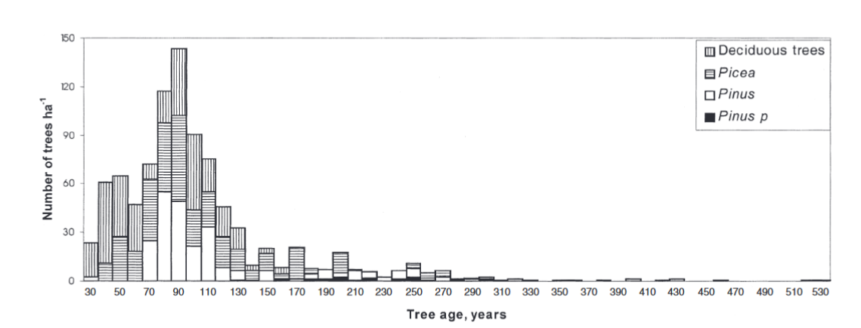

Figure 38. Distribution of no. of mature trees by age per hectare based on data from an old growth forest in Vienansalo Wilderness, Eastern Fennoscandia [110].

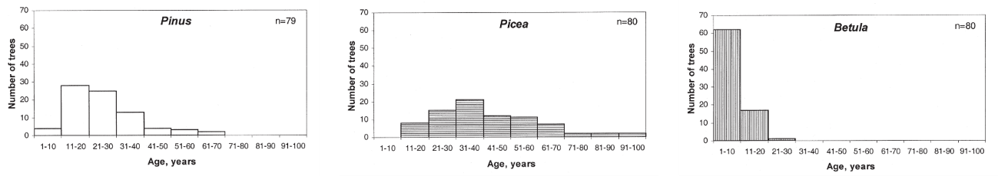

Figure 39. No. of seedlings and saplings per hectare based on data from an old growth forest in Vienansalo Wilderness, Eastern Fennoscandia [110].

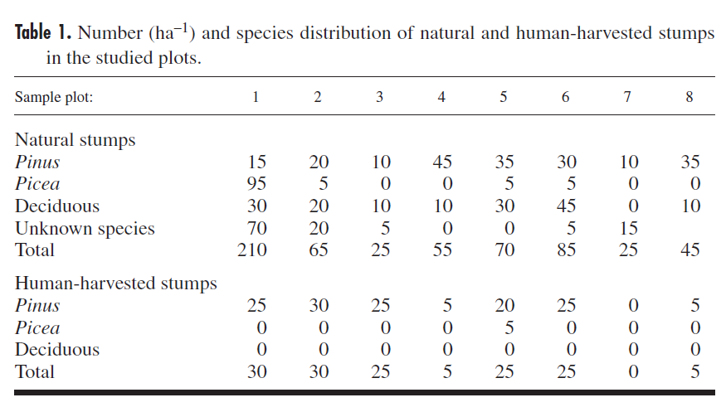

Figure 40. No. of dead tree stumps per hectare based on data from an old growth forest in Vienansalo Wilderness, Eastern Fennoscandia [110].

Since age of oldest and youngest trees in this forest differs from that in the microworld, to mimic age composition of the real forest, there was a need to map age group ranges in the microworld to corresponding ranges in the real forest. This scaling or range conversion was achieved via linear transformation [111] to obtain Table 17.

|  |  |  |  |  |  |  |  |  |
| --- | --- | --- | --- | --- | --- | --- | --- | --- |
| ***TREE AGE MAPPING*** | | | | | | | | |
| ***Life Stage*** | ***Microworld*** | | | | ***Real Forest*** | | | |
| Deciduous | | Coniferous | | Deciduous | | Coniferous | |
| Min | Max | Min | Max | Min | Max | Min | Max |
| Seedling | 0 | 3 | 0 | 4 | 0 | 15 | 0 | 50 |
| Sapling | 3 | 21 | 4 | 26 | 15 | 30 | 50 | 100 |
| Mature | 21 | 47 | 26 | 60 | 30 | 100 | 100 | 133 |
| Old Growth | 47 | 70 | 60 | 90 | 100 | 162 | 133 | 525 |
| Senescent | 70 | 80 | 90 | 100 | 162 | 212 | 525 | 575 |

Table 17. Mapping of tree ages in the microworld to those observed in a real forest.

Based on tree age groupings from Table 17 and approx. tree per hectare counts from Figure 38, Figure 39, and Figure 40, an approx. ideal age composition as in Table 18 was arrived at with seedlings and saplings making up 15% of the forest, mature trees comprising 35% of it, old growth trees and senescent trees contributing to 20% of it and dead trees accounting for the remaining 30% of it.

|  |  |  |  |  |  |  |
| --- | --- | --- | --- | --- | --- | --- |
| ***TREE AGE COMPOSITION*** | | | | | | |
| ***Life Stage*** | ***Real Forest*** | | | | | |
| Deciduous | | Coniferous | | Mean % | Approx. Round |
| Count | % | Count | % |
| Seedling | 65 | 11.50 | 115 | 13.05 | 12 | 15 |
| Sapling | 25 | 4.42 | 45 | 5.11 | 5 |
| Mature | 220 | 38.94 | 241 | 27.36 | 33 | 35 |
| Old Growth | 95 | 16.81 | 160 | 18.16 | 17 | 20 |
| Senescent | 5 | 0.88 | 10 | 1.14 | 1 |
| Dead | 155 | 27.43 | 310 | 35.19 | 31 | 30 |
| Total | 565 | 100.00 | 881 | 100.00 | 100 | 100 |

Table 18. Ideal proportion of each tree age category.

Calculating $B_{age}$ involves computing the following for each age grouping and then computing final biodiversity score as $B= \frac{B_{species}+B_{age}}{2}$. Computing $B_{age}$ involves follows calculations per tree age grouping.

* Current proportion of trees in this age group is $Prop_{ageGroup}=\frac{TreeCount_{ageGroup}}{36}×100$ where $TreeCount_{ageGroup}$ is no. of trees in this age group.
* Maximum and minimum possible error is $Error_{ageGroup}^{max}$ = $max\left(\left(100-Prop_{ageGroup}^{ideal}\right), \left(Prop_{ageGroup}^{ideal}-0\right)\right)$ where $Prop_{ageGroup}^{ideal}$ is ideal proportion of trees of this age group, and $Error_{ageGroup}^{min}=0$ respectively.
* Error per age group is $Error_{ageGroup}=Abs(Prop_{ageGroup}-Prop_{ageGroup}^{ideal})$.
* After min-max scaling to obtain values in the [0, 1] range, $Error_{ageGroup}^{scaled}=\frac{Error_{ageGroup}-Error_{ageGroup}^{min}}{Error_{ageGroup}^{max}-Error_{ageGroup}^{min}}$.

$B_{age}^{ageGroup}=1-Error_{ageGroup}^{scaled}$

$B_{age}=\frac{\sum_{ageGroup}{B_{age}^{ageGroup}}}{4}$

Given knowledge that ecosystems are more biodiverse than new forests or plantations [106] and that biodiversity is proportional to forest resilience, land categorization and biodiversity based stress reduction values in Table 19 were formulated. (*Back To Graph*)

|  |  |  |
| --- | --- | --- |
| Biodiversity Score Range | Land Category $(B_{cat})$ | Biodiversity Reduction Factor $(Factor_{stress}^{bRed})$ |
| $$0≤B≤0.25$$ | Unforested | 0 |
| $$0.25≤B≤0.5$$ | Plantation | 0.01 |
| $$0.25≤B≤0.75$$ | Forest | 0.1 |
| $$0.75≤B≤1$$ | Ecosystem | 0.3 |

Table 19. Mapping between biodiversity score range, land category, and biodiversity stress reduction factor.

#### **Planner**

The planner in MycroForest is an object that maintains the learner’s working forest management plan. It’s a mapping of years in the simulation timeline to

Management **Action**s. Targets set by the learner is also kept track of in the planner along with the latest Rotation Period setting. Furthermore, the planner contains switches which can be used to activate other income streams. (*Back To Graph*)

#### **Management Action**

Management actions are actions that affect the forest which learners may opt to execute. Creating a new management action involves selecting the action type, type of tree (species, age) to which the action is to apply, no. of trees to be affected, year in which the action is to be executed and whether the action is to be repeated every rotation. There are 2 types of management actions: Felling and Planting. Both felling and planting a tree involves paying a fee. If funds are insufficient, the action fails. When a tree is felled, 25% of it (roots = 21.3% [109] + stump + some foliage) remains in the soil to decay, while 75% is harvested and added to timber stock, with half sold for energy [83] and the other half for lumber. Planting is only possible if a free spot adjacent to the parent tree is available, in which case, a new seedling is added on land. ***Note:***Trees can reproduce naturally or be planted by learners. Even without intervention, if a mature or old-growth tree is present, a new seedling may sprout in an adjacent free spot. (*Back To Graph*)

#### **Target**

The microworld allows 2 target types: CO2 Level and Income per Rotation. If the CO2 level exceeds the set target during the simulation, the year this first occurs will be displayed next to the corresponding text field. If the plan fails to generate enough income to meet the set value in any rotation, the rotation where this first happens will be shown next to the text field. Successfully meeting a target, results in a green border around the text field, while a failure is indicated by a red border. (*Back To Graph*)

#### **Rotation Period**

In MycroForest, trees can be felled/planted every $x$ no. of years, known as the rotation period. This scheduling of management actions at the start of each rotation, mimics real-world forestry/agriculture practices. A rotation is defined as time between the formation/regeneration of a crop and its harvest [112]. (*Back To Graph*)

#### **Money**

Virtual currency in MycroForest is “coin”. Ways to earn from the forest are (i) Timber, (ii) Non Timber Forest Products, and (iii) Forest Recreation. (*Back To Graph*)

#### **Timber**

Timber in the microworld refers to wood harvested upon felling a tree.

*Availability:* Availabilityof this resource depends on number and size of trees felled.

*Income:* At the end of each simulation timestep, harvested wood is sold and used. In reality, wood prices vary by type, but on average, it is priced at approximately $3.3 per kg or €3.03 per kg [113]. In MycroForest, timber is thus valued at 3 coins per kg.

*Expenditure:* Felling the biggest trees can cost up to 3000 coins [114]. This max amount is multiplied by percent of full growth a tree has reached at time of chopping to obtain $Cost_{fell}=\frac{Height_{tree}}{Height_{tree}^{max}}×3000$. Planting a tree costs 277 coins [115]. (*Back To Graph*)

#### **Non Timber Forest Products**

Selling non-timber forest products (NTFPs) (mushrooms, berries, honey) fetches coins.

*Availability*

A good number for wild ***mushroom*** yield from a European forest is 44.5 kg/ha/year [116]. That is, 44.5 kg per 10000 $m^{2}$ per year = 0.00445 kg/year/ $m^{2}$. Thus, for the 1740 $m^{2}$ forest in the microworld, the value is around 7.743 kg/year $≈$ 8 kg/year. On average, around 20 kg of ***honey*** can be harvested from one bee hive per year [117]. In Europe, wild honeybee colony density has been estimated to be around 0.26/ $km^{2}$ [118]. This means there may be around 2.6e-8 colonies per $m^{2}$. Thus, a 1740 $m^{2}$ micro forest can have 4.524e-5 bee colonies, each outputting 20 kg of honey annually to result in total generation of around 9.05e-4 kg/year. With intensive ***berry*** picking, it is possible for a small group of people to harvest around 10 kg of wild berries per year by foraging [119]. Based on this, it is assumed that 5 kg of berries are foraged from MycroForest per year.

Overall, total availability of NTFPs would be around 13 kg/year. This income stream is not as dependable as timber. Thus, the decision was made to model availability using a normal distribution (data about true distribution could not be found, so assumed to be normal) where mean $μ=14 kg/year$ and standard deviation $σ=2.5$. Also, this stream is dependent on biodiversity score and amount of deadwood in the forest (saprophytes like mushrooms thrive on deadwood [120]) as follows.

* Let max availability of NTFPs before considering effects of biodiversity score and abundance of deadwood be $Availability_{ntfp}^{max}∈N(14, 2.5)$.
* W.r.t the impact of biodiversity score, mean of the normal distribution is assumed to be highest when biodiversity score = 1.0. Thus, given $B=$ biodiversity score, $Availability_{ntfp}=max\left(0, Availability_{ntfp}^{max}-\left(Factor_{avail}×Availability_{ntfp}^{max}×\left(1-B\right)\right)\right)$. Here, $Factor_{avail}=0.5$ is a arbitrarily chosen scaling factor to reduce harshness of impact of slight reductions in biodiversity.
* W.r.t the impact of proportion of deadwood on land, given $DW=\frac{no. of spots on land with deadwood}{total no. of spots on land}$, $Availability_{ntfp}=Availability_{ntfp}+\left(Factor_{avail}×Availabilty_{ntfp}^{max}×DW\right)$. Once again, the scaling factor $Factor_{avail}$ smoothens changes in availability for changes in deadwood proportion.

*Income:* In Ireland, as of 2024, wild mushrooms can fetch around €80 per kg [121], wild berries can fetch around €25 per kg [122], and wild honey can fetch around €65 per kg [123]. Thus, selling price for NTFPs may be assumed to be 170 coins per kg.

*Expenditure:* Harvesting NTFP requires a work force. It takes a person a little over 20 hours to cover one acre = 4046.86 $m^{2}$ by foot [124]. That's about 0.005 hrs per $m^{2}$. Thus, covering the 1740.15 $m^{2}$ of forest land in the microworld would take 1 person around 8.6 hrs. Let the employee take 15 hours to harvest (forage & gather) products (mushrooms, honey, berries) from 1740.15 $m^{2}$ of forest. Say, the worker needs to cover the equivalent of the whole forest 3 times a year for harvests, then they would need to work for 45 hrs/year. Let there be 2 workers, at a wage of 18 coins/hr [125], maintenance cost = $2×45×18=1620$ coins/year. If there are not enough funds to pay forest workers, then this income stream’s availability is set to 0. (*Back To Graph*)

#### **Forest Recreation**

Forests may be opened to the public for recreational use which can include forest trails, picnicking spots, and other activities like camping. This fetches coins.

*Availability:* As of 2022, there are 808,848 ha = 8088480000 $m^{2}$ of forest in Ireland. It is expected that they receive around 29105759 visits per annum [126]. Based on this, no. of visits per $m^{2}$ of forest per year may be computed as $\frac{29105759 }{8088480000 }≈0.0036$ visits/year/ $m^{2}$. Thus, on average, a 1740 $m^{2}$ forest in the microworld can receive around 7 visits/year. This can vary significantly based on several factors like climate, economic situation, etc. Thus, here too, availability is drawn from a normal distribution with $μ=7$ and $σ=2.5$ as $Availability_{rec}^{max}∈N(7, 2.5)$. One feature that will most likely affect no. of visits is biodiversity score of the forest as people generally prefer visiting healthier forests rich in life. Thus, availability of visitors depends on biodiversity score $B$ as $Availability_{rec}=max\left(0, Availability_{rec}^{max}-\left(Availability_{rec}^{max}×\left(1-B\right)\right)\right)$.

*Income:* Income from forests open to public recreation may be generated via: Admission/Parking Charges = 5 coins [127, 128], Guided Tours = 10 coins [127, 128], Special Activities (Zip Lining, Mushroom Picking, etc.) = 30 coins [127, 129, 130], or Group Events (Birthday Parties, Yoga, etc.) = 20 coins/individual [131]. Assuming 1 of all visits to be a guided tour, another 1 to be a special activity and the rest to be normal visits with 1 group (20 individuals) activity/year, annual income = $10+30+\left(Availabilty_{rec}×5\right)+\left(20×20\right)$.

*Expenditure*

Opening a forest for public recreation involves establishment of infrastructure which has associated one-time expenses. In 2006, restoration of around 44 hectares = 440000 $m^{2}$ of forest land cost about €8,000,000 [32]. Adjusting for change in currency value, in January 2024, that is around €10,114,114 ([CPI Inflation Calculator](https://visual.cso.ie/?body=entity/cpicalculator)). Thus, in the microworld, initial one-time cost to prepare forest land for recreational activities = $\frac{10114114}{440000}≈23$ coins per $m^{2}$. Thus, for a 1740 $m^{2}$ forest, this $≈$ 40020 coins.

Established infrastructure needs maintenance, which requires employees and resources. It was not possible to find definitive numbers about how many employees are required to maintain forest recreation facilities. This varies greatly. The estimate for no. of workers per $m^{2}$ of forest in the microworld was based on no. of people that Coillte (large forest owner in Ireland), with around 4.4e+9 $m^{2}$ of managed forest land [132], employs. In 2016, it employed around 862 people [133]. Considering no. of employees to be 850, no. of people employed per $m^{2}$ = $\frac{850}{4.4e+9}=1.93e-7$ employees/ $m^{2}$. Thus, no. of workers for a 1740 $m^{2}$ forest = $1740×1.93e-7=0.00034$. If each employee works for 8 hrs/day for 5 days/week for 52 weeks/year, then each employee works around 2080 hrs/year. In Ireland, as of 2024, forest workers get paid around €18 per hour [125]. Thus, maintenance cost due to employee wages per $m^{2}$ of forest for a 1740 $m^{2}$ forest can be computed as $0.00034×2080×18≈13$ coins/year. Purchase of resources needed to maintain facilities every year would also contribute to maintenance cost. It was difficult to acquire numbers for this. Thus, it is assumed to be a fraction (1%) of initial establishment cost $=0.01×40020≈400 coins/year.$

Thus, total maintenance cost for = 400 + 13 = 413 coins/year. (*Back To Graph*)

### Input Variables

Input variables here, refer to a collection of 41 global variables that comprise all informed simulation hyperparameter values based on research. These settings were separated from the rest of the program to facilitate easy experimentation with different simulation settings needing no code updates. Table 20 displays these variables organized into 9 categories.

|  |  |  |
| --- | --- | --- |
| Tree | | Carbon Dynamics |
| BIODIVERSITY_STRESS_REDUCTION_FACTOR C_PC_TREE C_WEIGHT_SCALE_FACTOR DECAY_HEIGHT_THRESHOLD HEIGHT_MAX HEIGHT_START_SEEDLING LIFE_STAGE_TREE REPRODUCTION_INTERVAL REPRODUCTION_STRESS_THRESHOLD TOLERANCE_CO2 TREE_REMAINS_AFTER_FELL  SEC_GROWTH_PC STRESS_AGING STRESS_RECOVERY_FACTOR WOOD_DENSITY WOOD_DRY_WEIGHT_PC | | C_START C_PC_DECAY CO2_FOSSIL_FUEL_ANNUAL_EMISSION_START TREE_VOLUME_MAINTENANCE_PC DECAY_PC_SOIL SOIL_RELEASE_PC |
| Land |
| BIODIVERSITY_CATEGORIES LAND_AGE_COMP LAND_FREE_PC_START LAND_SIZE SPECIES_COMPOSITION_START |
| Finances | Time | Targets |
| COST_MGMT_ACTION FUNDS_START INCOME_SOURCES | INIT_NUM_YEARS TIME_MAX SIMULATION_DELAY | TARGET_CO2_START TARGET_INCOME_START |
| Forest Management | | Air |
| ROTATION_START TIMBER_USAGE  AVAILABILITY_SCALE_FACTOR | | AIR_MASS ENV_SCALE ENV_SCALE_COLORS |

Table 20. Categorized input variables.

Please find a description of each variable in Appendices 8.8.

### UI Components

UI components were built using ReactJS and encapsulate visual and interactive elements of MycroForest. Page specific components are those that are used only within a single page. These are more specialized compared to page agnostic ones that may be useful across multiple application pages. Many components are output-only, meaning that their existence is solely justified by the need to display information to the user. Others are input-only such that their primary purpose is to present an interface via which users may provide input that gets incorporated into the simulation model. Few other components both, output data, and accept user input. These are input-output components. Together, this component architecture as displayed in Figure 41 keeps code modular and enhances maintainability and reusability.

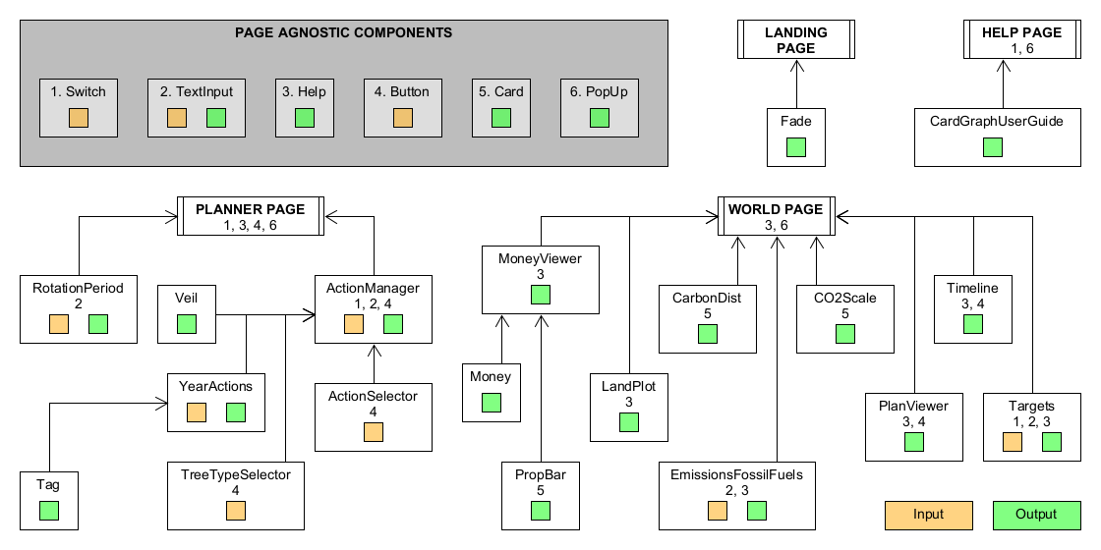

Figure 41. Illustration of how UI components relate to each other. Application pages may be thought of as root components. Page specific components are linked via arrows either directly or indirectly with their parent page. Page agnostic components are displayed within a grey box on the top left corner and are numbered. If the number corresponding to a page-agnostic component appears within the box representing a page-specific or root component, then this means that the latter incorporates one or more instances of the former. Green boxes in components indicate that this container outputs data. Similarly, an orange box indicates that it accepts input from users.

## Detailed Technical Design

This section describes some key development decisions w.r.t MycroForest.

### Tech Stack & Technical Architecture

MycroForest is a standalone, client-side, static web site with no separate backend or database since users need not sign-up/log-in to use the tool. All data is stored in JavaScript variables within React Components, meaning that system state is not persistent and gets updated upon browser refresh. However, learners can save and reload world state if needed. A database or user authentication was not included as this does not greatly add to the learning experience. It only serves to further complicate development, making successful completion within given timeframe, more challenging.

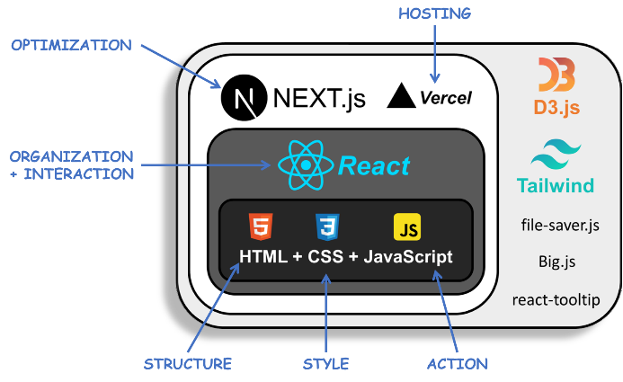

Figure 42. MycroForest – Tech Stack

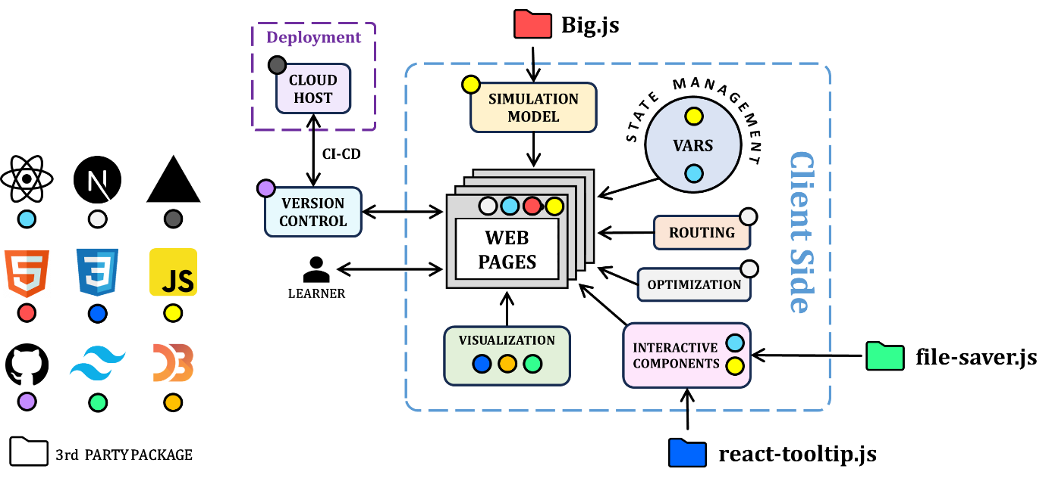

Figure 43. MycroForest - Technical Architecture. A coloured-coded circle maps each technology with associated function in the architecture diagram.

Following points explain the role of each technology leveraged.

* **HTML:** Hyper Text Markup Language (HTML) enables structuring and content arrangement.
* **CSS:** Cascading Style Sheets (CSS) facilitates website styling. It can be used to add colour, animation, etc. and thereby format HTML elements.
* **Tailwind CSS:** [Tailwind CSS](https://tailwindcss.com/) is a framework that makes CSS styling easier by providing utility classes that can directly be used in HTML.
* **JavaScript:** JavaScript (JS) enables user interaction facilitating detection of events like mouse move, click etc. It also allows embedding of working logic or functions.
* **Big.js:** The [Big.js](https://mikemcl.github.io/big.js/) library facilitates precision computation using very large/small numbers. Unlike native JavaScript numbers, which have precision limitations, Big.js stores numbers as objects with arbitrary precision. MycroForest models carbon amounts and environmental properties (e.g. mass of atmosphere) using large values as on Earth. Storing these (e.g. 5.1e+21, 6.25e+18, etc.) as JavaScript “number” objects led to overflow/underflow upon computations. Big.js helped overcome this.
* **file-saver.js:** The [file-saver.js](https://www.npmjs.com/package/file-saver) library enables saving files on the client side. When the learner clicks on the “download” icon on the planner page, the saveAs(…) function from the library may be used to save world data as a JSON file.
* **ReactJS:** [ReactJS](https://react.dev/) is a JavaScript library for building user interfaces. It allows creation of reusable UI components and easy state management via efficient virtual Document Object Model (DOM) manipulation. A DOM is the in-memory tree-like representation of webpage structure defined by HTML that the browser maintains [134]. React is especially apt for heavy user interaction as in MycroForest, because the built-in react-dom library maintains a virtual copy of DOM and rebuilds it upon state updates such that only necessary changes are reflected on the real DOM. This optimizes DOM update, which is otherwise computationally expensive. A React component is simply a function that returns JSX (JavaScript XML), notation that allows HTML/JavaScript-like content to coexist in React components allowing self-containment of structure and logic. Private data associated with components in React is referred to as States. MycroWorld’s code most frequently uses React hooks useEffect, useState, and useContext. A “hook” is a function that allows state variable updates. The useState hook does just this. Every time state is updated, ReactJS ensures re-rendering of relevant components. The useContext hook allows states to be globally accessible. The useEffect hook allows one to set up logic that gets executed each time particular state updates occur, or the corresponding component is first loaded. Thus, MycroForest leverages ReactJS to modularize app structure, encourage code reusability, and optimize DOM updates.
* **react-tooltip.js:** The [react-tooltip](https://www.npmjs.com/package/react-tooltip) library provides a ready-made tooltip component that is otherwise cumbersome to create from scratch.
* **NextJS:** [Next.js](https://nextjs.org/docs) is a React framework that simplifies building performant web applications. It offers features like Server-Side Rendering (SSR) and Static Site Generation (SSG). The advantage of SSR is that HTML for the webpage is generated on the server side and sent to client instead of it having to be built on client side, thereby hastening page loading. This also allows search engines to find the webpage more easily. Not all components can be rendered on server side. Those that users can interact with, are rendered on the client side because displayed content depends on user interaction (e.g. text input by user) and thus cannot be pre-rendered. All files with the line “use client” on the top of the page, are client side rendered. Others are server side rendered. NextJS optimizes rendering by allowing parts of the webpage to be server side rendered even if there are some interactive components that requires client side rendering. SSR is generally an attractive feature when content fetched from the server is dynamic (e.g. changes per user like with personalised recommendations). However, MycroForest is “static”, meaning that content displayed, barring implemented randomness, is same for all users. So SSR is not of much benefit here. That said, NextJS has SSG capabilities which readies the webpage at build time and much like SSR improves search engine optimization and initial loading time. SSG is advantageous for static web apps like MycroForest. Furthermore, in MycroForest, NextJS's useRouter provides client-side routing with a file-system-based convention, allowing easy page organization and automatic route generation as well as navigation without needing a separate backend.
* **D3.js:** D3.js is a graphics library that allows creation of custom plots. In MycroForest it was used to create the dynamic land content/tree-growth visualization involving a customized scatter plot representing land with trees.
* **GitHub:** [GitHub](https://github.com) is a cloud code warehouse that facilitates version control. All project code over time is stored in a GitHub repository [here](https://github.com/ggn1/microworld_dissertation_tcd). It was configured to allow code “pushes” to the repository that update only changed portions of files while preserving past versions in history which may be restored if required.
* **Vercel:** [Vercel](https://vercel.com) is a cloud platform where web apps can be deployed. It was built by creators of NextJS and hence the 2 are compatible. MycroForest is hosted on Vercel (Appendices 8.1). MycroForest’s Vercel project is linked to its GitHub repository such that each new push to GitHub triggers a deployment of a new app build on Vercel, facilitating Continuous Integration and Continuous Deployment (CICD). Vercel boasts a strong Content Delivery Network with multiple [edge locations](https://vercel.com/docs/edge-network/regions) in Europe (Dublin, Frankfurt, Stockholm, Paris, London) and built-in performance optimization (caching, streaming, response compression, etc.), ensuring that learners in Ireland experience minimal delay/disruption. Currently, MycroForest is hosted via the free, Hobby account. Key usage indicators include fast data transfer volume, fast origin transfer, edge requests, and data cache reads. Monthly limits are generous and supports multiple parallel users, although an exact number is difficult to estimate given limited documentation on usage restrictions. Nevertheless, usage limits may easily be scaled by subscribing to the pro plan or paying for additional usage. Moreover, the account owner is notified via email in advance if usage approaches limits to possibly avoid downtime. The Hobby plan was sufficient for the Bridge2College 2 hour learning session with the application accessed on 8 machines simultaneously. Incurred usage for that month (June) including tests were: Fast Data Transfer = 100.74 MB / 100 GB, Fast Origin Transfer = 1.92 MB / 10 GB, Edge Requests = 5,383 / 1,000,000, and Data Cache Reads = 301 / 1,000,000.

### Avoiding Bad Software Design

**Note:** Following content is based on knowledge from lectures and material put together by Prof. Siobhán Clarke for the CS7CS3 – Advanced Software Engineering module that this author took at TCD as part of the MSc. Computer Science programme (2023 – 24).

Generally, bad code, as in Table 21, is difficult to change, prone to breaking, difficult to reuse, and contains temporary hacks instead of appropriate long-term fixes. While developing MycroForest, measures were taken to prevent such consequences of bad design. Code adheres to the Model View Controller (MVC) design pattern and Object Oriented Programming (OOP) paradigm. Web pages are composed of reusable React components and temporary fixes were largely avoided.

|  |  |  |
| --- | --- | --- |
| **PROBLEM** | | **COUNTER MEASURES TAKEN** |
| RIGIDITY | Difficult to change. | MycroForest adheres to the MVC design pattern which promotes Separation of Concerns. The underlying model is separate from React components and is organized into classes in an Object-Oriented Fashion. |
| FRAGILITY | Prone to breaking. | The app and specific components were tested immediately after implementation of each new feature. GitHub was used for version control. |
| IMMOBILITY | Difficult to reuse. | Choice to use ReactJS allows for creation of reusable components. Example: <Button/>, <Switch/>, <Card/>, <Veil/>, etc. |
| VISCOSITY | Hacks over the right thing. | Temporary fixes were avoided or immediately replaced with long term solutions. E.g. Decision to change structure of code early on and start afresh instead of continuing to work using the initial prototype codebase. |

Table 21. Countermeasures taken against common characteristics of bad software design.

Figure 44 shows Model View Controller (MVC) separation in code. Simulation model files are in a "model" folder, React Components are in a "components" folder, and each webpage has its own page.jsx file following NextJS conventions. The model handles simulation logic, the view is the returned JSX (what the learner sees), and the controller here, is the code above the return statement in components and pages because it processes input, interacts with the model, and updates the UI, acting as a bridge between the model and view. Following the MVC design pattern [135] supports the Separation of Concerns (SoC) principle which advocates for any complex software system to be designed as a conglomeration of smaller, simpler, specialized components with distinct functions [136]. The OO idea of encapsulation also encourages this. These practices promote code maintainability and reusability.

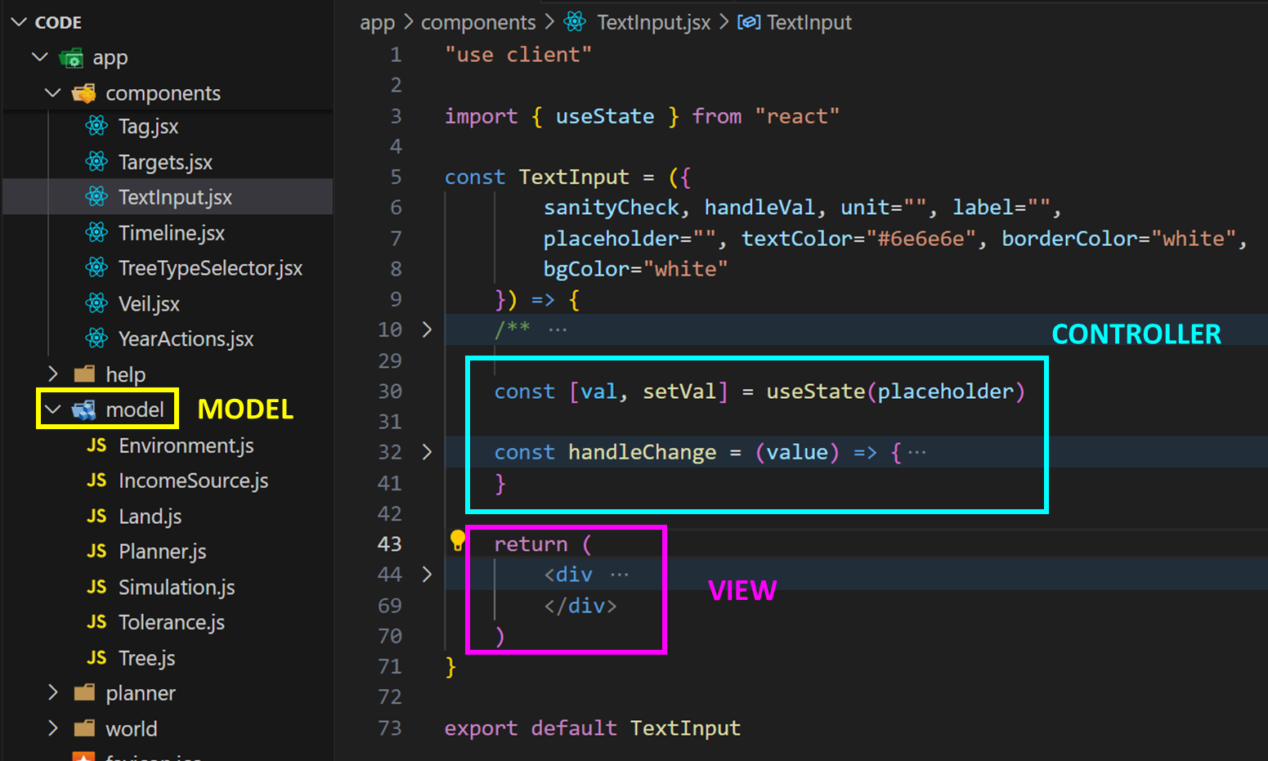

Figure 44. Model View Controller separation in code.

The simulation model is contained within a global sim variable in the world/page.jsx file. Both UI components and controller logic access this same model, thereby adhering to the Single Source of Truth (SSOT) software engineering principle [136].

### Code Re-Design

The importance of following software engineering best practices was experienced first-hand during project development.

Figure 45 shows the difference in code structure between an early MycroForest prototype and the current version.

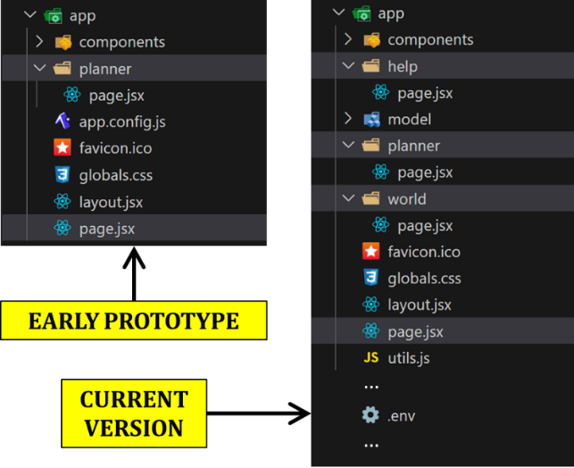

Figure 45. Early prototype versus now. Difference in code structure.

The underlying simulation model of the prototype was very similar to the current model. UI components, though fewer (since was incomplete), still served the same purposes as counterparts now (e.g. old LandPlot like new LandPlot, old timeline and new Timeline serve same purpose, old planner has similar plan viewer).

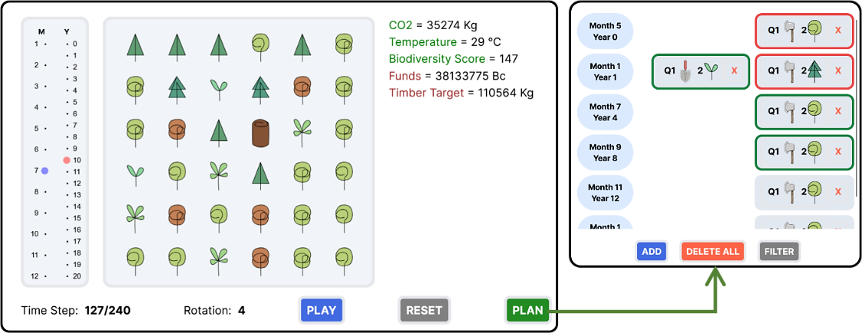

Figure 46. Early prototype.

Code organization, however, is drastically different between the early prototype and current version of the application. For instance, in the first approach, there was little separation between configuration and code. Input variables to the simulation model was defined in the same app.config.js file as other global functions used in the UI components. Accessing these variables required wrapping all of them in one object and exporting it. Thus, to use even just one of these variables, other files had to import the entire object (import GlobalConfig from '../app.config.js'). In new code, all simulation model hyperparameters (input variables) are maintained separate from the rest of the application in an environment file (.env). Any other file can access individual variables via JSON.parse(process.env.NEXT_PUBLIC_<VARIABLE_NAME>). This made it much easier to change configurations (edit hyperparameter values, add/delete parameters) without affecting the rest of the code. The latest version maintains global miscellaneous functions used by multiple files in another utils.js file which is separate from the .env file with critical simulation model configurations.

Another notable difference between old and new codebases is the monolithic nature of the former compared to the more modular later approach. In the early prototype, simulation model classes, and all other functions were placed in a single World.jsx component that was imported into the main landing page. This violates the MVC design pattern and many other software engineering best practices like Single Responsibility Principle (SRP) and Don’t Repeat Yourself (DRY). At the time, focus was on brining designed model on paper to life in code and to see if the idea of using a timeline in conjunction with a custom scatter plot to depict changing land composition, was viable. This prototype also helped confirm compatibility and utility of selected technology stack. Programming the application with the sole intention of evaluating soundness of theoretical ideas in practice led to tunnel vision and software development best practices took a back seat. Soon, this monolithic codebase was extremely difficult to work with, primarily because code was very hard to change. Hours had to be spent investigating highly coupled function calls to find sources of error or areas for improvement. Further, changes often broke functionality at multiple, even directly unrelated, parts of the code. This difficulty was the prime motivating factor for complete upheaval of the codebase such that a new GitHub project (current one) was created. This time, good coding practices were incorporated throughout development and quick fixes were no longer favoured over more long term solutions. E.g. when programming planner action tags, it is easier to simply use <div> tags. But, choosing to invest effort in implementing a React <Tag/> component, made it easier to later make action tags optionally selectable by introducing new variables selected and selectable in code definition of the <Tag/> component just once, instead of having to edit every <div>.

As a result, the current codebase is very flexible. Multiple changes were made in response to supervisor feedback leading up to the Bridge2College session with minimal code breakage and need to re-write entire sections. A most notable example of this is when Dr. Caldararu suggested that the initial design of just one tree per land spot be altered to allow at least another decaying tree to co-exist in a single land spot to mirror how plants often regenerate as previously existing trees are still decaying. This lower time between death and regeneration is important as it directly affects amount of CO2 in the air (faster tree regeneration sequesters some carbon that would otherwise have been lost due to decay and prevents it from re-entering the atmosphere). Such change involves significant code alteration (e.g. land content representation changes from 2D array to 3D array, isLandEmpty() function significantly changes to consider a spot with a partially decayed tree as empty for new plant growth, etc.). Given the new, modular, and well-commented codebase, it was possible to identify areas that needed edits and administer them quickly. The new feature was implemented and deployed in just 1 day. With the old codebase, this likely would have cost multiple days.

### Simulation Model Classes

The simulation model in MycroForest abides by Object Oriented principles to ensure code modularity, reusability, maintainability, flexibility, extensibility, and good organization. Please find an explanation of OOP in JS in Appendices 8.15

Figure 47 captures design of the simulation conceptual model in a class diagram.

Objects of the blue Tree, Land, and Environment classes comprise ABS components, and the green Planner class contributes to DES. In code, the world page.jsx file defines a global sim variable which contains an object of the yellow Simulation class. This object is the gateway to the simulation model. The Simulation class’s primary purpose is to act as coordinator and perform time synchronization.

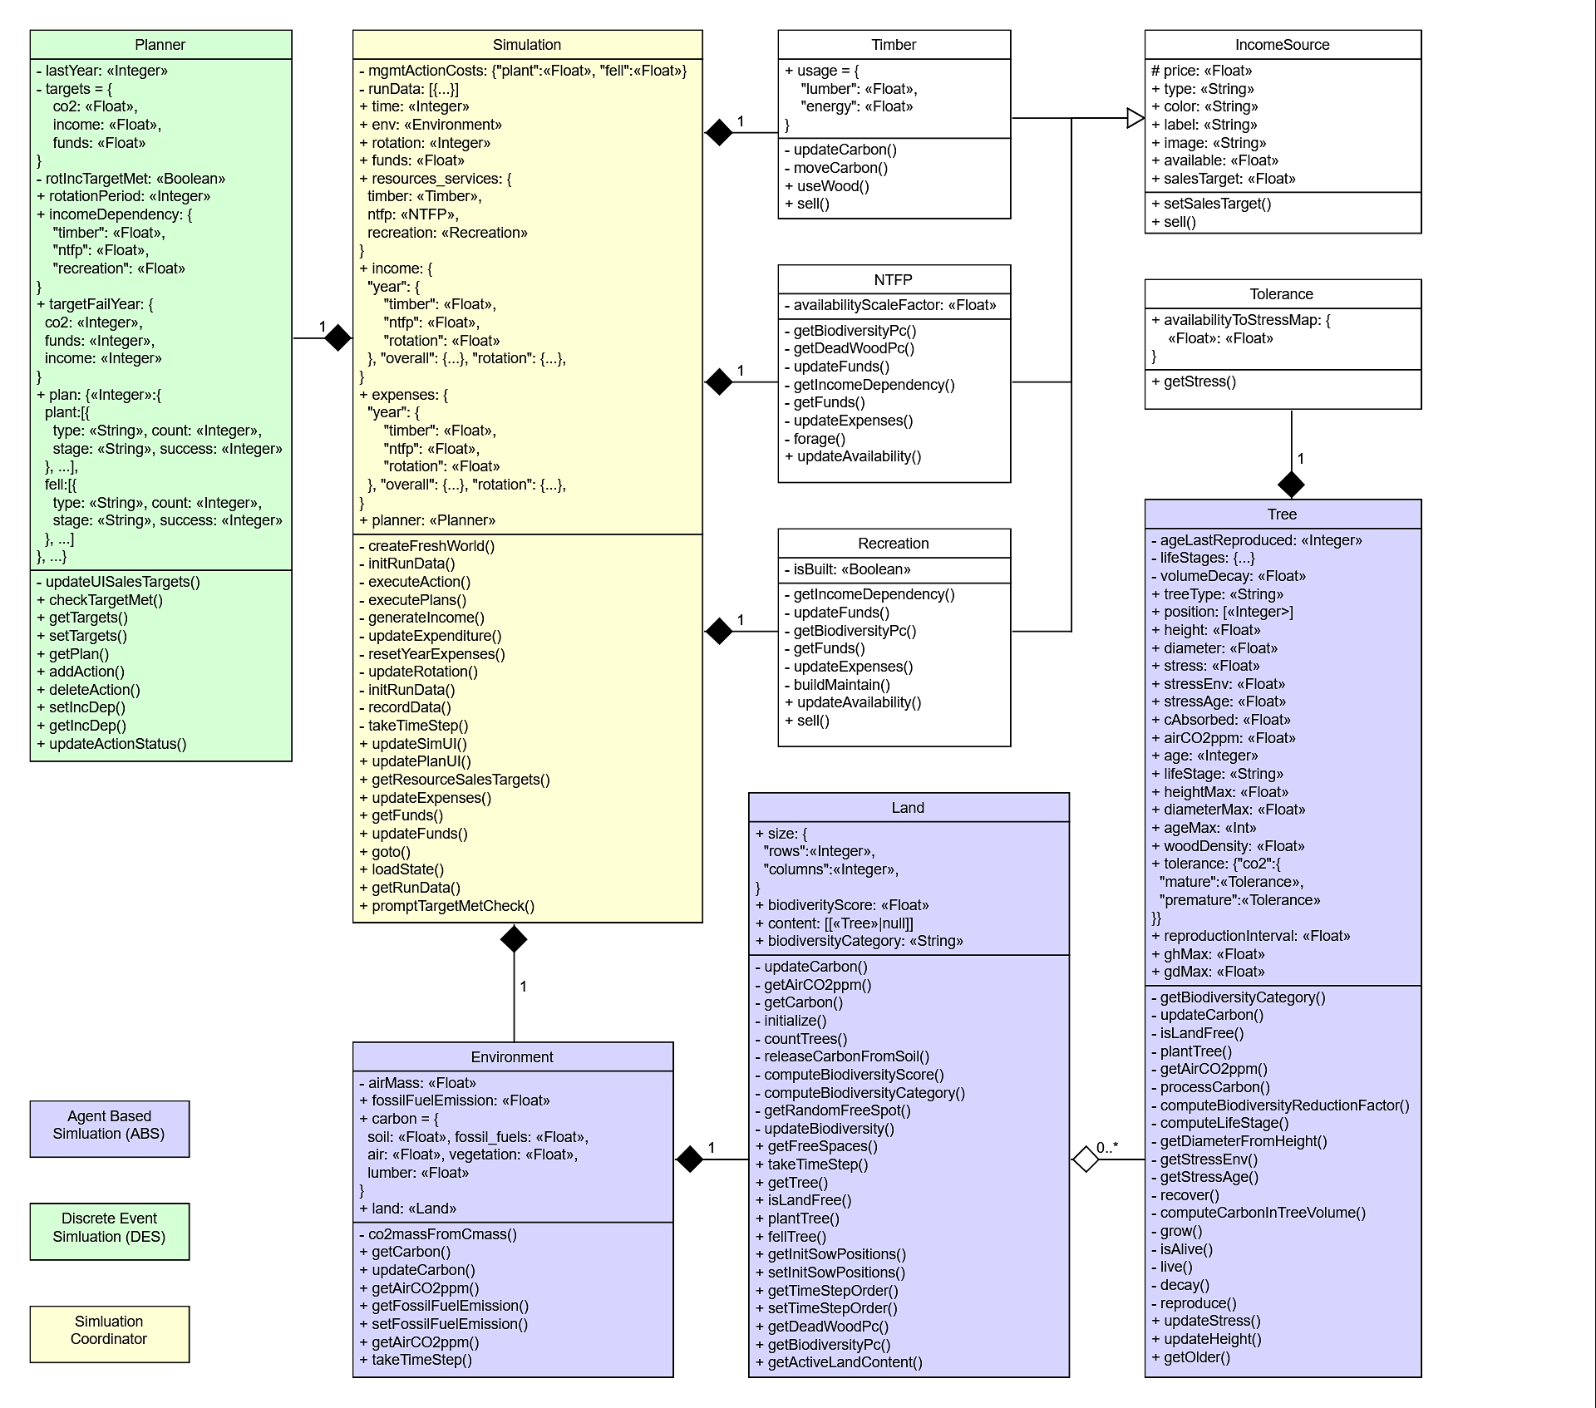

Figure 47. Simulation model class diagram.

Explained below, are key aspects of 5 of the 10 classes above. Please find a higher resolution image of the class diagram and short explanations of the 5 remaining classes in Appendices 8.9.

#### **Class – Planner**

This class facilitates creation and editing of forest management plans and other learner decisions like CO2 target, income target, income stream activation status, and rotation period. Key attributes include plan, targets, rotationPeriod, and incomeDependency. The active forest management plan is stored in the plan attribute as a JS object, where each year maps to an object containing management actions ("plant" and "fell"). Each action includes details like no. of trees affected, tree life stage, tree type, and action completion status. This plan functions like a DES priority queue, with earlier actions executed first.

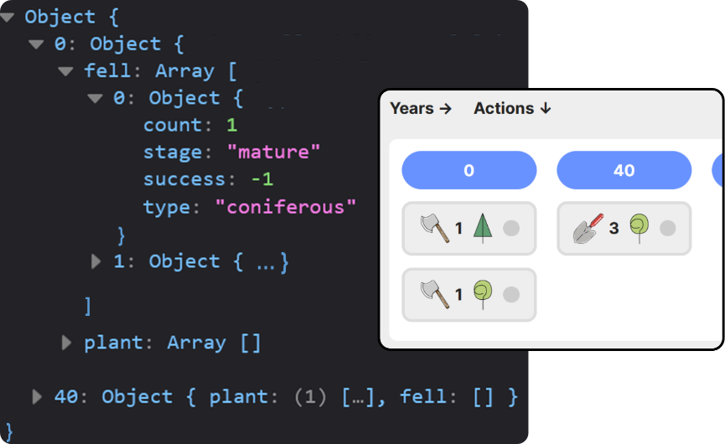

Figure 48. Code representation of management plan alongside graphical representation.

Initially, plan was implemented as an array of year-action mappings – [{year:1, action: {actionType: "plant", count: 1, treeType: "coniferous", …}, …}]. This was abandoned due to higher time complexity (O(n), with n = 300 years) since it requires array traversal to find/delete actions. The current approach as in Figure 48, utilizes a JS object that only includes years with planned actions as keys, which helps save memory. Lookup operation time complexity is also thereby reduced to O(1) constant time. Management actions are executed only when simulation time equals corresponding planned year, thus implementing DES "Next Event" time advancement.

Functions addAction(…) and deleteAction(…) add or delete forest management actions respectively. Function checkTargetMet(…) returns whether given air CO2 concentration or rotation income value satisfies current set targets. When learners update target text fields, the setTarget(…) function updates targets = {co2:float, income:float}.

Other components that a Planner object interacts with, includes Simulation and UI components like RotationPeriod, Targets, and ActionManager. The Simulation object runs executePlans(…) per timestep, which acts like a listener for management action events. All actions scheduled for the current simulation year, get triggered. The RotationPeriod, Targets, and ActionManager React components interact with the Planner either directly/indirectly via the Simulation object to update model values rotationPeriod, targets, and incomeDependency to reflect learner inputs.

Thus, the Planner class manages all 3 DES steps including execution of calendar (plan) events (management actions) and composite processes as well as triggering of UI and system state updates via executePlans(…) and direct or indirect influence on other components like RotationPeriod, Targets, and ActionManager.

#### **Class – Environment**

This class defines simulated environmental conditions including the atmosphere, land, and carbon reservoirs. It provides functions like getCarbon() and updateCarbon(…) that facilitate carbon flow. Land, Tree, and Timber objects use these functions to add/remove to/from carbon reservoirs.

The getAirCO2ppm() function is important because it computes concentration of CO2 in air based on the amount of carbon in it (carbon[air]) and mass of the atmosphere (airMass). Mass of Carbon in air differs from that of CO2 in it since the latter has additional Oxygen atoms. Thus, getAirCO2ppm() calls co2massFromCmass(carbon[air]) to compute mass of CO2 based on mass of carbon and molar mass of CO2 as follows.

this.getAirCO2ppm = () => {

/** Computes conc. of CO2 in air given mass of carbon in it.

        * @return: Concentration of CO2 in the atmosphere in PPM.

        */

const airC = this.carbon.air // Current mass of carbon in the air.

    // 1. Compute mass of CO2 in the air.

      const massCO2air = this.#co2massFromCmass(airC) // gCO2

      // 2. Compute CO2 concentration.

      const ppm = (massCO2air.div(this.#airMass)).mul(1e+6).toNumber()

      return ppm

}

#co2massFromCmass (cMassBig) {

/**

        * Given mass of C, returns that of CO2 assuming all C exists as CO2.

        * @param cMassBig: Mass of carbon as a Big object.

        * @return co2Mass: Mass of CO2 as a Big object.

        */

const molarMassCO2 = 44.01

      const molarMassC = 12.01

      return cMassBig.mul(molarMassCO2/molarMassC)

}

This class also maintains a fossilFuelEmission attribute to track amount of carbon released into air from the fossil fuels reservoir, emulating anthropogenic usage. Initially, this was a public attribute. Later, it was made public “static” because:

* When the simulation resets to year 0, the environment object is recreated.
* Value of fossilFuelEmission may be set by the user.
* When a preexisting Environment object is replaced with a new one, its public attributes are re-initialized.
* This means that if fossilFuelEmission had public visibility, then learners would need to re-enter fossilFuelEmission values each time simulation year = 0.
* Making fossilFuelEmission static public, avoids this because unlike public variables that get created/destroyed along with object instances, static variables retain their value as long as at least one object of the class exists in the program.

The EmissionsFossilFuels UI component through which learners view/set fossil fuel emission levels, interacts with this Environment object to use getFossilFuelEmission() and setFossilFuelEmission(…).

The takeTimeStep(…) function in this class gets called from within a Simulation object’s takeTimeStep(…) function as part of “Time Step” simulation time advancement. Environment’s takeTimeStep() involves first emulating fossil fuel usage by moving set annual emitted amount of carbon from the fossil fuels reservoir to the air reservoir followed by triggering takeTimeStep() of its constituent Land object.

This Environment object is important w.r.t the carbon flow ABS since it both acts like an agent and independently updates carbon reservoirs (air, fossil fuel) via takeTimeStep() alongside being an environment that other class objects interact with, given that it provides functions like getCarbon() and updateCarbon(…).

#### **Class – Land**

Main responsibilities of a Land object are as follows.

* **Spatial Representation:** Property size stores of land grid row and column count.
* **Land Content Management:** Attribute content holds information about tree distribution. It is a 2D array wherein each element represents a grid cell and can either contain an empty list or a list with 1 or 2 Tree objects such that only 1 among them is alive. Initially, all land [x, y] positions contained either null or a single Tree object (dead/alive). This was abandoned for the current design where grid cells contain a list, because it allows new trees to exist at the same spot while a dead one is still decaying, adhering to a suggestion from Dr. Caldararu. The Simulation object leverages functions plantTree(…) and fellTree(…) provided by Land while executing management actions. A land spot is considered free for planting if either it is empty (content [x, y] = []) or there is only 1 partially decayed tree on it. The isLandFree(…) function checks if a given land spot is free. At any point in the simulation, only the last added tree is active and will get displayed on screen. The getActiveLandContent() function returns a land spot’s active content. If another tree exists in addition to the active one, then it is dead and has partially decayed. It continues to decay in the background but is not displayed on screen as learners are only able to interact with live trees. Upon initialization, land is empty. Seedlings planted as part of the initialize() function grow and reproduce naturally for a warm-up period of 200 years. It is this 200-year-old forest that learners see when they first view the world page. An alternative is to present empty land and allow learners to determine tree age/species composition and grow a forest from scratch through inoculating land with seedlings via a management plan. After discussion with supervisors, the decision was made to go with the current approach of the learner coming into possession of an existing forest with a predefined starting composition as this is more realistic and is also the approach adopted by other similar tools [3-5]. Due to random seedling positions and update order, land composition changes upon browser refresh. Thus, 2 global variables (initSowPositions and timeStepOrder) store initial seedling positions and land spot update order to ensure that upon returning to the world page from the planner page, starting composition and land spot update order remains unchanged.
* **Soil Carbon Release:** Soil naturally loses a portion of its carbon content each year. The releaseCarbonFromSoil() function simulates this. Land is considered an ABS agent because is interacts with the Environment and moves carbon between soil and air.
* **Biodiversity Tracking:** The updateBioDiversity() function calls, computeBiodiversityScore() and computeBiodiversityCategory() to compute $B= \frac{B_{species}+B_{age}}{2}$ as discussed in section 3.4.1. This requires counting trees, facilitated by countTrees() which returns a JS object {deciduous: count, coniferous: count, seedling: count, sapling: count, mature: count, old_growth: count, senescent: count, dead: count}.
* **Simulation Advancement:** The takeTimeStep() function implements time step updates. It loops through every tree on land and triggers its aging. Then, it moves a certain portion of carbon from the soil reservoir to the air reservoir to emulate natural annual soil carbon loss, before finally updating biodiversity score and category.

#### **Class – Tree**

The Tree class represents an individual tree as an agent. It’s takeTimeStep() function encapsulates tree lifecycle processes and interactions with the environment. Tree properties are related to identity (treeType, position), physical characteristics (height, diameter, heightMax, diameterMax, woodDensity), growth (ghMax, gdMax, reproductionInterval), environmental interactions (stress, airCO2ppm, tolerance, volumeDecay) and aging (lifeStages, age, ageMax). The most important function here, is getOlder(), which the Land object triggers from its takeTimeStep() function. This function emulates all independent annual tree life functions (aging, stress recovery, growth, reproduction) if it is alive or the process of decaying, otherwise.

Trees die when stress from environmental conditions or aging exceeds 1. In each simulation time step, the getOlder() function increments tree age and compounds environmental and age-related stress. If the tree is alive, the live() function is called. It triggers recovery from stress by calling the recover() function. The grow() function models tree growth and transfers carbon from the air to vegetation reservoir using the processCarbon(…) function, which interacts with the Environment object to update carbon reservoirs. The grow() function also moves carbon from air to soil, simulating carbon lost due to shed biomass. If the tree is dead, decay() is called instead of live(), which transfers carbon from the vegetation reservoir to air and soil.

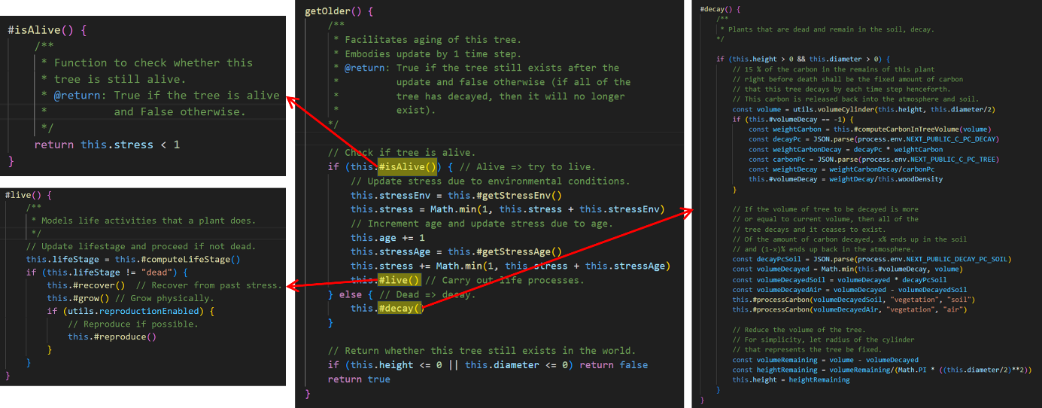

Figure 49. Tree class getOlder() and nested functions.

#### **Class – Simulation**

An object of this class serves as the gateway to the entire simulation model, coordinating all other objects and implementing the time step mechanism via two functions: takeTimeStep() and goTo(…). The takeTimeStep() function updates all simulation objects to step forward in time by 1 year, as shown in the following code snippet. It is triggered by goTo(…), which is crucial for timeline navigation.

#takeTimeStep() {

      /** Step forward in time by one step. */

      this.#resetYearExpenses()

      const rotationUpdated = this.#updateRotation()

      this.#executePlans(this.time)

      this.time += 1

      this.env.takeTimeStep()

      this.resources.ntfp.updateAvailability()

      this.resources.recreation.updateAvailability()

      this.#updateExpenditure(rotationUpdated)

      this.#generateIncome(rotationUpdated)

      this.promptTargetMetCheck()

this.#recordData()

}

The goto(…) function takes target year as input, computes no. of timesteps between the current and target year, and updates system state accordingly. If the target year is ahead of current simulated year, takeTimeStep() is called as many times as necessary to advance the simulation until simulated year = target year. If it is behind, the simulation is reset with createFreshWorld() before advancing.

The updateSimUI() function refreshes the UI after each time step to reflect state changes. When the learner presses play or a next/previous step button on the Timeline, a loop advances the simulation by 1 year every 100 milliseconds, creating a smooth animation of the microworld changing over time. The sequence diagram in Figure 50 illustrates processes executed when the user advances the simulation by 1 year.

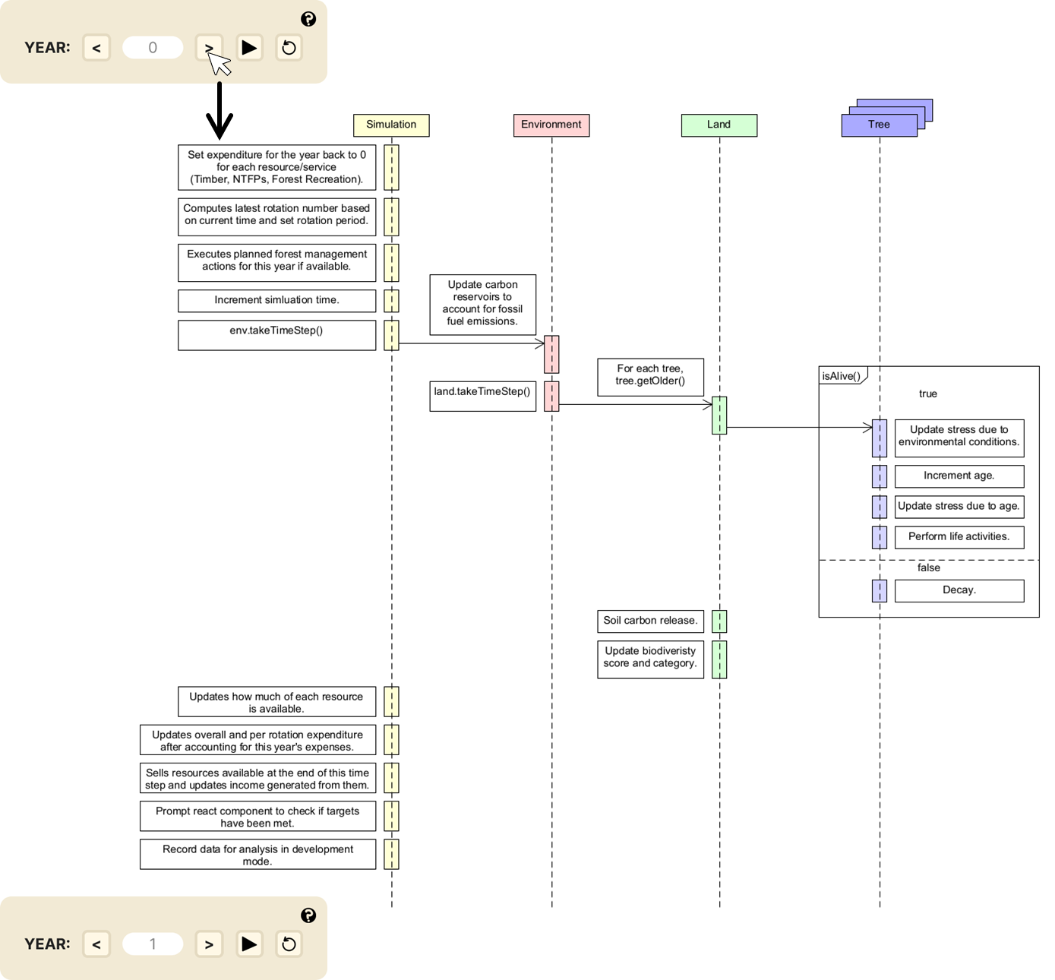

Figure 50. Graphical display of event flow within one user initiated timestep.

## Summary

This chapter covered project scope, pedagogical approach, HCI design, system design, and technical design choices. Throughout, collaboration with domain experts in education technology and natural sciences ensured correctness of underlying simulation model and effectiveness of MycroForest as a teaching tool.

Project scope included developing a user-friendly interface that provides realistic cause-and-effect simulations of forest management strategies on land composition and atmospheric CO2 levels, excluding detailed biochemical processes. The tool supports learning through gamification, where users set and achieve goals related to CO2 levels and income generation. Functional and non-functional requirements prioritized user experience, educational value, and system performance.

Pedagogically, MycroForest integrates elements from simulations, microworlds, and games to enhance learning. It supports constructionist self-regulated learning (SRL) by allowing users to explore and manipulate variables to design and evaluate custom forest management plans.

Research highlighted the importance of good UI and UX for effective learning. Therefore, MycroForest's design followed good HCI (Norman’s Model, Nielsen's Usability Heuristics) and data visualization principles. This chapter discussed design of key app pages, UI interactions, and associated rationale. Data visualization theory considered was also discussed w.r.t what data was visualized, why, and how.

Under the hood, MycroForest is a standalone, client-side static web application with no separate backend or database. Its system architecture comprises 3 main components: the simulation model, UI components, and input variables. The simulation model, explained in this chapter in detail with associated research and design logic, manages all microworld entities and oversees the flow of money and carbon. Key input variables and the organization of UI components were also discussed.

Technical design of MycroForest is structured around reusable React components promoting modularity. System and codebase design followed good software design practices like the model view controller design pattern, separation of concerns, object oriented programming, single source of truth and don’t repeat yourself. The tech stack incorporates frameworks like NextJS and ReactJS along with classic web technologies like JavaScript. A Continuous Integration and Continuous Deployment (CICD) pipeline facilitated by GitHub (for version control) and Vercel (for deployment). Notable coding choices and simulation model class diagram was also explained in this chapter.

Overall, design, architectural, and technical decisions discussed in this design chapter ensures that MycroForest is both user-friendly and technically robust, providing a smooth and effective learning experience.

# Implementation

This chapter discusses development methodology and some challenges faced.

## Development Methodology

The development of MycroForest followed an Agile methodology. It was an iterative process comprising 3 broad stages, planning, building, and deployment with research conducted as and where required. Typically, an iteration would involve a whiteboarding phase, then a more concrete visualization stage, followed by coding.

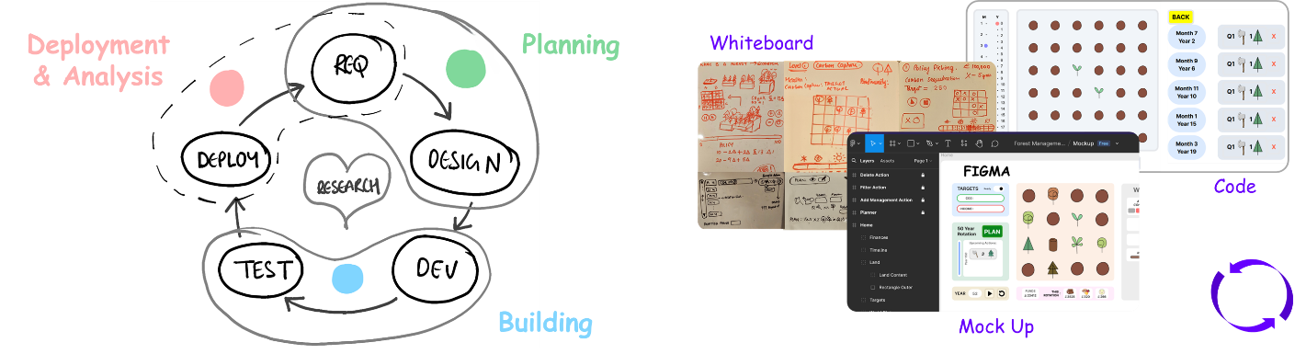

Figure 51. Agile strategy and iterative workflow.

Agile is a popular process management strategy adopted by several teams worldwide with great success resulting in measurable (profits, success rates, etc.) improvements in productivity [137]. Main associated advantages include greater flexibility (frequent changes allowed), lower risk (complex projects broken down into smaller parts), better communication (greater inter-team and team-client collaboration) and increased client satisfaction (focus on frequent delivery keeps end-user informed, interested and able to provide frequent feedback). While applicable in a no. of domains like business and logistics, agile is also widely adopted in software development [138].

There exist many flavours of Agile like SCRUM, KanBan, and XP, [138] but the Agile strategy itself is a broad set of ideas originally laid out in the [Official Agile Manifesto](https://agilemanifesto.org/principles.html). Here, the overarching aim is to “deliver working software frequently”, “welcome changing requirements”, and regularly reflect on how to improve effectiveness, all the while paying “attention to technical excellence”.

Established Agile frameworks (SCRUM, KanBan, XP) expect adherence to clearly laid out steps. They are aimed at medium-large teams in corporate settings. Considering this academic, single developer project, the decision was made to adopt a more general Agile methodology, especially since other academic commitments were expected to interfere with ability to diligently stick to steps in an established framework.

Adopted 3-stage strategy (planning, building, analysis, research), although simple, still adheres to Agile ideology because it allows for frequent delivery of project artefacts and/or working software as well as encourages regular project evaluation. Features to be implemented were broken down into small parts and added to a list resembling a product backlog (inspired from Scrum) wherein features were checked off after implementation and testing. Table 22 provides a glimpse of a portion of this product backlog table. It helped prioritise and stay focused. Meetings with the supervisor and/or co-supervisor were organized every 2 to 3 weeks, sometimes every week, almost regularly throughout, except for holidays/exam periods. Efforts to ensure delivery of new valuable project artifacts (e.g. simulation concept model update, UI mock-ups, etc.) or developed working features at each meeting was largely successful. Regular feedback so obtained, pending functional requirements, and bugs discovered during testing of an integrated feature, fed into creation of new tasks in the product backlog table.

|  |  |  |  |
| --- | --- | --- | --- |
| **Task** | **Effort**  (3 > 2 > 1) | **Importance**  (3 > 2 > 1) | **Status** |
| Add button response. | 3 | 1 | To Do |
| Update biodiversity score to promote mixed ages. | 3 | 3 | In Progress |
| Help as "info" buttons. | 3 | 3 | Done |
| New growth while decaying. | 3 | 2 | Done |
| Disable key press until intro is complete once first started. | 2 | 1 | Done |
| Help page visited leaf. | 2 | 1 | Abandoned |

Table 22. Portion of product backlog like list of tool features maintained during development.

Throughout development, GitHub was used for version control, and it was linked to the web application hosting platform Vercel, to set up CICD such that every new feature pushed to GitHub, triggered deployment of a new version of MycroForest.

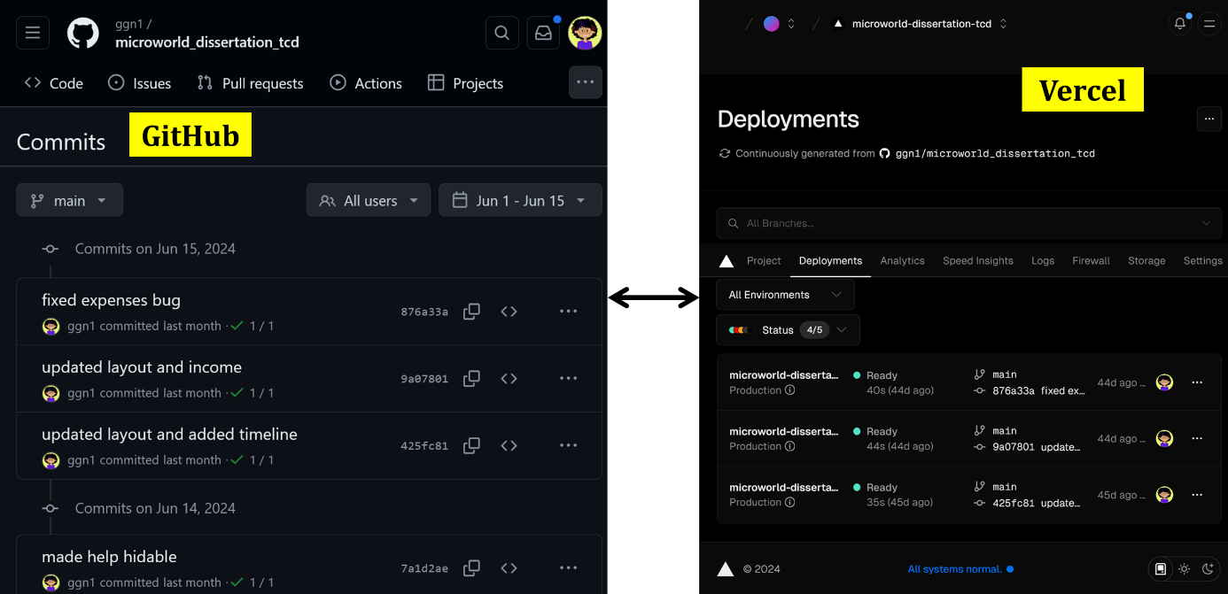

Figure 52. GitHub - Vercel CICD.

## Project Timeline

Figure 53 displays the rough project plan created in December 2023 (coloured Gray) beside the actual schedule followed throughout this project (coloured green).

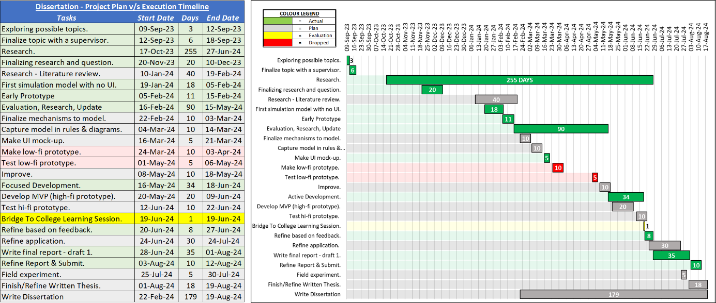

Figure 53. Project Timeline - Plan versus Actual. Gray colour represents the original plan. Green colour is associated with the actual task execution. Red indicates originally planned tasks that were dropped, and yellow highlights the Bridge2College learning session when students used and evaluated MycroForest. Please find a higher resolution image of this project timeline in Appendices 8.14.

Only 2 of all originally planned tasks, (i) the task of making a low fidelity prototype (e.g. a board game equivalent of the tool using pen, paper and carboard) and (ii) testing it, were skipped (coloured red) in favour of directly trying to create a limited capability, early prototype of MycroForest in software. This was because the simulation model was too complex to keep track of manually, and trying to build parts of the application as software from the get-go was an excellent early opportunity to test viability of ideas and technology choices. All other planned tasks were executed.

There are differences in task duration and order between the estimated and real schedule. This is because, when drafting the schedule, it was not possible to be certain of the amount of research required and the amount of time that would need to be dedicated to other modules comprising the MSc. Computer Science program at TCD. The research or literature review task, contrary to the original plan, spanned almost the entirety of this project. This is because, given the interdisciplinary and experimental nature of this project ongoing research was necessary to support decision making throughout the project timeline.

Information regarding actual dates and no. of days spent on tasks, and the order in which they were completed were gathered from GitHub commit history. All activities related to this project is available on GitHub spanning 2 repositories (Appendices 8.2). The first repository contains primarily documentation along with the early prototype. When the decision was made to re-organize the codebase in order to better adhere to good SW design principles thereby making the code more flexible, maintainable, and less rigid, a new project was created within a new repository which contains the current version of the app. The starting date for the research task was obtained by examining the date of creation of research material downloaded on the local machine.

Following paragraphs briefly state key activities that comprised notable periods of development along with images displaying associated outcomes.

**(19 Jan 2024 – 05 Feb 2024):** Development began with simulation model v1, which initially had air CO2 levels, temperature, and water as environmental stressors. Land plot was to be split into 4 quadrants to mirror real-world forest sub-plots. The model was to simulate time in days, months, and years, factoring in seasonal temperature variations. Timber demand was to be the primary target that users set and tried to meet.

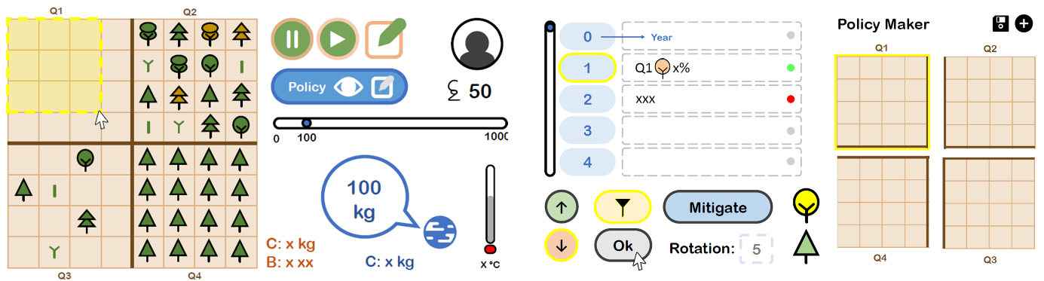

Figure 54. First mock-up of the tool made using MS PowerPoint.

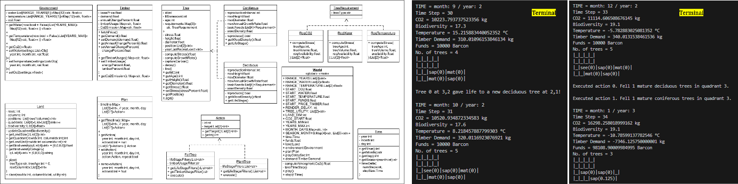

Figure 55. Initial simulation conceptual model and rudimentary printed terminal output of land changing land content and environmental parameter values.

**(28 Jan 2024 – 03 Feb 2024):** Implementation of forest growth as part ofsimulation model v1 is complete. However, all logic is in a single World component with no SoC. There are no global variables that store model hyperparameters and separate them from rest of the program. Output is printed on the terminal. There is no UI. Also, the management plan is coded as a list with a nested list for each day in simulated time.

**(04 Feb 2024 – 05 Feb 2024):** Forest management actions (plant, fell) have been implemented. Time step duration was changed from day to month as the former presented very slow simulation updates. The forest management plan is now coded as an object with ${month}-${year} keys mapped to a list of actions only for every month that has at least one planned action. This is more memory efficient.

**(06 Feb 2024 – 15 Feb 2024):** A UI is developed to complete the early prototype. All simulation processes work as expected. Target setting and user interaction apart from timeline controls is yet to be implemented. No alternate income streams. All logic is still in one World component although there is a separate file for simulation hyperparameters.

**(16 Feb 2024 - 15 May 2024):** Early prototype is analysed for efficiency and scope of improvement. The decision is made to re-implement it, this time, more closely following good design principles as previously discussed in section 3.5.3. The tool was simplified. Research informed better simulation model hyperparameter values and helped determine parts of the original conceptual model to retained versus discarded. Key decisions made includes the following.

* Let time step = 1 year.
* Introduce other income streams.
* Focus on CO2 as only explicitly modelled environmental stressor w.r.t tree growth.
* Get realistic simulation model hyperparameter values.
* Introduce lumber carbon reservoir.
* Add plan viewer on home page.
* Add landing page, help icons, help page.
* Display income and expenses in its own panel.
* Let CO2 concentration be main climate change indicator.
* Introduce fossil fuel usage emissions and fossil fuels carbon reservoir.
* Create a UI mock-up.

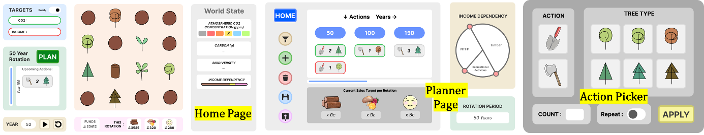

Figure 56. More complete mock-up made using the [Figma](https://www.figma.com) application.

**(16 May 2024 - 26 May 2024):** A new GitHub project hosts the improved codebase with a stronger, more practical conceptual model and UI. A stable (forest survives, atmospheric CO2 level fluctuation is less extreme) carbon cycle was achieved. Plant growth model along with the timeline panel, CO2 panel, carbon distribution panel, and biodiversity information panel, was implemented. Planner page does not exist. Simulation model is object oriented.

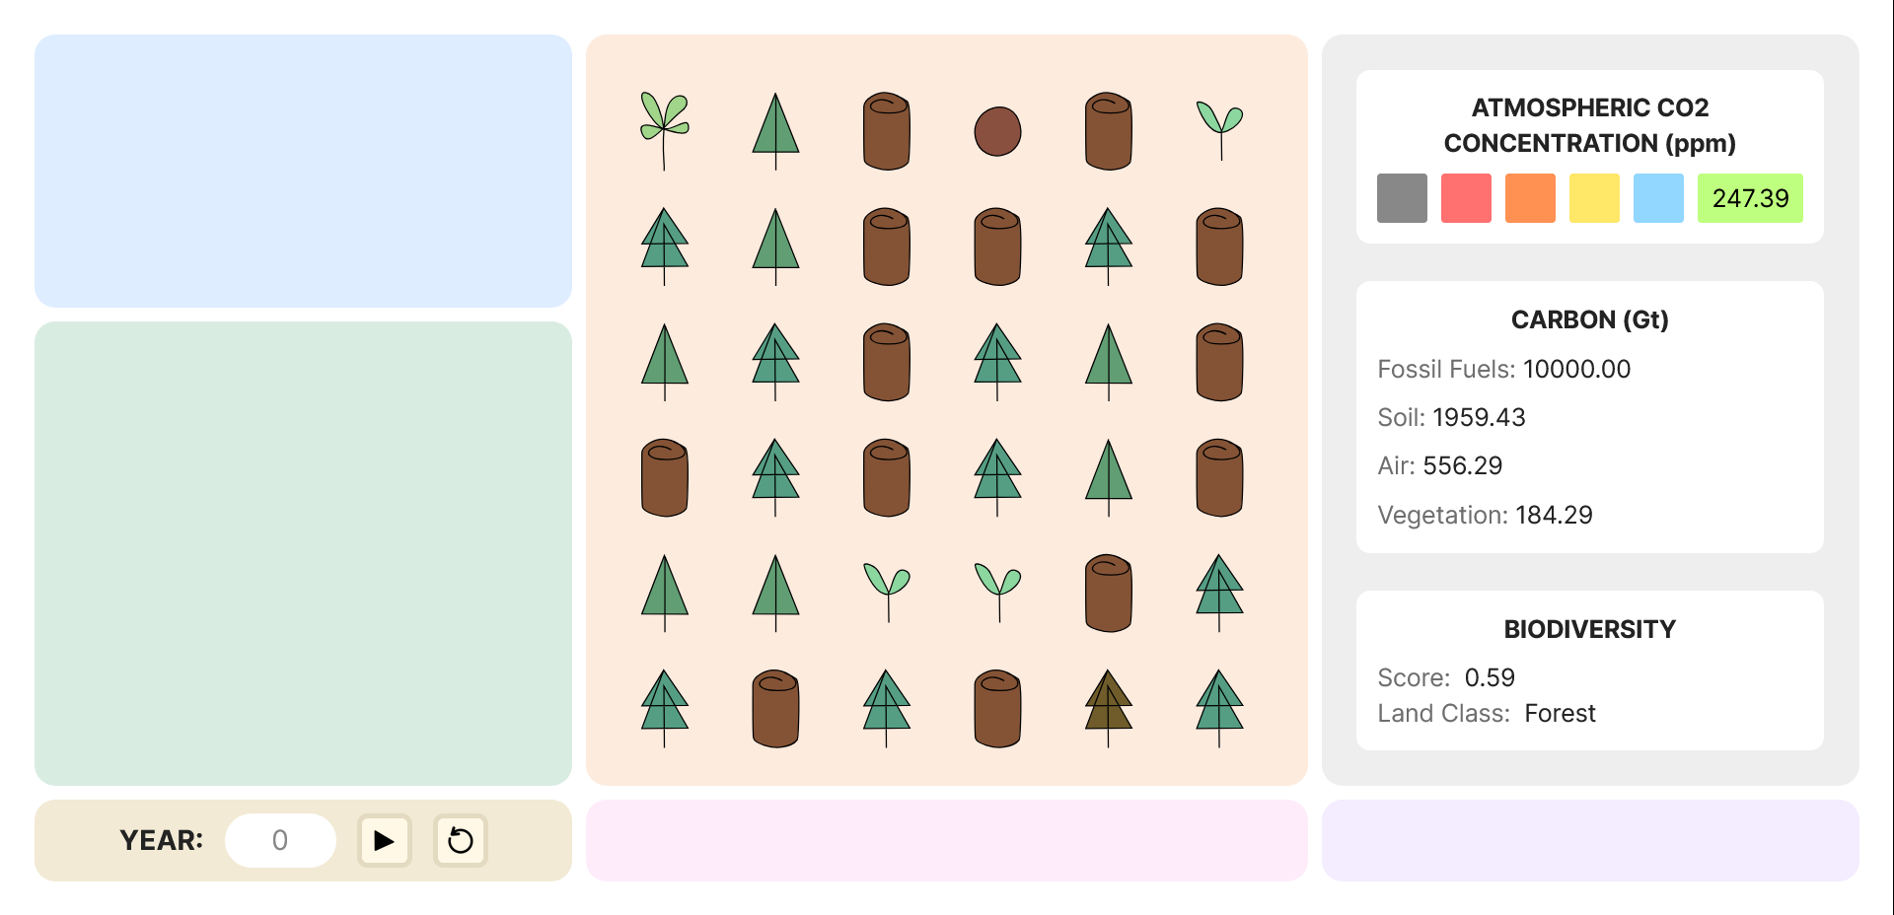

Figure 57. Output after initial stage of home page implementation using re-defined conceptual model and UI design.

**(27 May 2024 - 1 June 2024):** Target setting and monitoring is complete. Management action picker UI components and basic features like action creation or deletion is done.

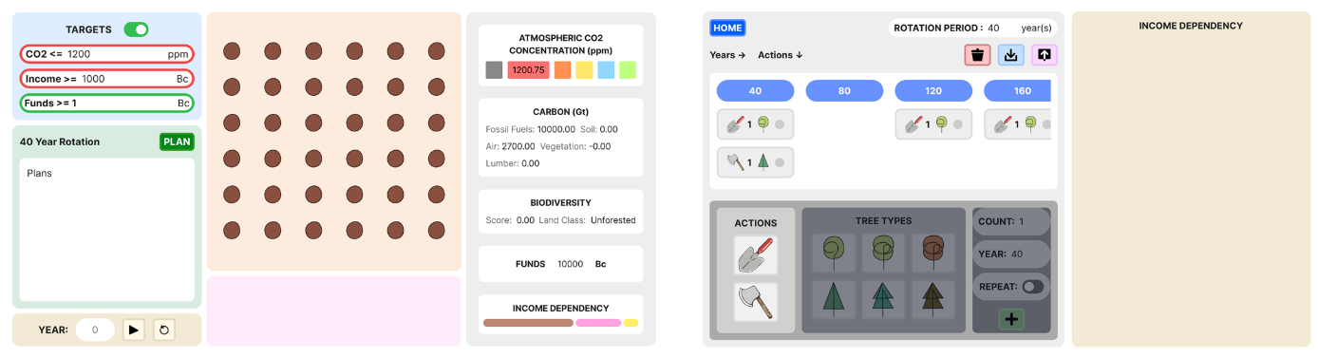

Figure 58. Output of the phase wherein implementation of the planner page had begun.

**(02 June 2024 – 11 June 2024):** Landing page is added. Other income streams are incorporated. All home page panels are implemented. Selective panel reveal to enable model progression across challenges added. All implemented features are fully working.

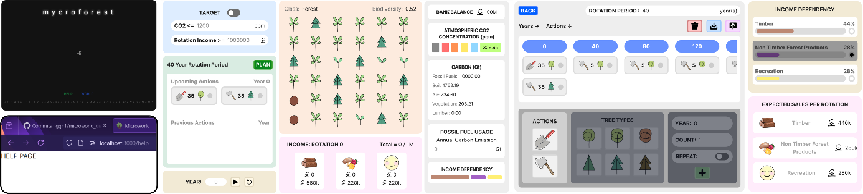

Figure 59. Preliminary complete implementation of all planned features and pages.

**(12 June 2024 – 18 June 2024):** Simulation model parameters more realistic upon further research. User guides in the form of easily accessible  icons and a help page is added. A 5 minute introductory video (Appendices 8.16) is created to quickly inform learners of tool features at the Bridge2College learning session on 19th June 2024. Initial form of virtual currency called “Barcon ” is replaced with the simpler, more universal “coin ”. Money viewer is implemented. It is made possible to step through the timeline one year at a time via addition of single time step buttons  and .

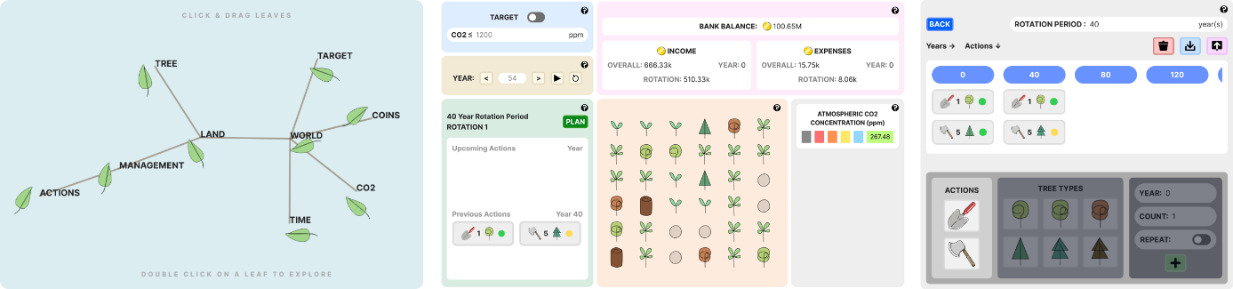

Figure 60. Version of the application that students in the Bridge2College program evaluated. The current implementation is almost identical to this one with only minor changes as per feedback. Students only attempted 2 of the 5 challenges. Hence the image only depicts those features that were visible to the students over the 2 challenges.

**(20 June 2024 – 27 June 2024):** Tree age information is now visible upon hovering over land content tree icons and colour is used to distinguish between seedling and sapling icons of different species in response to learner and evaluator feedback. Text and graphics in user help guide is made simpler and more comprehensive. Other income stream activation is made binary instead of continuous between 0 and 100% as it was realised that the latter approach is unrealistic (i.e. just because a forest owner plans to rely on NTFPs for only 5% of their target income, would they not still harvest and sell if more than 5% worth of income is available as NTFPs). Forest owners either fully committing to an income stream or not considering it at all (binary activation) is more realistic and easier to comprehend. A new option to view income stream based breakdown of "income" and "expenses" in the money viewer is implemented. An attempt was made to consider the ocean as an additional regulator of the carbon cycle by introducing water as another carbon reservoir to make the model more realistic. This however proved to be extremely challenging due to complex chemistry (air-water carbon exchange is complicated given the need to model partial pressure of CO2 in air and water; moreover, carbon is present in multiple carbon cycle relevant non-gaseous forms in water [139], that needs to be modelled accurately for stable model behaviour.

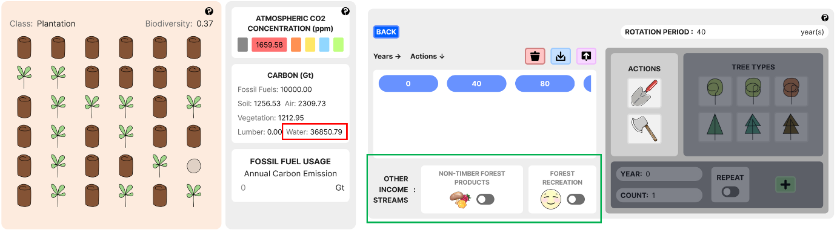

Figure 61. Output showcasing attempt to incorporate the “water” carbon reservoir and the change of income streams from continuous quantitative to binary activation.

**(28 June 2024 - 1 Aug 2024):** Trying to include the water carbon reserve led to high model instability (atmospheric CO2 levels fluctuated very quickly). Thus, this idea was dropped given that it only served to further complicate the model with no added educational value. Code base was cleaned to removed unused components. More comments were added to improve understandability. This was end of active development. Focus shifted toward preparing this document.

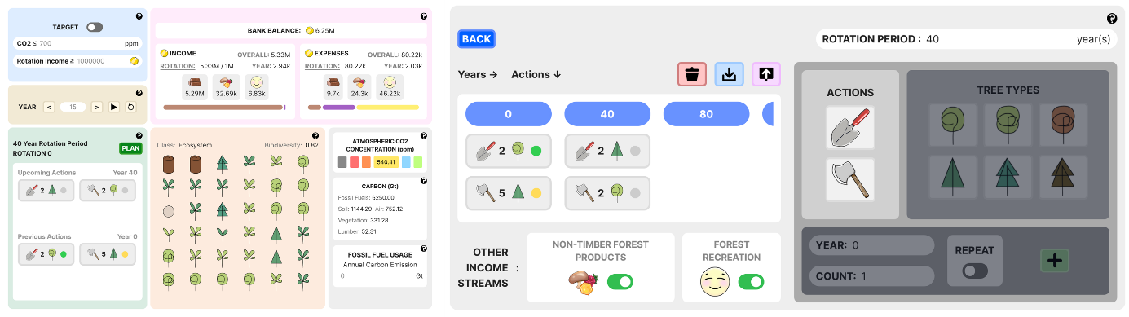

Figure 62. Home and planner pages of the final complete application at the time of submission (challenge 5 view).

**(3 Aug 2024 - 15 Aug 2024):** Refinement of this document and submission.

## Challenges Faced

Several challenges were faced during this project. Following paragraphs highlight a few.

#### **Complexity Management**

**Challenge:** A major challenge was finding the right level of complexity for the tool. As advised by the supervisor, beginning with creative, divergent thinking, ideas were too grand for scope as expected, so convergent thinking followed, which narrowed down ideas to what could realistically be achieved. Determining parts of initial broad ideas (Appendices 8.10) to retain versus discard, was challenging.

**Solution:** The solution focused on retaining only elements directly related to afforestation/deforestation, carbon levels, and forest income. Guided by research and a domain expert, many ideas were discarded (e.g. trees getting diseases, detailed land properties like slope/elevation, disaster mitigation management action, etc.) and others were simplified (e.g. trees categorized as “coniferous” and “deciduous” instead of specific species). This ensured that the tool remained focused on the educational goal of illustrating connection between forests, CO2 levels, and financial motives behind deforestation, without overwhelming young learners.

#### **Other Income Streams**

**Challenge:** When looking for income streams other than timber to incorporate within the application to educate about alternate means of income from forests other than wood sales, hunting/fishing and carbon offset credits were considered alongside NTFPs and forest recreation. Presenting too many options can confuse/overwhelm learners. Thus, it was decided to pick 2 other streams to complement the default timber income stream. Determining which among the 4 identified options to retain, was challenging.

**Solution:** NTFP and forest recreation income streams were retained.Hunting/fishing was dropped as according to the domain expert, in the real world, this is often overexploited causing biodiversity loss and forest health decline. Hence, presenting income generation from hunting/fishing permits as sustainable/climate-friendly, was deemed inappropriate. Projects like a Reduced carbon Emissions from Deforestation and forest Degradation (REDD+) [140] one, as may be applied to the virtual forest in MycroForest, can earn 1 carbon credit per tonne of CO2 or equivalent GHG that it stores, reduces, or avoids from entering the atmosphere. These credits may be sold to companies who claim it to have compensated for their carbon emissions [141, 142]. While intended to promote carbon neutrality, effectiveness of carbon credits is debated [142, 143]. High integrity carbon offsetting is notoriously difficult to ensure as verifying project effort validity, estimating amount of carbon offset (unintentional or intentional under/over estimation possible) and determining accurate baseline emissions that would have been emitted were it not for the project, is very difficult to do. Thus, carbon credits are often “junk” (i.e. void) due to projects failing to sequester agreed amount of carbon, overstating amount of carbon offset or the credit having already been used to compensate emissions elsewhere. Moreover, there is the issue of “offset and forget” wherein the very real possibility that bought credits re-enter the atmosphere sooner than estimated, is ignored. Thus, carbon offsetting is often considered an “accounting trick” that is likely to lead to more harm than good w.r.t climate change by encouraging buying carbon credits and continuing to emit GHGs instead of real decarbonisation efforts like switching to renewable energy. Negative impact of carbon offsetting is aggravated given the fact that a large portion of carbon credits is likely junk, meaning that net effect is increase in GHGs [140, 141]. Thus, the decision was made to avoid presenting carbon offset credit sales as a climate friendly source of income from forests.

#### **Precision Loss**

**Challenge:** JavaScript, the main language for logic of this tool, struggles with floating-point arithmetic and large integers. When handling global-scale numbers (e.g., atmosphere mass = 5.1e+21, carbon in fossil fuels = 6.25e+18, etc.), computation errors and NaN values occur.

**Solution:** This challenge was overcome by storing very large/small numbers as Big objects made available by the Big.js JavaScript library which allows arbitrary precision computation in JS by representing numbers as objects and providing methods for accurate arithmetic operations using them. Variables like fossilFuelEmission, airMass, income, funds, and carbonWeight are represented using Big objects.

#### **Land Content Icon Transition**

**Challenge:** Forest composition changes in response to learner actions should be visualized smoothly. I.e. a sapling icon should morph into a mature tree icon. Using separate images for each land content type icon and replacing one with the next, created choppy transitions, leading to poor UX which could distract learners.

**Solution:** Icons were defined using properties of a single SVG <path> element. By changing d, scale, and fill properties of this element and using transition().duration(50) functions from D3.js, fluid morphing of icons representing different stages of tree growth was achieved.

#### **Tree Composition**

**Challenge:** Earlier, coniferous trees dominated land after the 200-year warmup period, regardless of initial composition. This unrealistic outcome made the simulation less suitable for educational purposes, as according to the domain expert, such dominance was unlikely given assumed ideal conditions and initial seedling mix.

**Solution:** It was realised that frequent single-species dominance could have been due to the model's failure to consider seed dispersal distance. Deciduous trees, with seeds dispersed further by animals due to wide-appealing fruits produced, were not accurately represented. A new rule allowed deciduous trees to spawn seedlings up to 2 positions away, while coniferous trees still only spawned seedlings immediately adjacent to the parent tree. This adjustment gave shorter-lived deciduous trees a fair chance to compete against longer-lived coniferous trees, ensuring coexistence of both species. This modification is one example of how the model was progressively made more reflective of reality.

#### **Rule Organization**

**Challenge:** Organizing and maintaining a simulation conceptual model with complex and interconnected rules is a significant challenge. When all world rules were initially in a single document, it became overwhelming and difficult to navigate. This complexity led to difficulties in tracking dependencies, understanding the relationships between different topics, and identifying problems such as missing/cyclic relationships or logical flaws, difficult to detect.

**Solution:** This challenge was addressed by using Obsidian software to organize documentation in interconnected files (a personal web of hyperlinked knowledge), enabling easy navigation between topics. This helped develop a better mental model of the simulation conceptual framework.

#### **Simulation development.**

**Challenge:** Developing a realistic simulation model for educational use is challenging due to the complexity of capturing forest growth and carbon flow. The process involves numerous decisions, from conceptual parameters to implementation. It is important to ascertain if the model is accurate enough to serve the desired educational purpose.

**Solution:** The solution to ensuring sound simulation design was to follow a simulation development framework, appropriate for a HS model as in MycroForest. In 2018, T. Eldabi et. al. adapted the Simulation Lifecycle design and implementation framework first proposed by Brooks and Robinson in 2000 in their work “Simluation”, to work with HS approaches [54]. This iterative framework comprising following 5 stages was followed to bring structure to simulation design.

**Stage 1:** *Real-World Problem* – The goal here, is to understand the real-world problem, identify the target system, and pinpoint key components/mechanisms. The “application area” (broad focus) and “application context” (specific focus) are to be defined. W.r.t MycroForest, application area is “forests and climate change,” and application context is “effects of forest management activities on air CO2 levels” [54].

**Stage 2:** *Conceptual Modelling –* This stage involves abstract representation of the target system, capturing “objectives, inputs, outputs, content, assumptions, and simplifications”. Output of this stage could be a document with model components, mechanisms, and underlying rules, clearly defined. This stage involves working closely with domain experts to validate designs. In this project, multiple versions of a “world rules” document was produced and discussed with the domain expert co-supervisor to ensure design soundness. Section 3.4.1 above, explained the current such conceptual model in detail [54].

**Stage 3:** *Computer Modelling* – Now, the conceptual model is translated into a computational model involving coding, modelling paradigm integration (e.g., discrete-event simulation, agent-based modelling, and object oriented design in case of this project.), and preparation for experimentation [54]. Section 3.5 explains the latest technical design.

**Stage 4:** *Verification and Validation* - This stage involves experimentation (e.g. model hyperparameter tuning) and investigation (e.g. running simulations under known conditions to see if expected resulting behaviour is obtained) to evaluate model performance. Stages 2, 3, and 4 are repeated until the model is realistic enough for the specific use case [54]. To validate the MycroForest model, forest management plans with known outcomes were implemented to see if resulting state updates in the microworld matched real-world effects of those plans. E.g. a validation exercise could include setting up the following 4 scenarios in MycroForest.

1. **Scenario:** Chop as many trees as possible in rotations that are 10 years long. Replace all chopped ones with coniferous tree seedlings to create a plantation. **Result:** Overall profit = 123.05 M coins. CO2 concentration remained $≤$ 1040 ppm. Avg. no. of old growth or senescent trees at the end of each rotation = 0 trees. Mean biodiversity score at the end of each rotation = 0.46.
2. **Scenario:** Same scenario as in (i) except that rotation length is 40 years. **Result:** Overall profit = 119.61 M coins. CO2 concentration remained $≤$ 800 ppm. Avg. no. of old growth or senescent trees at the end of each rotation = 0.29 trees. Mean biodiversity score at the end of each rotation = 0.5.
3. **Scenario:** Same scenario as in (ii) except that chopped trees are replaced using equal no. of coniferous and deciduous trees. **Result:** Overall profit = 101.32 M coins. CO2 concentration remained below 830 ppm. Avg. no. of old growth or senescent trees at the end of each rotation = 0.29 trees. Mean biodiversity score at the end of each rotation = 0.84.
4. **Scenario:** No management. **Result:** Overall profit = 0 M coins. CO2 concentration remained $≤$ 495 ppm. Avg. no. of old growth or senescent trees at the end of each rotation = 9.43 trees. Mean biodiversity score at the end of each rotation = 0.78.

Above results reproduced following known observations [26, 27, 30], which suggests that MycroForest’s simulation model is appropriately realistic.

* Older forests diminish as rotation lengths shorten.
* Longer rotation length promotes old-growth forests, enhances biodiversity, and improves carbon sequestration, but wood income is reduced.
* Short rotation lengths result in higher wood harvests but reduces forest biodiversity and carbon sequestration.
* Mixed age and species forests support greater biodiversity.
* Best management strategy for carbon sequestration is “no management”.
* Preserving old trees is essential to maximal carbon sequestration.

**Stage 5:** *Solution and Implementation* – This stage involves incorporating the developed model into the specific solution. Here, developed simulation model + input parameters was incorporated into the rest of MycroForest (UI components, app pages) [54].

## Summary

This chapter outlined practical steps taken to develop MycroForest, beginning with introduction of adopted Agile development approach, chosen for its flexibility and adaptability, allowing iterative development and regular feedback integration. Also provided, is an account of how goals were translated into software, what the application looked like at different stages of development and, some challenges faced.

MycroForest development followed a simple Agile strategy, well-suited to the single-developer, academic nature of this project with 3 stages: planning, building, and deployment. Each stage incorporated research as needed. This enabled frequent delivery of working software and continuous evaluation. Tasks were managed using a product backlog inspired table to track and prioritize them. Regular meetings with supervisors ensured consistent feedback integration into design and development. Version control and deployment using GitHub and Vercel enabled CICD.

Project timeline was initially planned in December 2023, with adjustments made as the project progressed. Some tasks like creating a low-fidelity prototype, were dropped in favour of developing an early software prototype, which provided valuable insights into feasibility of theoretical ideas. The actual timeline differed from the original plan due to unpredictable demands of other academic commitments. Research was conducted throughout the project, as the interdisciplinary nature of MycroForest required ongoing investigation into various aspects of forest management and simulation modelling. The timeline reflects the iterative nature of the Agile methodology, with tasks being revisited and refined to integrate new knowledge and feedback.

Several challenges were encountered during development. A significant one was managing complexity of the simulation model to balance educational objectives with a manageable level of detail. Other challenges included selecting appropriate alternative income streams, handling precision issues in JavaScript, and ensuring smooth transitions between different land content icons. Solutions involved simplifying certain aspects of the model, using JavaScript libraries (e.g. Big.js for precision arithmetic), and employing D3.js for smooth visual transitions.

Implementation of MycroForest was complex, but largely successful. Agile methodology was effective w.r.t iterative development and feedback integration. It accommodated frequent changes that were required to refine the application. Despite challenges, project goals were achieved through careful planning, regular evaluation, and use of appropriate technologies. The current version of MycroForest is a functional educational tool that aligns with most original objectives.

# Testing and Evaluation

This chapter discusses evaluation of MycroForest by TY students (target user base) at the Bridge2College learning session. Student, educator, and domain expert feedback is presented here.

## Pilot Testing

MycroForest was tested by friends/family and educators prior to students at the Bridge2College event. Before educators, it was first tested by friends/family (N=4), all of whom reported a valuable experience with few suggestions as follows.

* Initially, the landing page did not have text reading “CLICK” to prompt learners to click on “Hi” to begin the click-through walkthrough. 3/4 testers failed to click this text without assistance. This led to inclusion of a “CLICK” prompt text as suggested.
* Further, 4/4 testers were inclined to press "H" or "W" keys during the introduction, to navigate to the "Help" or "World" page, interrupting the click-through walkthrough which contains important information. To address this, a feature was added that blocks navigation and requires learners to complete the brief introduction (if it's their first time taking it) before moving to other pages.
* At first, help was not as comprehensive. Testers expressed need for more details in the user guide like information about the different tree life stages, income streams, carbon reservoirs, etc. Help was thus, expanded with added images as well.

MycroForest was then reviewed by 2 educators who were to conduct the learning activity at the Bridge2College event, as well as the project supervisor, to assess tool readiness/suitability w.r.t providing a valuable interactive learning experience (educator review 1). Upon integrating feedback so obtained, an improved version was presented again, to the lead educator, (educator review 2) who then approved it for use at the Bridge2College learning session.

During educator review 1 on 14 June 2024, the app (as in Figure 63) was deemed promising but required UI updates and simpler learning activity challenges.

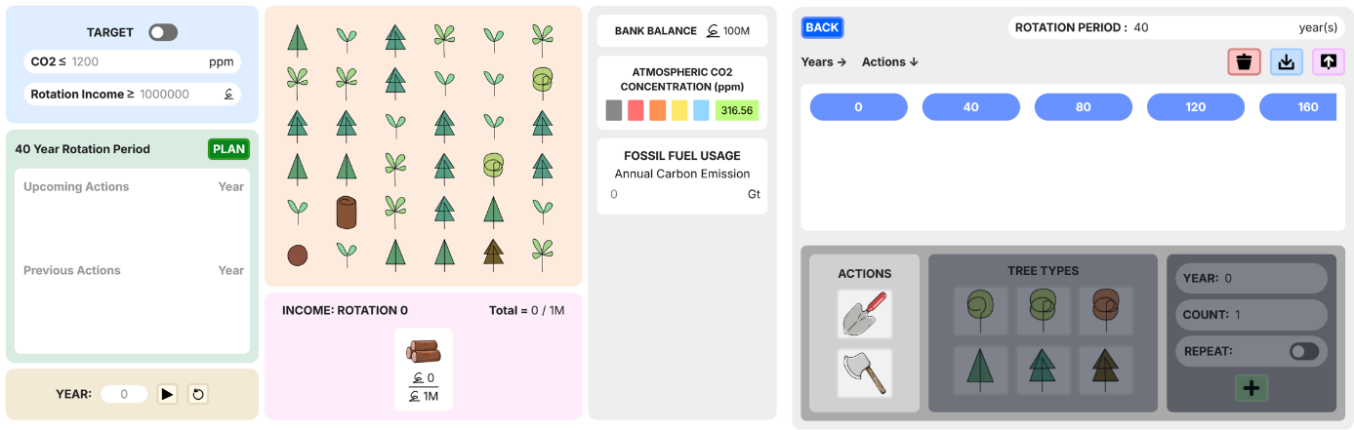

Figure 63. Version of MycroForest first presented to facilitators.

Figure 64 shows the 3 challenges initially proposed by this author as learning activities.

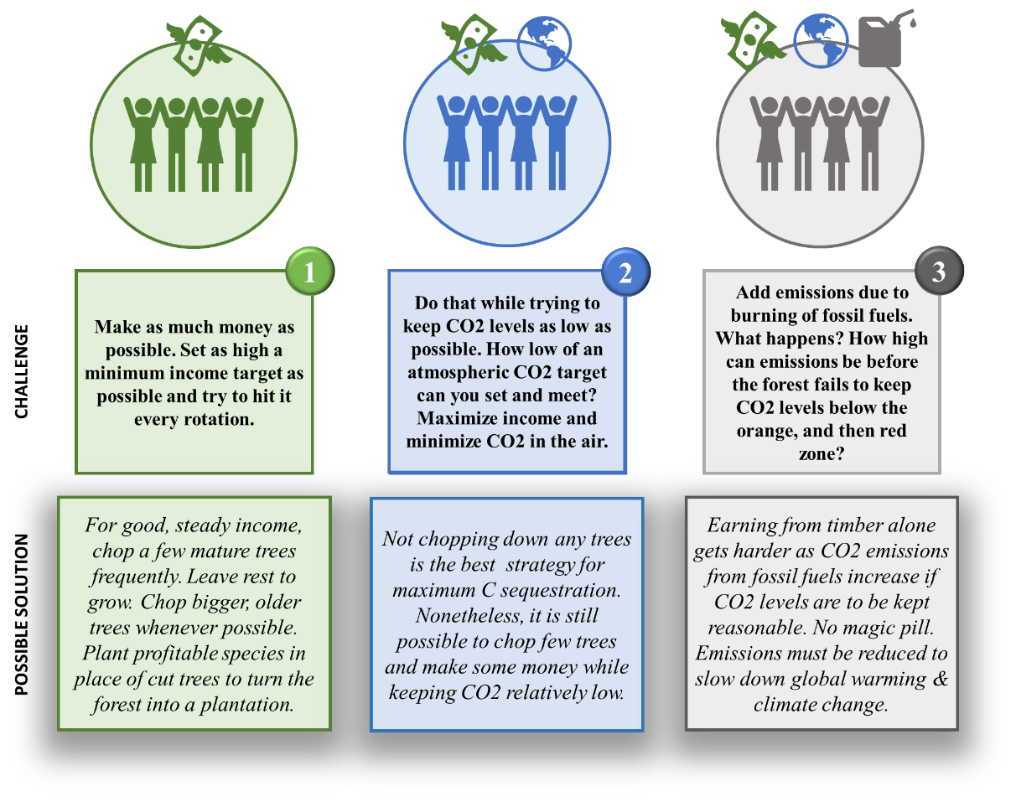

Figure 64. Initial challenges proposed for Bridge to college learning activity.

While educators appreciated scope for multiple learning activities using the tool, they also pointed out that challenges, although not considering other income streams, may still be too complex for a 2 hour session, and so, should be simplified. Other suggestions were UI related as follows, all of which were implemented prior to the learning session.

* The colour of empty land icon  resembles that of the dead tree icon . This may be confusing. Thus, the colour of the empty land icon was changed to .
* Fictional currency in the microworld, was Barcon . It was deemed that this may be hard to relate to and might distract learners. Hence, it was suggested that it be swapped for the simple, universally relatable idea of coins  to represent money.
* It was suggested that the income per rotation target setter 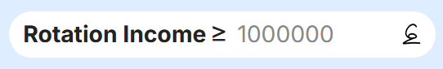 be hidden as it is more interactive for the learners to try and manually note down incomes per rotation and compare those values against that of peers. Also, learners may initially be interested in overall income only. Thus, the income per rotation target setter, for starting challenges may be too complex and distracting a feature.
* There were no buttons to take 1 year time steps. This was to be added as while 1 year stepping was possible by typing years into the text box, this is cumbersome.
* Viewing information about trees/land content upon hovering over icons on land was not possible. This feature was planned but not prioritised. An educator pointed out that including it is important since it may save reference material lookup time.
* Similarly, at the time, only the help page was implemented. Readily accessible, help  icons were not yet added. It was suggested this be included ASAP for better UX.
* Lastly, it was not possible to add management actions in years within a rotation period. It was suggested that learners be granted this option as it is more intuitive and reflective of real world practices (although management actions are often planned in rotations and executed at the start of each rotation, forest owners may still choose to perform certain actions in between rotations).

All above points were addressed. Challenges were updated and broken down into 5 simpler ones as was discussed in section 3.2. Of these, given the 2 hr time limit, students only attempted the first 2 (Table 23) at the Bridge2College workshop.

|  |  |  |
| --- | --- | --- |
| **Challenge** | **Goal** | **Active Features** |
| 1 | Maximize income from the forest. | Timeline, Land, Money Viewer, Plan Viewer, Planner, Timber Income Stream |
| 2 | Keep atmospheric CO2 concentration at as desirable a value as possible. | Challenge 1 Features + CO2 Target Setter + CO2 Scale - Money Viewer |

Table 23. Challenges undertaken by transition year students at the Bridge2College workshop.

After all suggestions were addressed, the lead educator took another look at the tool (Figure 65) on 18 June 2024, a day prior to the learning session, and approved it for use.

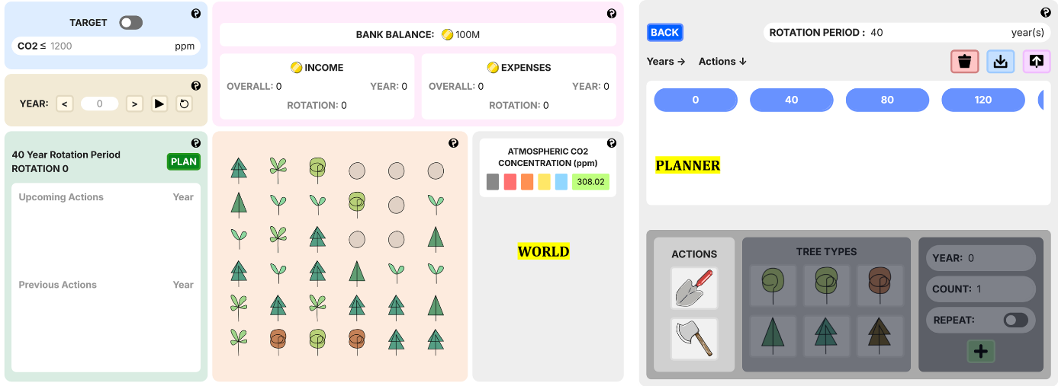

Figure 65. MycroForest as viewed by students at the Bridge2College learning session.

## Bridge2College

The Bridge2College (B2C) programme is an out-of-school education initiative part of Trinity Access Programmes (TAP) at TCD. It aims to help develop 21st-century skills in Transition Year students from the Irish secondary school system. The program involves workshops where students engage in collaborative, project-based, and technology-mediated learning, focusing on skills like communication, critical thinking, and use of technology, with the goal of boosting confidence in these areas [144].

The particular learning session as part of the B2C workshop wherein MycroForest was used, was held during the summer break. Thus, attendance was lower than usual. Of the large no. of students who attended the B2C workshop on the day, 10 students interested in Computer Science, took part in the learning activity using MycroForest.

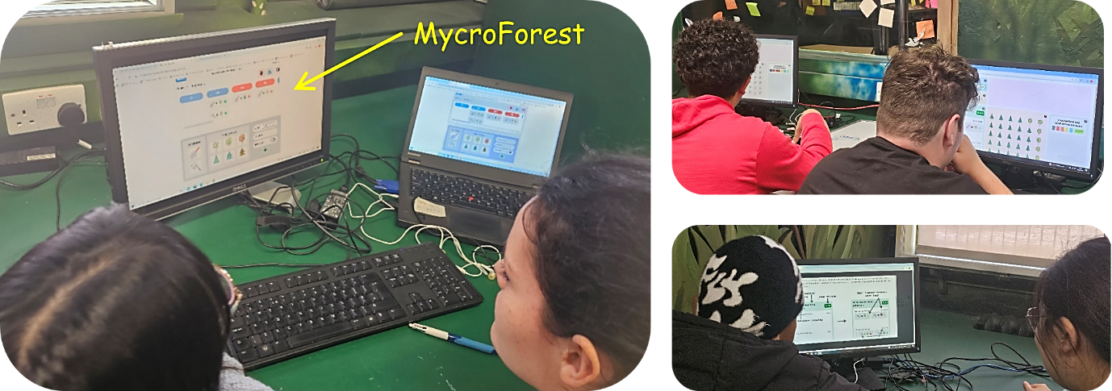

Figure 66. Students interacting with MycroForest at the Bridge2College learning session.

The teaching tool proposed was presented at a 2 hour learning session as part of the B2C workshop to students (N = 10) interested in Computer Science where they discovered the possibility of interdisciplinary (software engineering, forestry, botany, teaching, climate change) application of Computer Science skills through the example of MycroForest. Additionally, using the tool, they had the opportunity to learn about forestry, sustainable forest management, and the importance of forests in slowing down climate change. As part of the learning activity described below, students attempted 2 challenges in teams and tried to outcompete each other in highest income earned (challenge 1) and lowest atmospheric CO2 level achieved (challenge 2).

Learning Activity:

1. Introduction (short welcome and explanation by educators + 5 minute [video](https://drive.google.com/file/d/1fmZnytlSHVmVTtLfOQVJ6j6zXO0tmod8/view?usp=drive_link)).
2. Challenge 1 – Maximize income.
3. Discussion.
4. Challenge 2 – Maximize carbon capture.
5. Discussion.
6. Presentation by this author regarding development of MycroForest with some under-the-hood implementation and approach details that students may find interesting given their inclination towards Computer Science.
7. Questionnaire – UX, educational experience, attitude towards climate change.

## Usability Evaluation

Usability is a critical quality measure of any software application. Most informative of education technology will impart no knowledge if learners find it difficult to use. This section discusses methodology and results of usability evaluation of MycroForest.

Usability is generally assessed based on 3 factors as given below [145, 146].

1. **Effectiveness:** Degree of task completion achieved by users.
2. **Efficiency:** Resources (e.g. time, effort) needed to complete a task.
3. **Satisfaction:** Perceived usability, a subjective measure of ease of use.

The System Usability Scale (SUS) and the Post Study Usability Questionnaire (PSSUQ) are 2 popular tools (questionnaire formats) used to evaluate EduTech usability [146].

### System Usability Scale (SUS)

SUS is a short 10-question survey that provides a quick overview of a software application's subjective usability, using a 5-point Likert scale (1 = strongly disagree, 5 = strongly agree). SUS questions were carefully picked and organized. They were formulated based on questions among 50 questionnaire items that induced most extreme responses in an experiment with 20 people. This is appropriate as Likert Scale responses are considered most suitable ways of measuring responses when corresponding questions provoke extreme expression of attitude. Moreover, SUS structures positive (common response is agreement) and negative (common response is disagreement) questions in an alternating fashion to encourage thinking before answering. The final SUS score (0-100) is calculated as sum of scores associated with each question (0-4) multiplied by 2.5 such that odd numbered questions are scored = scale position – 1 and even numbered questions are scored = 5 – scale position. Overall, SUS is an excellence choice for quick and broad usability assessment [145].

### Post-Study Usability Questionnaire (PSSUQ)

PSSUQ is another usability assessment format with both a long (19 questions) and short (16 questions) version which uses a 7-point Likert scale (7 = most disagreement, 1 = most agreement). Unlike SUS that primarily focuses on measuring satisfaction [145], PSSUQ covers all 3 aspects of usability (effectiveness, efficiency, satisfaction). Another advantage of PSSUQ over SUS is that its score can be expressed in terms of 3 subcategories (questions 1 to 6 = system usefulness, 7 to 12 = information quality, questions 13 to 15 = interface quality) in addition to an overall usability score. This, more detailed breakdown, makes it easier to identify key areas of improvement. Calculating scores for multiple questions in the PSSUQ evaluation framework, simply involves averaging all individual question scores = $\left(\frac{∑ scores}{no. of questions}\right)$ [146]. Overall, PSSUQ is a well-rounded choice of evaluation framework if detailed feedback is required to identify more specific areas for improvement in a system.

### Adopted Questionnaire

PSSUQ has been shown to be effective with small sample sizes [146] as was the case with students available for the learning session (N = 10) due to it having been during the summer break. It is also favoured over SUS if the objective is to obtain more detailed feedback across all usability metrics (effectiveness, efficiency, satisfaction). Furthermore, observing the questions from both frameworks, some questions in SUS appear inapplicable to MycroForest or likely vague to young users. Consider the evaluation item “I think that I would like to use this system frequently”. This is not directly applicable to MycroForest as it is not a tool students are likely to use regularly for extended periods of time. Other evaluation items from SUS like “I found the various functions in this system were well integrated” and “I thought there was too much inconsistency in this system”, are both likely to cause some confusion because identifying features that may be considered as a “system function” and judging whether it was “integrated well” as well as interpreting what “inconsistency” might mean w.r.t to a web app, are challenging tasks that might lead to young learners answering these questions without much thought. Evaluation items in the PSSUQ form have simpler wording and is more straightforward. Thus, the questionnaire that was used to evaluate MycroForest at the Bridge2College program uses questions and the response format from the PSSUQ usability evaluation framework.

Although its pros outweigh its cons, one disadvantage of PSSUQ is that it is longer (up to 19 questions) than SUS (10 questions) [146]. To minimize ill effects like responder fatigue, the shorter version of PSSUQ with 16 questions was considered when creating the post-activity questionnaire for the B2C learning session.

Neither the SUS nor the PSSUQ frameworks have open ended questions. Adding them, gives learners the opportunity to freely express more unique thoughts/suggestions which can provide useful direction for application improvement.

Further, although PSSUQ addresses evaluation of general usability metrics, it is known that no generalized framework can evaluate context-specific metrics associated with a system [145]. Here, value of the tool as a learning aid, is the context-specific metric. So, it may be beneficial to include additional questions that evaluate effectiveness of the application at imparting valuable knowledge and gauge whether a microworld based tool that is expected to be engaging, was indeed so. Additionally, given that the tool tries to raise awareness about climate change, it would also be interesting to note differences in attitude of learners towards this, before and after the learning activity. Thus, 10 questions were added to the MycroForest evaluation questionnaire in addition to the 16 questions from PSSUQ (26 questions in total). 2 of these are open ended, allowing learners to express subjective thoughts more freely. All responses were anonymous. No personally identifying data (contact details, name, school details, etc.) was collected from learners. Please find a PSSUQ template with questions used in the MycroForest questionnaire in Appendices 8.11 [147]. The 10 added questions (questions 17 to 26) regarding educational experience and attitude towards climate change are as follows.

1. This system made me think about responsible forest management and the important role that forests play in keeping atmospheric CO2 levels in check. (Response type = Likert scale from 1 to 7.)
2. I feel like I learned something valuable using this system. (Response type = Likert scale from 1 to 7.)
3. Tools like MycroForest makes learning engaging. (Response type = Likert scale from 1 to 7.)
4. I think a lesson using this tool will be a valuable use of time at school. (Response type = Likert scale from 1 to 7.)
5. What did you like best about this tool? (Response type = Open ended.)
6. How do you think this tool can be improved to further enhance your learning or user experience? (Response type = Open ended.)
7. If you come into possession of a forest, what will you do? (Response type = Open ended.)
8. Please state your one key takeaway from this experience. (Response type = Open ended.)
9. On a scale of 1 to 10, how concerned were you about climate change before this learning activity. (Response type = Likert scale from 1 to 10.)
10. One a scale of 1 to 10, how concerned are you about climate change after this learning activity. (Response type = Likert scale from 1 to 10.)

Please find the complete questionnaire presented to learners at in Appendices 8.12.

## User and Educator Feedback

Questions in the MycroForest evaluation form focuses on 3 main areas: general usability (questions 1-16 from PSSUQ and questions 21 and 22), educational value (questions 17-20 and questions 23 and 24), and attitude towards climate change (questions 25 and 26). Henceforth, these shall be color-coded as "yellow," "blue," and "green" respectively.

Responses per question category by the 10 evaluators (learners) is summarized within the 3 tables below. Please find raw feedback and detailed summary in Appendices 8.13.

|  |  |  |  |  |  |  |  |  |  |
| --- | --- | --- | --- | --- | --- | --- | --- | --- | --- |
| # |  | PSSUQ Analysis | PSSUQ Overall Score | PSSUQ System Usefulness Score | PSSUQ Information Quality Score | PSSUQ Interface Quality Score |  | 21. What did you like best about this tool? | 22. How do you think this tool can be improved to further enhance your learning or user experience? |
| 1 |  | Individual Scores → | 3.3 | 4.0 | 2.7 | 2.7 |  | It was fun | Nothing |
| 2 |  | 2.1 | 2.0 | 2.2 | 2.0 |  | simple & quick | different scenarios |
| 3 |  | 1.6 | 1.2 | 2.5 | 1.0 |  | Tree | More tree |
| 4 |  | 4.2 | 3.7 | 4.2 | 5.3 |  | Deforestation | Idk |
| 5 |  | 1.6 | 1.8 | 1.7 | 1.3 |  | How easy it was to use | Manage money |
| 6 |  | 1.4 | 1.3 | 1.7 | 1.3 |  | The simplicity | Add timing for the trees being planted etc |
| 7 |  | 1.6 | 1.3 | 2.2 | 1.3 |  | How clearly it showed us how forestry affects CO2 emissions | No error messages came up |
| 8 |  | 2.3 | 2.8 | 2.0 | 1.7 |  | it was good, very useful | I do not know |
| 9 |  | 1.7 | 1.3 | 2.0 | 1.7 |  | It was easy to use and very informative | Make it more clear how the years and rotation period work |
| 10 |  | 1.8 | 1.3 | 2.3 | 1.7 |  | The idea of how forestry model worked | The information page is hard to find |
|  |  | Average Score → | 2.2 | 2.1 | 2.3 | 2.0 |  |  |  |

Table 24. Learner Evaluation - Usability related responses.

|  |  |  |  |  |  |  |
| --- | --- | --- | --- | --- | --- | --- |
| # |  | Educational Value Score | |  | 23. If you come into possession of a forest, what will you do? | 24. Please state your one key takeaway from this experience. |
| 1 |  | Individual Scores → | 2.0 |  | Balance CO2 with money | Lower CO2 more air in the atmosphere |
| 2 |  | 1.8 |  | manage it accordingly | the effect trees have |
| 3 |  | 1.0 |  | Not deforestation | Trees |
| 4 |  | 5.8 |  | Chop it down and make some money then buy a yacht | Thumbs up. |
| 5 |  | 1.0 |  | Manage the forest | Climate change |
| 6 |  | 1.5 |  | Research for a good plan to keep co2 low enough and make money at the same time | Comp science can mix with forestry |
| 7 |  | 1.0 |  | Manage the CO2 emissions | The most sustainable way to manage a forest doesn't necessarily affect profits |
| 8 |  | 1.0 |  | try to find the perfect middle ground and think about our world | . |
| 9 |  | 1.5 |  | Plan and manage it to make money while keeping C02 levels low | That it is important to manage forestry beforehand in order to do what’s best for the environment |
| 10 |  | 1.0 |  | Think about my life decisions | Forest are important |
|  |  | Average Score → | 1.8 |  |  |  |

Table 25. Learner Evaluation - Educational value related responses.

|  |  |  |  |
| --- | --- | --- | --- |
| # |  | 25. One a scale of 1 to 10, how concerned were you about climate change before this learning activity. | 26. One a scale of 1 to 10, how concerned are you about climate change after this learning activity. |
| 1 |  | 8 | 8 |
| 2 |  | 8 | 8 |
| 3 |  | 10 | 10 |
| 4 |  | 1 | 1 |
| 5 |  | 8 | 8 |
| 6 |  | 6 | 3 |
| 7 |  | 9 | 10 |
| 8 |  | 7 | 9 |
| 9 |  | 7 | 8 |
| 10 |  | 8 | 7 |

Table 26. Learner Evaluation - Attitude towards climate change related responses.

Feedback about usability and educational value from educators at B2C is as follows.

Lead Educator: “The MycroForest application is an effective and engaging learning tool for students. Students found it easy to navigate and use after a brief explanation and demonstration. The learners were very interested in and engaged with the scenarios presented and were keen to meet the goals we asked them to meet. The tool has layered detail such that it can be adapted to whatever time is available for a workshop or session - while we used the tool for a couple of hours, I could easily design much longer learning activities using MycroForest and would enthusiastically do so given the chance. The group discussions that took place after student interaction with the app were very interesting and made it clear that the learning outcomes had been met or exceeded, despite the fact that most students had no prior knowledge of forest ecosystems, the forestry industry, or the associated impacts on atmospheric CO2. I would happily utilise MycroForest as a learning tool again.”

Educator 2: “I found the students really engaged with the app as the UI and overall web design was quite user friendly and easy to follow. The scale of the simulation allowed the students to get an introduction to forestry and its importance, while also allowing them to imagine its effects on a much bigger, realistic scale. I found the students responding well when they thought of it as a game with goals to reach each time. Through turning a rather complex subject into an interactive activity, the students could easily grasp the concept of forestry, perhaps more so than reading/learning in a traditional classroom setting.”

Educator 3: “I think the forestry app is an amazing learning tool for all ages. It is extremely interactive and provides you with knowledge while still being fun. The students found it very easy to understand how the app works and really enjoyed the challenges that were set! I’m confident that the students understood by the end of the session the overall teaching of the effects of deforestation on our world, and what that could mean for their future.”

Feedback from project co-supervisor, who is a Domain Expert is as follows.

“MycroForest tackles a concept that is critical but rarely explained to the lay public and especially to young learners. We frequently talk about forests as climate solutions but without explaining both how long that takes and what it looks like and what the financial trade-offs are. MycroForest achieves a good balance of complexity and clarity, allowing the learner to quickly grasp what is going on but giving sufficient depth to reflect he real world situation. I was very impressed that learners naturally came up with real-world land management strategies, despite these not being explained, planned or prescribed in any way.”

“There are two main issues that I think could be further improved in potential future iterations, although I want to stress that these do not take away from MycroForest being an excellent learning tool as it is. The first is that of spatial scale – the setup is for managing a forest, yet the learner is shown the global atmospheric CO2 concentration, which is impacted by many other things and larger areas of land. We discussed this multiple times during development and the current implementation was the best we could come up with. Second, there is the implication that making money and reducing CO2 levels are somehow equivalent goals. In the face of the global climate crisis, one might argue that reducing CO2 overshadows all else, and especially for young learners who are very aware of the crisis we are facing and frequently active in the activism space, the way we phrase the problem is crucial.”

Additionally, the author of this document had noted down few ideas from learner discussions at the end of each challenge during the B2C learning session (Figure 67).

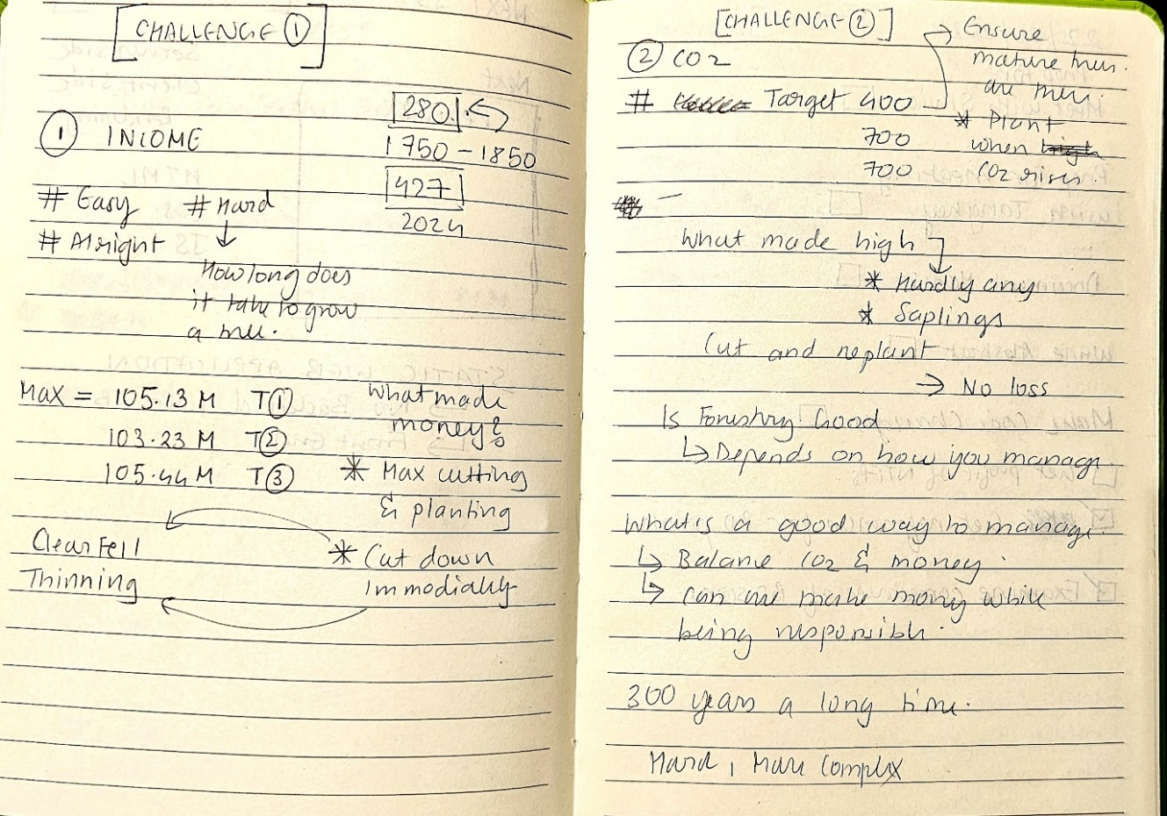

Figure 67. Bridge2College - Learner discussion notes.

## Findings

Based on responses from above section 5.4, **learner feedback** on MycroForest is largely positive. Average usability scores range between 2 and 2.3 on the 7 point PSSUQ scale. On average, all 3 usability subcategories of system usefulness, information quality, and interface quality received similarly good ratings. This suggests that most learners found the tool very usable across the board given that 1 = most usable and 7 = least usable. Average education value related score is also most positive at 1.8 meaning that most students found the experience of using MycroForest, educationally rewarding.

Considering individual usability and educational value ratings, it can be observed that only 3/10 individuals ever reported a negative score (> 4). Figure 68 displays distribution of scores for questions that received at least one negative response. The biggest area for improvement here, is regarding error messages as many learners would have liked to receive more error messages to promote right behaviour. It is unclear what actions and resulting conditions caused learners to feel this need for error messages. Thus, MycroForest would benefit from more testing to identify errors and apt error messages. Another notable issue with the tool was that 20% of learners found is difficult to find required built-in user guidance ("help" information). Post evaluation, efforts have been made through content modification and re-organization of “help” information to try and address this. Further testing is required to analyse its effectiveness.

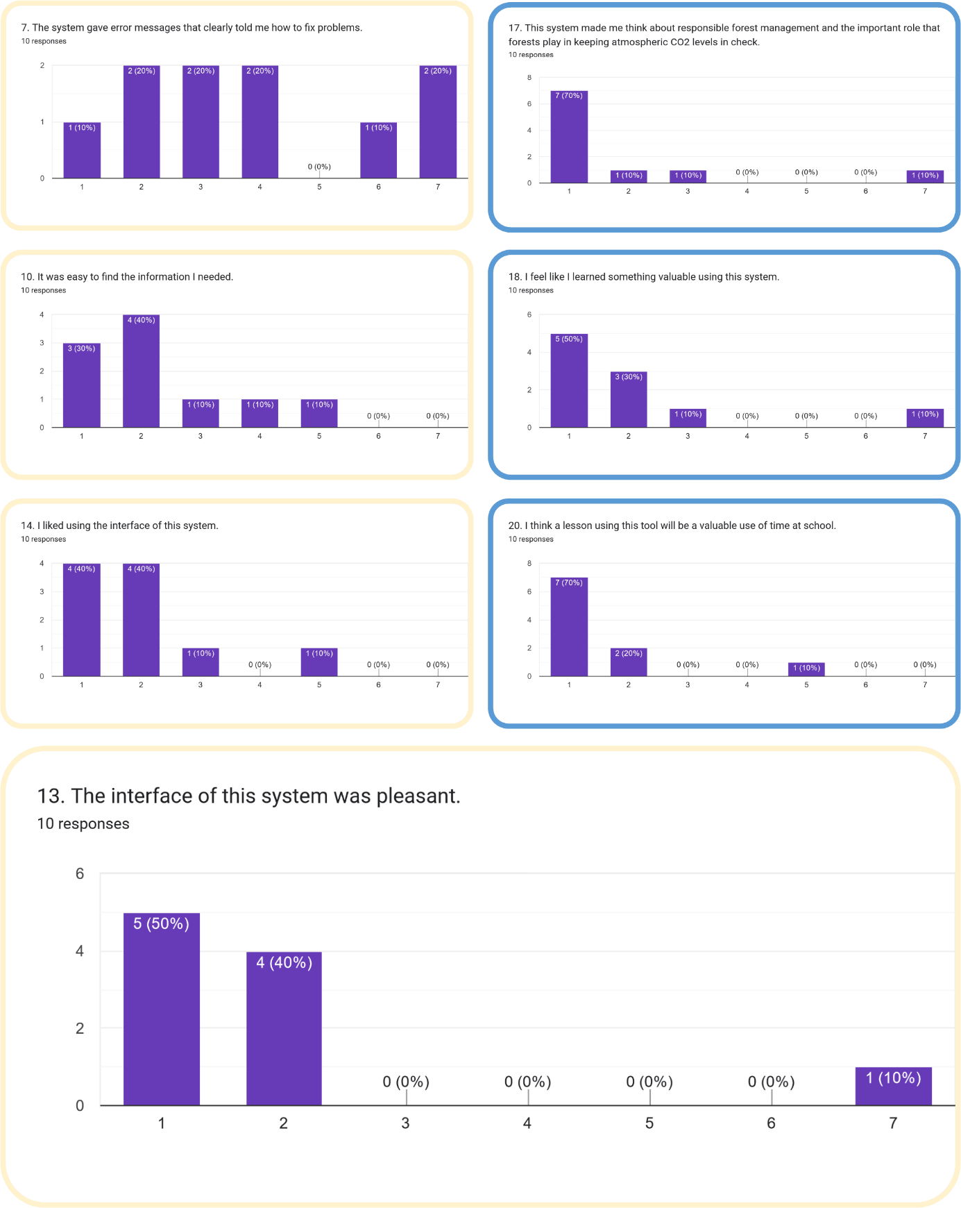

Figure 68. Evaluation items that received at least one negative score.

Only 1 individual disliked the UI. It is interesting to note that the score for most questions that received a negative score (question 13, 14, 17, 18, 20), is assigned by the same single individual alone. This learner also reported least concern about climate change (level of concern = 1/10) both before and after using the tool. This, along with open ended answers like “Deforestation” was what they best liked about the app and that if they come to own a forest, primary course of action would be to “chop it down and make some money to buy …”, etc. hints at the possibility that responses may have been biased or perhaps the student was hesitant to fully commit to the activity. There is also the possibility that this tool/activity failed to sufficiently promote/inform this learner about the importance of SFM. However, this is less likely as all other learners found the experience valuable such that their concern about climate change either rose (for 3/10 learners) or remained at the same high level (for 4/10 people at $≥$ 8). This also points towards a third possibility that perhaps the learning activity is more impactful/appreciated by those already concerned (concern > 5) about climate change, but not nearly as much for individuals who are not concerned about it to begin with. Once again, these warrants testing with a bigger sample size. Also, it is estimated that continuing through to challenges 3, 4, and 5, may help stress the importance of sustainable forest management and dangers of ignoring climate change further. Due to time shortage, the B2C learners did not get the chance to reach challenge 4 as in Table 11 wherein fossil fuel emissions due to anthropogenic activities present a climate “crisis” as atmospheric CO2 levels rise rapidly.

Furthermore, it is interesting to note that the remaining 2 learners reported a drop in concern regarding climate change after using the app compared to prior to this (concern dropped from 8/10 to 7/10 and 6/10 to 3/10). Once again, this may be due to their only having been time for 2 challenges wherein emissions due to human activity that actively moves carbon from the slow to fast carbon cycle through burning of fossil fuels, was not yet considered. But, it may also be that these students left the experience more hopeful about the future and with greater confidence in the positive role that SFM can play in mitigating rapid climate change. The key takeaway reported by one of these students was “that it is important to manage forestry beforehand in order to do what’s best for the environment”. Given a forest, this student reported that they would “try to find the perfect middle ground and think about our world”. The other student also reported that if they owned a forest, they would “research for a good plan to keep co2 low enough and make money at the same time”. Both these responses point towards willingness to make climate conscious decisions and act in the right direction with a healthy amount of concern for the future. This is referred to as “positive reappraisal” and is considered to be among most effective crisis coping mechanisms [2]. Positive reappraisal is important to motivate action against climate change, especially since a large portion of youth reports feelings of helplessness or despair regarding climate change known as climate change anxiety which often leads to inaction or counter-productive behaviour [2, 13].

**Educator feedback** was very positive. All 3 educators felt that students were engaged in the activity and that learning outcomes were met. Educator 2 points out how the activity being very interactive, likely contributed to learners having understood concepts at a deeper level than perhaps what they may have grasped in a traditional, explanatory classroom setting. This is consistent with existing research [8, 10, 20, 36, 50] that report well defined microworlds to lead to more effective learning through promotion of learner engagement when compared to classic explanatory teaching.

Further, all 3 educators report that students seem to appreciate and even “enjoy” added gamification elements like challenges and were keen to meet “goals”. This validates the decision to facilitate goal setting via target setters alongside existing work like [4, 9, 20, 39, 63] which support the idea that non-distracting gamification with clear goals can motivate learners and provide structure to learning activities involving a microworld.

The lead educator as well as educator 2 greatly appreciated “layers of complexity” or “scale” that the tool presents, which made it suitable for multiple learning activities. Educator 3 also sees this tool potentially being adapted for use across a wider age group. All 3 educators reported that learners found MycroForest “easy” to use/understand after a brief introduction even though many students were unfamiliar with forestry.

Also, it is worth noting that the lead educator reports discussions “after” tool usage to be interesting and particularly indicative of learning objective achievement. This parallels the notion that w.r.t tools like MycroForest, “learning begins when the game is over” [4]. This emphasizes the need for debriefing/discussion sessions post learning activities.

Feedback from the **domain expert** – “MycroForest tackles a concept that is critical but rarely explained …”, recognizes motivation of this project as relevant. She merits MycroForest on giving a glimpse of realistic forestry practices (management activities planned in rotations) and long timescales over which forests grow. During discussion, multiple students pointed out about how 300 years (timeframe of simulation) is a “long time”. Conversations regarding this with educators and peers seemed to leave learners with a better understanding of true time scales over which natural climate solutions operate. This may have left them more aware of the need for early and consistent forest management efforts to maximize the role of forests as carbon sinks.

The domain expert was most impressed with how students discovered 2 real world forest management strategies (clear-felling, thinning), entirely on their own using the tool with no prior knowledge about them or instructions from educators. Further, they also correctly recognized that while clear-felling can be profitable, it is the worst strategy when goal maximum carbon capture. During discussion, students also reported a correctly observed need for preservation of old/big trees to prevent rapid rise of CO2 which captures the important SFM principle of old growth protection.

Lastly, the expert shared 2 limitations. First, she mentions how there is a discrepancy in figures w.r.t scale of the forest presented to the learner. This stems from how a virtual forest of maximum 36 trees influence Earth-scale carbon figures reported in the microworld. The decision was made to present users with at most 36 trees as this allows intuitive application of management actions and mental tracking of consequences. Global-scale carbon and environmental parameter values are considered because real-world figures are more readily available at this level. Carbon absorption and release by individual trees were scaled by a factor of 2.4e+8 so that few trees may noticeably influence world CO2 levels. While this does not significantly disrupt learning as the expert also clarified, it does present a slightly distorted view of how much carbon a single tree might absorb/release. A part of the user guide which reads “Please note that the virtual forest presented does not reflect any single real-world forest, it is a simplified, abstract representation of all forests on Earth.” as well as educator comments during introduction, informs users of this abstract nature of the forest in MycroForest. The second limitation of MycroForest, as the expert rightly notes, is that while it correctly responds to profit-oriented management plans with an increase in atmospheric CO2, the focus on income generation, albeit to show trade-off between ecosystem service and production related objectives, might lead learners to mistakenly believe that carbon sequestration and income generation are equally important. This is more likely if learners only attempt challenges 1, 2, and 3 (B2C learning session students attempted challenges 1 and 2 only). In reality, the urgent need to combat climate change means that carbon capture takes clear precedence over income generation. This limitation was addressed in discussion sessions where educators emphasized the importance of a climate-first approach to forest management.

## Development Success

This section states how successful, development of MycroForest was, w.r.t features that were to be implemented (FRs and NFRs as in section 3.1) and the project timeline.

Of the 12 NFRs, 11 were fully satisfied, while NFR 9 – “providing sufficient, easily accessible built-in help”, which had a fairly high MoSCoW priority of SHOULD, was only partially met, as 3 learners reported difficulty finding necessary user guide information. All but one FR was implemented. FR 11 (allowing users to sign up and log in to save information) was not implemented as the decision was made to keep the application static given that increased development complexity associated with implementing sign-up/log-in was not seen as a worthwhile endeavour within the project timeframe, especially since educational value so added was not great (group activities can be performed through structuring of learning activities and does not strictly require built-in multi-learner support, since world state may be saved/reloaded there is no strict need for storing user data). Thus, this feature was of lowest priority, seen as nice-to-have, but not essential.

Regarding the development timeline, all planned activities, except for the development and testing of a low-fidelity prototype, were executed, though in a slightly different order or duration than initially planned. A working, viable teaching tool was developed and refined in time for the Bridge2College learning session. Sufficient time was allocated for research to make informed design decisions, and this document was prepared and refined within the allotted time.

## Summary

This chapter discussed evaluation of MycroForest and analysed feedback so obtained. Initial testing involved informal and formal evaluations by friends, family, and educators, leading to improved UX and educational effectiveness like added premature navigation prevention, expansion of built-in user guide, and making the UI more intuitive/simpler.

Next, 10 transition year students, as part of a 2 hr B2C learning session, engaged with MycroForest via a learning activity comprising 2 structured challenges. Evaluation utilized a customized PSSUQ, supplemented with questions targeting educational value, and attitude towards climate change. This allowed for a nuanced understanding of MycroForest’s best and worst aspects.

Learner and educator feedback about MycroForest was largely positive, particularly w.r.t educational value and usability. Average scores on the PSSUQ scale indicated that most learners found the tool highly usable across all 3 usability dimensions including system usefulness, information quality, and interface quality. Students appreciated how MycroForest was easy to use and provided a realistic view of forestry practices. Educators praised the tool for its ability to promote deep learning through interactive and gamified elements, which kept students motivated and engaged. The domain expert also recognized the relevance of MycroForest, commending it for effectively illustrating complex concepts like sustainable forest management and the importance of old-growth tree preservation. She was also impressed by students discovering for themselves, real-world management strategies through self-regulated learning using MycroForest.

MycroForest also received some criticisms. Learners suggested inclusion of more error messages. This warrants more app testing. Also, some learners (20%) reported difficulty in finding appropriate built-in help information. In-app user guide was improved post this. Another concern was that focus on income generation in few challenges might lead to students mistakenly viewing carbon sequestration and income generation from forests as equally important, potentially downplaying the urgency of climate-first management. This issue was mitigated by educators during discussions. Moreover, the risk for such misconception would have been lower if students had enough time to attempt all 5 learning activity challenges instead of just the first 2. Lastly, the expert pointed out a discrepancy in the scale of the virtual forest, which although does not significantly take away from the learning experience, could distort learner views of how much carbon a single tree might absorbs/releases.

Overall, despite room for improvement, MycroForest successfully met most design objectives and received positive feedback from both educators and target users (youth) for its educational value and usability. Thus, it has proven to be an effective educational tool that successfully engaged learners and simplistically informed about economic viability of climate aware forest management highlighting trade-offs inherent in balancing economic versus climate goals.

# Conclusion

The aim of this project was to develop an engaging microworld to promote self-regulated learning (SRL) and evaluate its effectiveness in educating youth about the critical role forests play in sequestering atmospheric carbon and how forest management practices, often economic-driven, can impact their carbon storage ability.

## Recap

There is an urgent need to reduce carbon emissions and remove GHGs to slow global warming. Photosynthesis, which absorbs CO2, the most abundant GHG, is vital to this. Forests are major natural carbon sinks. However, they are rapidly being cleared, worsening climate change. Young adults, as future decision-makers, play a crucial role in combating this. Thus, effectively educating 15-24 year olds regarding the importance of maintaining carbon sequestration capabilities of forests and underlying economic factors like financial gains from timber sales that hinders this, can foster climate awareness. This could, albeit a little, contribute to the transformative societal change needed to address the existential threat of climate change.

Effective education resulting in deep subject understanding and self-reflection, demands high learner engagement. Education technology that encourages SRL characterised by intrinsic motivation and high mental/behavioural activation, have been shown to achieve this. Research suggests that a microworld, especially when appropriately gamified to maintain user motivation, combined with a well-designed simulation of the target system, can support SRL and be very effective at teaching about cause-effect relationships in natural systems like forests and the carbon cycle.

Multiple approaches to simulation design were explored. MycroForest incorporates a proposed, simple, forest growth – carbon flow and learner generated management action execution model, that combines Agent Based Simulation, Discrete Event Simulation, and Object Oriented design. Equations, parameter values, assumptions, simplifications, and characteristics represented were informed by research and valuable advice from a domain expert to ensure sufficient realism. Further, to enhance learning, good UX and efficient data visualization were found crucial, driving research into and incorporation of Human-Computer Interaction (HCI) best practices, including Norman’s model and Nielsen's usability heuristics. Additionally, 5 similar tools were analysed. Best observed ideas/features were borrowed and bad ones were avoided.

Implementation involved standard software engineering activities like requirements documentation, class diagram design, CICD, and incremental feature development within an Agile workflow. Software design principles like OOP, SoC, SSoT and so on, were followed, aiming to minimize code rigidity, fragility, immobility, and viscosity. Technically, MycroForest is a NextJS based static web application hosted on Vercel using libraries like D3.js, Big.js Tailwind CSS, etc. and GitHub for version control.

MycroForest was used for a 2 hour learning session as part of the TAP Bridge2College programme where it was evaluated by 10 transition year students for usability, educational value, and attitude towards climate change. Students submitted feedback via a custom form incorporating questions from the PSSUQ evaluation framework.

Learner feedback on MycroForest is generally positive, with average usability scores indicating high satisfaction. Most learners found the tool educationally rewarding, though some issues were noted. Specifically, learners wanted more error messages and found built-in user guidance inadequate. Although 1 learner, who had low concern about climate change, gave negative feedback, possibly due to lack of engagement, all others reported good engagement such that most students either increased or maintained their concern about climate change. Only 2 other learners reported a drop in concern, potentially due to limited time availability allowing completion of only 2 of 5 proposed learning activity challenges. That said, given their climate responsible comments coupled with still high concern levels even after the drop, this could also be the result of reduced “climate anxiety” and more hope for the future, which is recognized as a good crisis coping attitude. Overall, MycroForest seems to effectively promote climate-conscious decisions, though further testing is needed.

Educator feedback on MycroForest was very positive, with all 3 educators confirming high student engagement and successful learning outcomes. They appreciated how interactive and gamified elements, such as challenges and goal setting, enhanced understanding more effectively than traditional methods. The tool's "layers of complexity" was praised for supporting diverse learning activities, possibly for a broader user base. Educators also reported students finding MycroForest easy to use, despite unfamiliarity with forestry practices, and highlighted the value of post-activity discussions in reinforcing learning objectives.

Feedback from the domain expert highlighted MycroForest’s effective depiction of realistic forestry practices and long timescales associated with natural climate solutions. She praised how students independently discovered real-world forest management strategies and their impact on carbon capture as well as the significance of preserving old trees. However, 2 limitations were noted: the simulation's simplified forest scale can distort perceptions of individual tree carbon absorption, and the focus on profit-oriented management in learning activity challenges might lead learners to undervalue carbon sequestration compared to income generation by viewing both goals as equally important. Educators had addressed these issues by informing of the abstract nature of the simulation and emphasizing need for carbon capture.

Overall, from what the students reported, and faculty confirmed, learners left the B2C session with greater awareness and appreciation regarding the need to reduce atmospheric CO2, and manage forests sustainably.

## Limitations

Project limitations are as follows.

1. **Limited Testing:** Evaluation of MycroForest was conducted with 10 students. It was not possible to have more students try the tool as schools were on holiday. The deadline for submission of this work made waiting until more students were available, impractical. Responses from 10 learners was interpreted based on simple descriptive statistics like mean scores. More elaborate analysis like say, hypothesis testing when sample size is as small as 10, was deemed unnecessary since results cannot be confirmed as being statistically significant. This means that evaluation as presented in this work is not conclusive although it shows the approach to follow. Notwithstanding criticisms, the positive results suggest that MycroForest is on right lines and merits further use and evaluation, as the Bridge2College team plans to do.
2. **Challenges Not Built-In:** Currently, pressing Ctrl + Alt + 1, Ctrl + Alt + 2, … Ctrl + Alt + 5 on the keyboard, progressively reveals only those tool features required for each corresponding challenge proposed as part of the learning activity. Challenge 5 reveals all features of the application. Apart from such selective reveal, explicit instructions that guide learners through challenge goals are not built into the tool as say, a walkthrough. Thus, the learning experience may be less rewarding without an educator. That said, research suggests that microworlds are most effective when used by students in the presence of a knowledgeable facilitator who can provide guidance/structure to learning and ensure correctness of learner conclusions. MycroForest is thus, intended to be used in the presence of an educator. Further, educators might find the tool flexible because it has no rigid built-in challenges/learning activity, allowing custom activities to be designed around it. To this end, while it is possible to change visibility of features with ease, altering current progressive reveal settings, requires minor source code changes which limits flexibility of the application. However, there is an easy solution to this as presented in the next Future Work sub-section, point 6.
3. **Forest-World Scale Mismatch and Large CO2 Fluctuations:** CO2 levels fluctuate more in MycroForest than on Earth, as carbon released/absorbed by each of up to 36 trees is multiplied by a large number, 2.4e+8, to allow few trees to impact global atmospheric CO2 levels as like entire forests would on Earth. This inaccuracy is not so great as to hinder learning. Cause effect relationship between learner management actions and microworld atmospheric CO2 concentration changes as well as quality of life classification associated with CO2 levels remain realistic. That is, fluctuations remain within appropriate quality of life categories for specific management strategies. E.g. on earth, CO2 concentration has remained in the 180 to 430 range throughout known history [148]. In MycroForest, natural fluctuations with no or limited felling causes CO2 concentration fluctuations up to 700 ppm. On earth, it would be ideal to keep level below 430 ppm. In MycroForest, a higher concentration of up to 700 ppm, is considered tolerable. Learners were briefed about this and informed that they have more leeway in the tool than we do on Earth since it is only an abstract representation of all forests on Earth. In both MycroForest and the real world, as CO2 levels get higher still (> 700 ppm), this leads to very dangerous climate conditions. Another undesirable consequence of the CO2 fluctuation in MycroForest is that levels sometimes drop too low, and trees die due to lack of CO2. This is not common on Earth. However, death of parts of the forest due to chance events like diseases/disasters do occur in the real world, and so, occasional death of few trees may be presented as reflective of natural chance conditions to keep the educational experience sufficiently realistic. Reducing this instability could involve eliminating the tree carbon exchange scaling factor (i.e. multiplying by 2.4e+8) and scaling down all environment carbon amounts while maintaining Earth's ratios, followed by hyperparameter reconfiguration for realistic system behaviour. This was not done due to time constraints. Fluctuations may also be due to indirect effects of some unmodelled parameter or behaviour. Further discussion with the domain expert and more thorough research could uncover any key missing relationship. Doing so was not possible within the project timeframe.
4. **Simple Simulation Model:** Currently, the underlying tree growth and carbon exchange simulation model is simple, only CO2 is explicitly modelled as a resource that trees require since this is most relevant to carbon sequestration. Other growth conditions are assumed to be ideal. Modelling plant growth in more detail will likely produce a more realistic model which may even result in lesser fluctuation of atmospheric CO2 levels as mentioned above. However, given that educational focus is on changing atmospheric CO2 concentration in response to forest management strategies as opposed to plant growth processes, the current simple model was found to be adequately accurate, capturing key cause effect relationships well, as confirmed through experiments and validated by the fact that students were able to observe real world management strategies via the tool.
5. **Lack of Error Messages:** Learners reported that they would like more helpful error messages. There already exist some error displays like text boxes turning red and not accepting changes when input is invalid (e.g. text in a numeric field). Further testing of the tool is required to identify situations that require added error messages that could appear in a closeable pop-up box on the screen.
6. **Income Generation versus Carbon Sequestration:** The domain expert noted that incorporating economic gain from forests alongside CO2 reduction in challenges might suggest to learners that both are equally important, when in reality, given the urgency of climate change, carbon sequestration is more critical than income generation from forests. These goals were proposed to illustrate the difficulty of sustainable forest management and the opposing nature of economic and climate-friendly objectives. Challenges 4 and 5 make it more difficult to exploit forest timber without CO2 levels reaching critical. Thus, if learners attempt all proposed challenges, they may be less likely to consider both goals equal. Further, educators are free to develop their own different learning activities with other challenges that might circumvent this risk. In the B2C learning session, educators stressed the need for action against climate change in the real world during the introduction to mitigate this risk to some extent.
7. **Time Navigation Mechanism:** When the user navigates to any point in time before the current simulated year, the microworld is re-initialized, and simulation steps are repeated until requested year is reached. That is, event flow is unidirectional. E.g., if the learner pauses at year 100 and wishes to view world state at year 10, under the hood, the microworld state is first reset to year 0, and then 10 simulation step updates follow, to display state at year 10. Although this saves a lot of memory as world state for every year need not be stored, it is not scalable, with performance slowing down if many more years are simulated. For a simulation period of 300 years and a warm-up period of 200 to 500 years, as is the case now, the slightly slower response when navigating back in time is negligible and does not significantly impact UX. However, future work should explore alternatives.

## Future Work

Following are few starting points for expansion on this work.

1. **More Testing:** MycroForest requires further evaluation to determine whether observed responses are conclusive.
2. **More Detailed Simulation:** Plant growth and carbon exchange simulation may be made more detailed/realistic by modelling other factors like effect of soil nutrients, water, etc. This may mitigate limitations 4 and 5. Alternatively the possibility of leveraging existing third party detailed plant growth models may be considered. E.g. TreeSim is a Python based Individual Tree Simulation framework [149].
3. **Expose More Parameters to Learners:** Currently, only those parameters related to forest management and fossil fuel usage emissions can be manipulated by users via the GUI. This was intentional as this keeps the tool focussed on climate aware forest management. However, exposing more model settings can expand possible learning scenarios. E.g. a slider may be provided that allow users to adjust the proportion of harvested timber being burned for energy versus being turned into lumber that preserves stored carbon for longer.
4. **Activity Persistence and Built-In Team Mode:** A natural expansion of MycroForest would be for it to be made a dynamic web application with an added database that stores learner data and progress. The tool could also support team creation and communication (e.g. a feature like group chat or the Blackboard discussion space).
5. **More Income Streams:** Other income streams from forests like agroforestry may be incorporated.
6. **Selective Reveal Settings:** The need for small code changes in order to hide/show MycroForest features, as mentioned in limitation 2, can be circumvented by introducing a “settings” feature wherein educators may toggle UI panels or tool features ON/OFF via the GUI.
7. **Alternate Time Navigation Implementation:** Investigating alternate ways to facilitate forwards and backwards time navigation can help overcome limitation 7. Smooth, memory/computational resource efficient, bi-directional traversal is challenging. Most existing similar tools, including those analysed in this work, do not support this. Cashing, parallel/distributed processing, and keeping track of changes between simulation steps are areas to explore for solutions. It may also be interesting to experiment with world state compression/decompression or encoding/decoding mechanisms to make storage more efficient.

## Personal Reflection

Throughout this project. I, this author, have learned a lot about forestry and effective education technology design elements. I've also furthered my research and web development skills. This project was a great opportunity wherein to apply lessons from the “Advanced Software Engineering”, “Data Visualization”, and “Research and Innovation Methods” modules undertaken as part of the MSc. Computer Science Programme at TCD. It was most exciting to have had real users evaluate MycroForest.

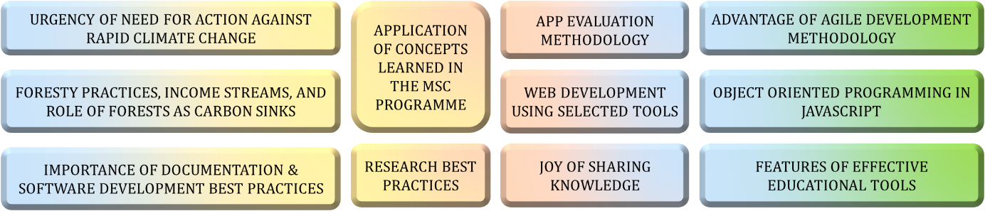

Figure 69. Key Personal Takeaways - What did I learn?

Overall, I am satisfied about how this project led to a functional teaching tool that students and faculty found valuable. I am happy to have honed research and web development skills and am grateful for the opportunity I got to help impart knowledge. This project was a challenging, yet rewarding endeavour that has left me more technically able, and with a greater appreciation for the natural world.

# Bibliography

1. *Forests can help us limit climate change – here is how*. 2023, United Nations Development Programme (UNDP).

2. Karsgaard, C. and D. Davidson, *Must we wait for youth to speak out before we listen? International youth perspectives and climate change education.* Educational Review, 2023. **75**(1): p. 74-92.

3. Fouqueray, T., et al., *Interdisciplinary modeling and participatory simulation of forest management to foster adaptation to climate change.* Environmental Modelling &amp; Software, 2022. **151**: p. 105338.

4. Garcia, C. and E. Speelman, *Landscape Approaches, Wicked Problems and Role Playing Games*. 2017.

5. International Institute for Applied Systems Analysis (IIASA), S.S., Centre for Systems Solutions, Games 4 Sustainability, *About That Forest*. 2018.

6. Agency, E.S. *Forest Kids game on biodiversity now available* 2022 [cited 2024 3 July]; Available from: <https://www.esa.int/Education/Forest_Kids_game_on_biodiversity_now_available>.

7. Yoshida, R., et al., *Life-size Board Game “Human SUGOROKU” To Teach Children about Vegetation Succession - Application of Human Sensing Technology to Embodied Education.* CSEDU 2015 - 7th International Conference on Computer Supported Education, Proceedings, 2015. **2**: p. 295-300.

8. Hoyles, C., R. Noss, and R. Adamson, *Rethinking the Microworld Idea.* Journal of Educational Computing Research, 2002. **27**(1): p. 29-53.

9. Rieber, L.P. *Multimedia Learning in Games, Simulations, and Microworlds*. Cambridge Handbook of Multimedia Learning, 2005.

10. Dabholkar, S., *Restructurating Science Learning with Emergent Systems Microworld (ESM)-based Learning Environments*. 2021, Northwestern University: United States -- Illinois. p. 356.

11. Lilian, G.K., *Education for Sustainable Development Pedagogy in Pre-Primary Social Studies Curriculum in Kenya: Review of Literature.* Journal La Edusci, 2022. **3**(3): p. 1-12.

12. Gabric, A.J., *The Climate Change Crisis: A Review of Its Causes and Possible Responses.* Atmosphere, 2023. **14**(7): p. 1081.

13. Kabir, M., et al., *Climate change due to increasing concentration of carbon dioxide and its impacts on environment in 21st century; a mini review.* Journal of King Saud University - Science, 2023. **35**(5): p. 102693.

14. Hausfather, Z. *Extreme CO2 levels could trigger clouds ‘tipping point’ and 8C of global warming*. 2019 [cited 2024; Available from: <https://www.carbonbrief.org/extreme-co2-levels-could-trigger-clouds-tipping-point-and-8c-of-global-warming/>.

15. Society, N.G. *Carbon Sources and Sinks*. 2023 [cited 2024 7 July]; Available from: <https://education.nationalgeographic.org/resource/carbon-sources-and-sinks/>.

16. Fergesen, J. *Trees Help Protect the Planet From Climate Change. But The World Isn’t Doing Enough to Protect Forests*. 2022.

17. Andrew Moseman, C.H., Cesar Terrer. *How many new trees would we need to offset our carbon emissions?* 2024 [cited 2024 9 July]; Available from: <https://climate.mit.edu/ask-mit/how-many-new-trees-would-we-need-offset-our-carbon-emissions>.

18. Daigneault, A., et al., *How the future of the global forest sink depends on timber demand, forest management, and carbon policies.* Global Environmental Change, 2022. **76**: p. 102582.

19. Mills, M.B., et al., *Tropical forests post-logging are a persistent net carbon source to the atmosphere.* Proceedings of the National Academy of Sciences, 2023. **120**(3).

20. Rieber, L.P., *Seriously considering play: Designing interactive learning environments based on the blending of microworlds, simulations, and games.* Educational Technology Research and Development, 1996. **44**(2): p. 43-58.

21. Piaget, J., *Play, Dreams And Imitation In Childhood.* 1951.

22. Morado, M.F., A.E. Melo, and A. Jarman, *Learning by making: A framework to revisit practices in a constructionist learning environment.* British Journal of Educational Technology, 2021. **52**(3): p. 1093-1115.

23. Ram Booj, N.I., *Sustainability Education: Setting the Context*, in *Sustainability Education for a Better World*, N.I. Ram Booj, Editor. 2022, Cambridge Scholars. p. 1-30.

24. Belcher, B.K., K., *Can environmental services improve local livelihoods?* Ecosystem Services. 2005: id21 natural resources highlights.

25. Hensbergen, H.v., K. Shono, and J. Cedergren, *A guide to multiple-use forest management planning for small and medium forest enterprises.* Vol. 39. 2023, Rome: Food and Agriculture Organization of the United Nations. 144.

26. Başkent, E.Z. and J. Kašpar, *Exploring the effects of various rotation lengths on the ecosystem services within a multiple-use management framework.* Forest Ecology and Management, 2023. **538**: p. 120974.

27. Mäkelä, A., et al., *Effect of forest management choices on carbon sequestration and biodiversity at national scale.* Ambio, 2023. **52**(11): p. 1737-1756.

28. Gert-Jan Nabuurs, P.J.V., Mart-Jan Schelhaas, Hans Verkerk, José Ramón González Olabarria, Antoni Trasobares, Emil Cienciala, *Climate-Smart Forestry: mitigation impacts in three European regions*, L. Hetemäki, Editor. 2018, European Forest Institute: ResearchGate.

29. Khaine, I. and S.Y. Woo, *An overview of interrelationship between climate change and forests.* Forest Science and Technology, 2015. **11**(1): p. 11-18.

30. Montaigne, F. *Why Keeping Mature Forests Intact Is Key to the Climate Fight*. 2019.

31. Program, U.N.D. *Forests can help us limit climate change – here is how*. 2023.

32. Murphy, W., *Forest Recreation in a Commercial Environmen*. CONFORD Ireland.

33. Bond, M., et al., *Mapping research in student engagement and educational technology in higher education: a systematic evidence map.* International Journal of Educational Technology in Higher Education, 2020. **17**(1).

34. Mulla, S. and G. Nagarjuna, *EdTech as an Empowering Tool: Designing Digital Learning Environments to Extend the Action Space for Learning and Foster Digital Agency*. 2023, Springer Nature Switzerland. p. 69-74.

35. Hargraves, V. *Dewey’s educational philosophy*. 2021 [cited 2024; Available from: <https://theeducationhub.org.nz/deweys-educational-philosophy/>.

36. Rieber, L.P., *Microworlds*, in *Handbook of research on educational communications and technology, 2nd ed.* 2004, Lawrence Erlbaum Associates Publishers: Mahwah, NJ, US. p. 583-603.

37. Green, D.W., *Understanding Microworlds.* The Quarterly Journal of Experimental Psychology Section A, 2001. **54**(3): p. 879-901.

38. Oikonomidis, A. and C. Iliopoulos. *Web-Based Simulation Systems in Technological Education Implemented as Micro-worlds*. 2010. IEEE.

39. Nagalingam, V. and R. Ibrahim, *User Experience of Educational Games: A Review of the Elements.* Procedia Computer Science, 2015. **72**: p. 423-433.

40. Xiang, L., S. Goodpaster, and A. Mitchell, *Supporting Three-dimensional Learning on Ecosystems Using an Agent-Based Computer Model.* Journal of Science Education and Technology, 2022. **31**(4): p. 473-489.

41. Thakur, A.K., *Model: Mechanistic vs Empirical*, in *New Trends in Pharmacokinetics*, A. Rescigno and A.K. Thakur, Editors. 1991, Springer US: Boston, MA. p. 41-51.

42. Peng, C., *Understanding the role of forest simulation models in sustainable forest management.* Environmental Impact Assessment Review, 2000. **20**(4): p. 481-501.

43. Moon, Y.B., *Simulation modelling for sustainability: a review of the literature.* International Journal of Sustainable Engineering, 2017. **10**(1): p. 2-19.

44. Macal, C.M. and M.J. North. *Tutorial on agent-based modeling and simulation*. in *Proceedings of the Winter Simulation Conference, 2005.* 2005.

45. Zhang, B. and D.L. DeAngelis, *An overview of agent-based models in plant biology and ecology.* Annals of Botany, 2020. **126**(4): p. 539-557.

46. Botkin, D.B., J.F. Janak, and J.R. Wallis, *Some Ecological Consequences of a Computer Model of Forest Growth.* The Journal of Ecology, 1972. **60**(3): p. 849.

47. Gayler, S., et al., *A Dynamical Model of Environmental Effects on Allocation to Carbon-based Secondary Compounds in Juvenile Trees.* Annals of botany, 2008. **101**: p. 1089-98.

48. Opacic, L. and T. Sowlati, *Applications of Discrete-Event Simulation in the Forest Products Sector: A Review.* Forest Products Journal, 2017. **67**(3-4): p. 219-229.

49. Ullrich, O. and D. Lückerath, *An Introduction to Discrete-Event Modeling and Simulation.* SNE Simulation Notes Europe, 2017. **27**(1): p. 9-16.

50. Ingalls, R.G. *Introduction to simulation*. 2011. IEEE.

51. Westlund, K., L.E. Sundström, and L. Eliasson, *An optimization and discrete event simulation framework for evaluating delivery performance in Swedish wood supply chains under stochastic weather variations.* International Journal of Forest Engineering, 2024. **35**(2): p. 326-337.

52. Da Silva, T.M.P., et al., *Discrete event simulation to build simulators for teaching.* Journal of Simulation, 2014. **8**(4): p. 325-334.

53. Heath, S.K., et al. *Cross-paradigm simulation modeling: Challenges and successes*. 2011. IEEE.

54. Eldabi, T., et al. *HYBRID SIMULATION CHALLENGES AND OPPORTUNITIES: A LIFE-CYCLE APPROACH*. 2018. IEEE.

55. Djanatliev, A. and R. German. *Towards a guide to domain-specific hybrid simulation*. 2015. IEEE.

56. Bischak, D.P. and S.D. Roberts. *Object-oriented simulation*. 1991. IEEE.

57. Baley, A. *What Is The Lifespan Of A Tree: How The Age Of A Tree Is Determined*. 2021 [cited 2024 July]; 15]. Available from: <https://www.gardeningknowhow.com/ornamental/trees/tgen/lifespan-of-a-tree.htm>.

58. Hinze-Hoare, V., *The Review and Analysis of Human Computer Interaction (HCI) Principles.* arXiv pre-print server, 2007.

59. Gupta, J., M. Ahuja, and N. Garg. *A Review on Human-Computer Interaction (HCI)*. 2022. IEEE.

60. Jyoti, G.K., *Research Paper on Human Computer Interaction (HCI).* International Journal for Multidisciplinary Research (IJFMR), 2023. **5**(2).

61. Pastel, R. *CS4760, HU4642 & CS5760: Human-Computer Interactions & Usability*. 2016 [cited 2024; Available from: <https://cs4760.csl.mtu.edu/2016/lectures/normans-interaction-theory/>.

62. Muys, B., et al., *Simulation tools for decision support to adaptive forest management in Europe.* Forest Systems, 2011. **19**.

63. Waeber, P.O., et al., *Fostering Innovation, Transition, and Reconstruction of Forestry: Critical Thinking and Transdisciplinarity in Forest Education with Strategy Games*. 2023, MDPI AG.

64. Murray, T., L. Winship, and N. Stillings. *Evaluation of the SimForest inquiry learning environment: Inquiry cycles and collaborative teaching practices*. in *Annual Meeting of the American Educational Research Association (AERA 2004). San Diego, CA*. 2004.

65. Cristal, I., et al., *A Decision Support Tool for Assessing the Impact of Climate Change on Multiple Ecosystem Services.* Forests, 2019. **10**(5): p. 440.

66. Tom Murray, L.W., Neil Stillings, Esther Shartar, Ayala Galton. *Classroom Strategies for Simulation-Based Collaborative Inquiry Learning*. in *ICLS-2004*. 2004. San Mateo.

67. TregearBPM, *Process Insights: Context Diagram*. 2022: YouTube.

68. ProductPlan. *MoSCoW Prioritization*. [cited 2024; Available from: <https://www.productplan.com/glossary/moscow-prioritization/>.

69. Majid, A., et al., *Differential coding of perception in the world’s languages.* Proceedings of the National Academy of Sciences of the United States of America, 2018. **115**(45): p. 11369-11376.

70. Riebeek, H. *The Carbon Cycle*. 2011 [cited 2024; Available from: <https://earthobservatory.nasa.gov/features/CarbonCycle>.

71. Williams, D.D.R. *Earth Fact Sheet*. 2024 [cited 2024; Available from: <https://nssdc.gsfc.nasa.gov/planetary/factsheet/earthfact.html>.

72. Sands, D. *Parts Per Million | PPM Definition, Units & Calculation*. 2023 [cited 2024; Available from: <https://study.com/academy/lesson/parts-per-million-definition-calculation-example.html>.

73. Meter, C. *What is CO2 ppm?* 2023 [cited 2024; Available from: <https://www.co2meter.com/blogs/news/co2-ppm>.

74. Davis, U. *What is Carbon Sequestration and How Does it Work?* 2019 [cited 2024; Available from: <https://clear.ucdavis.edu/explainers/what-carbon-sequestration>.

75. Lugt, P.v.d., *Carbon Storage Utilising Timber Products*, in *ENVIRONMENT INDUSTRY MAGAZINE*. 2020. p. 76-80.

76. Scion. *Locking up carbon long-term in timber buildings*. Scion Connections Issue 34 2019 [cited 2024; Available from: <https://www.scionresearch.com/about-us/about-scion/corporate-publications/scion-connections/past-issues-list/scion-connections-issue-34,-december-2019/locking-up-carbon-long-term-in-timber-buildings>.

77. Gov, M. *Greenhouse CO2 Supplement*. [cited 2024; Available from: <https://www.gov.mb.ca/agriculture/crops/crop-management/co2-supplement.html>.

78. Megha Poudel, B.D. *Greenhouse Carbon Dioxide Supplementation*. 2023 [cited 2024; Available from: <https://extension.okstate.edu/fact-sheets/greenhouse-carbon-dioxide-supplementation.html>.

79. Moseman, A. *What is the ideal level of carbon dioxide in the atmosphere for human life?* 2021 [cited 2024; Available from: <https://climate.mit.edu/ask-mit/what-ideal-level-carbon-dioxide-atmosphere-human-life>.

80. ecotree. *How much CO2 does a tree absorb?* ; Available from: <https://ecotree.green/en/how-much-co2-does-a-tree-absorb>.

81. Marisa Stone, K.N., Sebastian Seibold, David Lindenmayer. *This unassuming item releases 10.9 billion tonnes of carbon every year.* 2021 [cited 2024; Available from: <https://www.weforum.org/agenda/2021/09/decaying-forest-wood-carbon-climate-change-co2/>.

82. Gastronomicus. Where does the CO2 absorbed by trees end up? 2021; Available from: <https://www.reddit.com/r/askscience/comments/phvr8h/where_does_the_co2_absorbed_by_trees_end_up/>.

83. Wisconsin, U.o. *Facts About Wood*. 2020 [cited 2024; Available from: <https://www3.uwsp.edu/cnr-ap/KEEP/Documents/Activities/Energy%20Fact%20Sheets/FactsAboutWood.pdf>.

84. He, H., et al., *Allometric biomass equations for 12 tree species in coniferous and broadleaved mixed forests, Northeastern China.* PLOS ONE, 2018. **13**(1): p. e0186226.

85. Cassidy, E. *Emissions from Fossil Fuels Continue to Rise*. 2024 [cited 2024; Available from: <https://earthobservatory.nasa.gov/images/152519/emissions-from-fossil-fuels-continue-to-rise>.

86. Forestry, S. *Forestry Facts*. [cited 2024; Available from: <https://swsforestry.ie/why-plant/forestry-facts/>.

87. Department of Agriculture, F.a.t.M.I., *Forest Statistics Ireland 2023*. 2023, Ireland: Department of Agriculture, Food and the Marine Ireland.

88. Thomas H. Everett, G.P.B. *Popular classifications*. 2024 [cited 2024; Available from: <https://www.britannica.com/plant/tree/Popular-classifications>.

89. Eckenwalder, J.E. *conifer*. [cited 2024; Available from: <https://www.britannica.com/plant/conifer>.

90. Moran, N., *Tree Guide*. 2023, dlr Comhairle Contae County Council.

91. Biondi, F., D.M. Meko, and G. Piovesan, *Maximum tree lifespans derived from public-domain dendrochronological data.* iScience, 2023. **26**(3): p. 106138.

92. Matmatch. *Density of wood in kg/m3, g/cm3, lb/ft3 – the ultimate guide*. [cited 2024; Available from: <https://matmatch.com/learn/property/density-of-wood>.

93. Greenmax. *The Impressive Power of Conifers for the Climate*. [cited 2024; Available from: <https://greenmax.eu/en/the-impressive-power-of-conifers-for-the-climate/>.

94. Wall, S.B.V., *MASTING IN ANIMAL-DISPERSED PINES FACILITATES SEED DISPERSAL.* ECOLOGY, 2002. **83**(12): p. 3243-3532.

95. Wikipedia. *Conifer*. [cited 2024; Available from: <https://en.wikipedia.org/wiki/Conifer>.

96. Services, T.T. *Education: Reclamation: Seedling Characteristics*. [cited 2024; Available from: <https://treetimeservices.ca/education/reclamation/seedling-characteristics>.

97. Pedersen, B.S., *Modeling tree mortality in response to short- and long-term environmental stresses.* Ecological Modelling, 1998. **105**(2): p. 347-351.

98. Whyte, G., et al., *The Tree Decline Recovery Seesaw; a conceptual model of the decline and recovery of drought stressed plantation trees.* Forest Ecology and Management, 2016. **370**: p. 102-113.

99. Hülsmann, L., et al., *How to kill a tree: empirical mortality models for 18 species and their performance in a dynamic forest model.* Ecological Applications, 2018. **28**(2): p. 522-540.

100. Das, A.J., N.L. Stephenson, and K.P. Davis, *Why do trees die? Characterizing the drivers of background tree mortality.* Ecology, 2016. **97**(10): p. 2616-2627.

101. Ryan, M.G. and B.J. Yoder, *Hydraulic Limits to Tree Height and Tree Growth.* BioScience, 1997. **47**(4): p. 235-242.

102. Bredenkamp, B.V. and H.E. Burkhart, *Diameter growth of Eucalyptus grandis under conditions of extreme suppression.* New Zealand journal of forestry science, 1990. **20**: p. 162-167.

103. Pastur, G.M., et al., *Diameter growth: can live trees decrease?* Forestry: An International Journal of Forest Research, 2007. **80**(1): p. 83-88.

104. Brockerhoff, E.G., et al., *Forest biodiversity, ecosystem functioning and the provision of ecosystem services.* Biodiversity and Conservation, 2017. **26**(13): p. 3005-3035.

105. Chen, X. and D.G. Brockway, *Height-diameter Relationships in Longleaf Pine and Four Swamp Tree Species.* Journal of Plant Studies, 2017. **6**(2): p. 94.

106. Scotland, F.A.L. *Biodiversity and you* 2020 [cited 2024; Available from: <https://forestryandland.gov.scot/blog/biodiversity-and-you>.

107. I. Thompson, B.M., S. McNulty, A. Mosseler, *Forest Resilience, Biodiversity, and Climate Change: a synthesis of the biodiversity/resilience/stability relationship in forest ecosystems.* . 2009, Secretariat of the Convention on Biological Diversity: Montreal. p. 1-67.

108. Wang, X., et al., *The biodiversity benefit of native forests and mixed‐species plantations over monoculture plantations.* Diversity and Distributions, 2019. **25**(11): p. 1721-1735.

109. Hertzog, L.R., et al., *Mixing of tree species is especially beneficial for biodiversity in fragmented landscapes, without compromising forest functioning.* Journal of Applied Ecology, 2021. **58**(12): p. 2903-2913.

110. Kuuluvainen, T., et al., *Tree age distributions in old-growth forest sites in Vienansalo wilderness, eastern Fennoscandia.* Silva Fennica, 2002. **36**(1).

111. MPW, u., ed. *Shift numbers into a different range*. 2014, Stack Exchange Mathematics.

112. studocu. *ROTATION*. 2023 [cited 2024; Available from: <https://www.studocu.com/in/document/sam-higginbottom-university-of-agriculture-technology-and-sciences/agroforestry-management/rotation/27330074>.

113. Press, L.A. *Buying Wood by the Pound*. 2021 [cited 2024; Available from: <https://blog.lostartpress.com/2021/03/21/buying-wood-by-the-pound/>.

114. Services, G. *Factors Influencing Tree Removal Costs*. [cited 2024; Available from: <https://www.grasshopperservices.ie/tree-removal-cost/>.

115. Nita, A. *How Much Does it Cost to Plant a Tree in 2024?* 2023; Available from: <https://lawnlove.com/blog/cost-to-plant-tree/>.

116. Miina, J., et al., *Promoting wild mushroom yields by forest management*. 2016.

117. Flanagan, D. *Bee Keeping and Honey Production*. 2017 [cited 2024; Available from: <https://www.teagasc.ie/rural-economy/rural-development/diversification/bee-keeping-and-honey-production/>.

118. Visick, O.D. and F.L.W. Ratnieks, *Density of wild honey bee, <i>Apis mellifera</i>, colonies worldwide.* Ecology and Evolution, 2023. **13**(10).

119. Riedl, M., et al., *Analysis of Significant Factors Influencing the Amount of Collected Forest Berries in the Czech Republic.* Forests, 2020. **11**(10): p. 1114.

120. Forest, H.o.E. *5 fungi to spot in the Forest*. 2020 [cited 2024; Available from: <https://heartofenglandforest.org/news/5-fungi-spot-forest>.

121. Mushrooms, B.M. *Wild Irish Mushrooms*. 2024 [cited 2024; Available from: <https://ballyhouramushrooms.ie/store/Wild-Irish-Mushrooms-c87664037>.

122. Pick, P.W. *Wild Berries*. 2024 [cited 2024; Available from: <https://pacificwildpick.com/collections/berries>.

123. Killester, D.H. *Pure Irish Honey*. 2024 [cited 2024; Available from: <https://dublinhoneykillester.ie/product/pure-irish-honey-killester/>.

124. Liu, V. How long does it take a person to walk an acre? 2021; Available from: <https://www.quora.com/How-long-does-it-take-a-person-to-walk-an-acre>.

125. Expert, S. *Forest Worker Avg. Salary*. 2024 [cited 2024; Available from: <https://www.salaryexpert.com/salary/job/forest-worker/ireland>.

126. Department of Agriculture, F.a.t.M.I., *Forest Statistics 2022*. 2022, Department of Agriculture, Food and the Marine Ireland.

127. Avondale, B.T.T. *Tickets & Prices*. 2024 [cited 2024; Available from: <https://www.beyondthetreesavondale.com/plan-your-visit/tickets-prices/>.

128. Park, L.K.F.A.A. *Admission Charges 2023*. 2023 [cited 2024; Available from: <https://loughkey.ie/admission-prices/>.

129. PARK, A. *Zipit Farran Park*. 2024 [cited 2024; Available from: <https://zipit.ie/locations/farran-park/park-info/>.

130. Park, L.K.F.A.A. *Boda Borg*. 2024 [cited 2024; Available from: <https://loughkey.ie/activities/boda-borg/>.

131. Club, T.F. *Birth Day Parties*. 2024; Available from: <https://www.theforestclub.ie/childrens-birthday-parties>.

132. Coillte. *FORESTRY*. [cited 2024; Available from: <https://www.coillte.ie/our-business/our-divisions/forestry/>.

133. Wikipedia. *Coillte*. [cited 2024; Available from: <https://en.wikipedia.org/wiki/Coillte>.

134. Mozilla. *Document Object Model (DOM)*. [cited 2024; Available from: <https://developer.mozilla.org/en-US/docs/Web/API/Document_Object_Model#:~:text=The%20DOM%20represents%20a%20document,and%20each%20node%20contains%20objects>.

135. GeeksforGeeks. *MVC Design Pattern*. 2024 [cited 2924; Available from: <https://www.geeksforgeeks.org/mvc-design-pattern/>.

136. srinam. *Separation of Concerns (SoC)*. 2024 [cited 2024; Available from: <https://www.geeksforgeeks.org/separation-of-concerns-soc/>.

137. Beckman, J. *Agile Statistics: How Many Companies Use Agile in 2023?* 2024 [cited 2024; Available from: <https://techreport.com/statistics/business-workplace/how-many-companies-use-agile/>.

138. Text, O. *What is Agile Development?* [cited 2024; Available from: <https://www.opentext.com/what-is/agile-development#resources>.

139. Review, W.O. *How the ocean absorbs carbon dioxide*. 2024 [cited 2024; Available from: <https://worldoceanreview.com/en/wor-8/the-role-of-the-ocean-in-the-global-carbon-cyclee/how-the-ocean-absorbs-carbon-dioxide/>.

140. West, T.A.P., et al., *Action needed to make carbon offsets from forest conservation work for climate change mitigation.* Science, 2023. **381**(6660): p. 873-877.

141. Institute, T.A., *The Problem with Carbon Credits and Offsets Explained* in *The Australian Institute*. 2023, The Australian Institute.

142. EcoCart. *Carbon Credits vs Carbon Offsets: Which Is Right For You?* 2024 [cited 2024; Available from: <https://ecocart.io/what-are-carbon-credits-carbon-credits-vs-carbon-offsets/>.

143. Miltenberger, O., C. Jospe, and J. Pittman, *The Good Is Never Perfect: Why the Current Flaws of Voluntary Carbon Markets Are Services, Not Barriers to Successful Climate Change Action.* Frontiers in Climate, 2021. **3**.

144. Sullivan, K., Bray, A. & Tangney, B, *Developing twenty-first-century skills in out-of-school education: the Bridge21 Transition Year programme.* Technology, pedagogy and education, 2021. **30**(4): p. 525–541.

145. Brooke, J., *SUS: A quick and dirty usability scale.* Usability Eval. Ind., 1995. **189**.

146. Vlachogianni, P. and N. Tselios, *Perceived Usability Evaluation of Educational Technology Using the Post-Study System Usability Questionnaire (PSSUQ): A Systematic Review.* Sustainability, 2023. **15**(17): p. 12954.

147. T, W. *PSSUQ (Post - Study System Usability Questionnaire)*. [cited 2024; Available from: <https://uiuxtrend.com/pssuq-post-study-system-usability-questionnaire/>.

148. Lüthi, D., et al., *High-resolution carbon dioxide concentration record 650,000–800,000 years before present.* Nature, 2008. **453**(7193): p. 379-382.

149. Nabhani, A. and H.K. Sjølie, *TreeSim: An object-oriented individual tree simulator and 3D visualization tool in Python.* SoftwareX, 2022. **20**: p. 101221.

150. R. Morelli, R.W., *Java, Java, Java Object-Oriented Problem Solving*. 2017: Trinity College Hartford, CT.

151. Parr, K. *The Four Pillars of Object-Oriented Programming*. 2020 [cited 2024; Available from: <https://www.freecodecamp.org/news/four-pillars-of-object-oriented-programming/>.

152. Makode, K. *Object-Oriented Programming in JavaScript*. 2023 [cited 2024; Available from: <https://www.freecodecamp.org/news/object-oriented-programming-javascript/>.

# Appendices

## MycroForest

Please find the proposed teaching tool deployed at the following link.

* <https://microworld-dissertation-tcd.vercel.app/>

## GitHub

Please find project and development history of MycroForest at the following 2 GitHub repositories.

* Latest tool: <https://github.com/ggn1/microworld_dissertation_tcd>
* Early prototype and documents: <https://github.com/ggn1/Dissertation-TCD>

## Survey Instruments Used

The questionnaire used to gather feedback from learners was created and distributed as a Google Form. Google Forms was chosen because it is simple to use and automatically runs basic analytics on results like creation of response frequency distribution charts. Online questionnaires are also easier to distribute via links accessible on any PC or smart phone connected to the internet.

## Use of GenAI in this Work

GenAI used includes ChatGPT, Gemini, and Perplexity AI.

Gemini, and Perplexity AI were used sparingly to complement research and suggest credible research papers or other resources on a topic that was “most popular”, “most important”, or “most easy to understand”. Note that this was only occasionally done, mostly in the domain of Botany, forestry or climate change which is not this author’s area of expertise. For the most part of research, traditional databases (Google Scholar, IEEE Xplore, Scopus, Springer, Web of Science, ACM Digital Library) were manually searched using advanced search options and Boolean operators as informed about in the CS7CS6 Research and Innovation Methods module.

ChatGPT was used to help shorten text in this report. Initial drafts of this document contained over 60,000 words when still incomplete. No text was ever directly copy pasted from GenAI responses into this document. It was always manually examined to ensure that all intended points are retained in the shortened version and was often edited to make it so. Also, it is important to stress that no content in this document was generated by AI. AI only helped shorten text (on the scale of individual paragraphs only, not entire sections) by providing an alternate way to present existing, original content written by this author. The supervisor has seen original content before AI was used to shorten some paragraphs.

Below, are 2 examples of the difference after ChatGPT helped shorten text.

1. **Original**: A carbon sink refers to any mechanism that absorbs more carbon than it releases to effectively remove it from the air so as not to contribute towards global warming [15]. Enhancing existing carbon sinks or creating new ones is among three suggested courses of action against climate change to avoid a dire future with the others being reduction of greenhouse gas (GHG) emissions and modification of Earth’s energy balance. Efforts to lower GHG emissions have been historically inefficient and climate geo-engineering ideas like ocean iron fertilization, solar radiation management and marine cloud brightening have often proven infeasible or risky [12]. This means focussing on development and preservation of carbon sinks is a most practical option among the 3. Although Carbon Dioxide (CO2) is an important GHG that keeps Earth warm enough to support life, it’s concentration in the atmosphere in excess is the primary driver of global warming and climate change [13]. Plants require CO2 for photosynthesis. Consequently, the almost 4 billion hectares of forests on earth absorb a large amount (around 30% of global emissions in 2022 [16]) of carbon from the air and store a portion of it as biomass. They are thus an important carbon sink [17, 18]. This carbon sink status of forests is however, fragile [18]. Forests that are logged can turn into carbon sources. A carbon source refers to a system that releases more CO2 than it absorbs. This is because although forest regrowth is associated with fast absorption of carbon, deforestation leads to loss of a larger amount of sequestered carbon due to heterotrophic activity and biological respiration as well as harvested biomass being burned for energy [16, 19]. Moreover, it is estimated that humans emit more CO2 than what new growth can absorb. So, it is widely accepted that in addition to planting trees, active preservation of existing forests is necessary to fight climate change [17].

**Inspired from shorter version by ChatGPT:** A carbon sink absorbs more carbon than it releases, helping to reduce atmospheric CO2 and mitigate global warming [15]. Enhancing or creating carbon sinks is one of 3 key strategies to combat climate change, alongside reducing greenhouse gas (GHG) emissions and modifying Earth's energy balance. Past efforts to lower GHG emissions have been largely ineffective, and geo-engineering solutions have often been impractical or risky [12]. Thus, focusing on carbon sinks, particularly forests, is a practical approach. Forests, which cover nearly 4 billion hectares and absorb about 30% of global Carbon Dioxide (CO2) emissions [16], are crucial carbon sinks [17, 18]. However, their status is fragile; deforestation can turn forests into carbon sources that release more CO2 (an important GHG [13]) than they absorb [18]. This is because although forest regrowth absorbs carbon quickly, deforestation results in a greater loss of sequestered carbon due to biological processes like heterotrophic activity and burning of biomass by humans [16, 19]. Also, human CO2 emissions exceed what new growth can absorb. Therefore, alongside planting trees, preserving existing forests is essential to addressing climate change [17].

1. **Original**: Similar to Mine Set, MycroForest focuses more on the model correctly capturing causal links between system components than it producing accurate real-life outcomes. This approach is appropriate for learning tools where the focus is on management activities and their consequence on the environment as opposed to the science of plant growth or carbon transformations from one form to another. This is also more practical as it allows models to be simpler thereby making the learning tool faster and more user friendly. In MineSet, landscape composition, land type patch size, perimeter length of forest fragments, and species diversity comprise important indicators of change. Land composition changes over time and biodiversity score in MycroForest mirror this. MineSet adopts an approach of setting maximum values to limit figures within ranges that can be categorized into few, more mentally trackable categories of change. For instance, maximum Forest Cover associated with each game board cell in Mine Set, limits Forest Cover figures to the 1 to 10 range. This range is then divided into colour coded “Open Forest” (score = 0 to 4), “Low Density” (score = 5 to 8) and “High Density” (score = 9 to 10) forest cover areas. MycroForest adopts a similar range limiting and colour coded categorization strategy to make the atmospheric CO2 level indicator more impactful. Also, biodiversity score is mapped to land classes in MycroForest that make it easier to judge the health of the forest.

**Inspired from shorter version by ChatGPT:** Like Mine Set, MycroForest prioritizes capturing causal links between system components over producing accurate real-life outcomes. This focus suits learning tools aimed at understanding management activities and environmental impacts rather than plant growth or carbon transformations. A simpler model makes the tool faster and more user-friendly. MineSet uses indicators such as landscape composition and species diversity, with a maximum value approach to categorize changes into mentally trackable categories. MycroForest mirrors this approach with range-limiting and color-coded categories for atmospheric CO2 levels and biodiversity scores, enhancing the impact and clarity of these indicators.

## 4 Pillars of Object Oriented Design

Given below are 4 ideas known as the 4 pillars of OO design [150, 151].

1. **Abstraction**: This principle emphasizes implementing only essential attributes and functions, providing high-level functionality without exposing underlying details. E.g. it may be possible to call a function drive(A, B) that takes the caller from point A to B without having to call functions like startEngine(), shiftGears(), or pressAccelerator(). Following this principle simplifies code, improves efficiency, and enhances reusability. In MycroForest, the aim is to have trees absorb and release carbon such that their presence/absence affect atmospheric CO2 levels as observed in the real world. Thus, it is sufficient to keep track of carbon stored in a tree. Details about where it is stored and mechanism of carbon allocation between plant organs, is irrelevant. Thus, volume of the tree may be simplified to that of a cylinder and amount of carbon in a tree was abstracted to x% of the mass of that tree.
2. **Encapsulation**: This principle promotes self-contained objects with clear responsibilities, exposing only necessary attributes/methods with others kept private. This fosters modularity/separation of concerns ensuring code flexibility and minimal breakage upon updates. In MycroForest, the function computeBiodiversityScore(), accessible only from the Land class, encapsulates the biodiversity score calculation which allowed for easy replacement of the method as modifications were confined to a single function when requirements changed from a forest with most old trees being scored highest to one with a certain ratio of young and old trees as observed in nature, being assigned highest biodiversity score.
3. **Inheritance**: OO design supports class hierarchies where child classes inherit properties from parent classes, allowing for customization and extension of functionalities. For example, if Vehicle is the parent, then Car, Bus, and Truck may be children who inherit vehicle properties/functions like colour and drive()while also having unique features. This reduces code duplication. In MycroForest, classes Timber, NTFP, and Recreation are children of the class IncomeSource since income may be generated by selling timber, non-timber forest products (NTFPs) or forest recreational activity permits/tickets. Timber, NTFP, and Recreation, all inherit the sell() function from IncomeStream.
4. **Polymorphism**: This idea states that the same attribute or function may be redefined with a different value. Child classes commonly inherit from the parent and redefine or extend functions. This allows behaviour sharing with minimal resource overhead. E.g., in MycroForest, classes Timber and Recreation inherit the sell() function from the IncomeStream class. Selling wood and forest recreation permits involve extra unique computations different from simple selling method and hence both children redefine the sell() function.

## Landing Page – Click Through Introduction Dialogues

* “Hi.”
* “I’ve been expecting you.”
* “You’ve chosen well.”
* “They say it’s been here for at least 200 years.”
* “The forest is healthy and fairly large.”
* “I’d say it’s a good size for a first time forest owner like yourself.” – This suggests to the user that they will be assuming the role of a forest owner.
* “Your forest offers valuable resources like wood.” – This hints at how the user will be able to sell wood and other resources to earn coins.
* “I’m sorry to hear about global warming and rapid climate change on Earth.” – This directs attention to the theme of climate change.
* “But it’s not a bother here; your forest regulates the carbon cycle.” – This subtly informs about how the forest aids in managing atmospheric CO2 levels in the microworld.
* “As your adviser, I’ve arranged for help. An interactive map will manifest when you press ‘H’ on your keyboard. It’ll walk you through the lay of the land and all what you can do here.” – This informs about the help page.
* “Help will also appear upon clicking the ‘?’ symbol whenever available.” – This informs about quick access “Help” that is available on the world and planner pages.
* “When you’re ready, just press ‘W’ to delve into the world.” – This informs about the world page.
* “Press ‘Escape’ to return to this page.” – This informs about how to navigate back to the landing page.
* “Explore away! ⟲” – This marks the end of the dialogue. Clicking on the reset icon ⟲ displays the “Hi” message once again.

## CO2 Concentration Scale Background

Following points present information based on which CO2 concentration – human quality of life and CO2 concentration – photosynthetic efficiency scales were developed.

* Photosynthesis is most effective at CO2 concentrations between 700 and 1800 ppm, with peak efficiency around 1000 ppm. Beyond 1800 ppm, conditions may be toxic for plants [78]. Photosynthesis is difficult below 200 ppm of CO2 and is largely impossible at 150 ppm or lower [77]. Lowest known atmospheric CO2 level ever based on findings from ice cores $≈$ 172 ppm (650,000 to 800,000 years ago) [148].
* Throughout human evolution, atmospheric CO2 levels $≈$ 200 to 300 ppm. Pre-industrial levels $≈280$ ppm, and 20th century levels $≈$ 300 to 250 ppm [79].
* Predicted atmospheric level of CO2 that would push the world past its target for avoiding dangerous climate change $≈$ 430 ppm [79]. One of our best estimates of an atmospheric CO2 level that would be a tipping point beyond which global temperatures would rise by 8 to 10 $°C≈$ 1200 ppm [14].

## Input Variable Descriptions

Given below are brief descriptions of each input variable.

Tree: This category comprises settings related to tree agents within the simulation.

* BIODIVERSITY_STRESS_REDUCTION_FACTOR = A mapping of land category (Unforested, Plantation, Forest, Ecosystem) to a value in the range 0 to 1. This value is the factor that stress which trees are under gets reduced by as a result of land biodiversity. Greater biodiversity often implies greater resilience and hence more recovery from stress.
* C_PC_TREE = The proportion of carbon in dry mass of a tree.
* C_WEIGHT_SCALE_FACTOR = The factor by which carbon absorbed or released by a tree is scaled so that a very small no. of trees may simulate carbon absorbed and released at rates similar to that of all of Earth’s forests.
* DECAY_HEIGHT_THRESHOLD = The proportion of the original height of the live tree which when a decaying tree should be reduced to before a new seedling may grow at that spot on the land.
* HEIGHT_MAX = Maximum height of the tree.
* HEIGHT_START_SEEDLING = Height of a seedling when it first spawns.
* LIFE_STAGE_TREE = Each life stage category mapped to the no. of years after which the tree shall be considered to belong to that age group.
* REPRODUCTION_INTERVAL = No. of years after which trees may reproduce.
* REPRODUCTION_STRESS_THRESHOLD = The value that stress must be below for a tree to be able to reproduce.
* TOLERANCE_CO2 = Atmospheric CO2 levels mapped to stress that the tree will be under when at that level.
* TREE_REMAINS_AFTER_FELL = Proportion of the original tree that remains on land after it has been chopped.
* SEC_GROWTH_PC = Proportion of maximum growth volume that accounts for secondary growth.
* STRESS_AGING = The amount of stress that a tree is under after it enters the senescence life stage.
* STRESS_RECOVERY_FACTOR = The proportion of a tree’s remaining health by which value it can recover from stress.
* WOOD_DENSITY = Density of wood in g/ $m^{3}$.
* WOOD_DRY_WEIGHT_PC = The proportion of a dry weight in a tree’s mass.

Carbon Dynamics: This category comprises settings related to amount of carbon that is in or gets transferred between carbon reservoirs in the microworld.

* C_START = Each carbon reservoir (air, soil, vegetation, lumber, fossil fuels) mapped to the amount of carbon in g within it at the initialization of the world.
* C_PC_DECAY = The proportion of carbon in a tree that is lost per decay action.
* CO2_FOSSIL_FUEL_ANNUAL_EMISSION_START = The default amount of CO2 that is released into the air at the beginning of the simulation.
* TREE_MAINTENANCE_PC = The proportion of carbon in a tree that gets moved from the air to the soil as the tree ages to represent the amount of biomass that trees replace for reasons other than growth such as damage or natural shedding.
* DECAY_PC_SOIL = The proportion of carbon in the decayed portion of a tree that gets transferred into the soil. The remainder is transferred into the air.
* SOIL_RELEASE_PC = The proportion of stored carbon that soil naturally releases into the air every year.

Land: This category comprises settings related to the land upon which the forest grows.

* BIODIVERSITY_CATEGORIES = A mapping between names under which the land gets classified based on biodiversity and corresponding biodiversity score value range that shall result in this categorization.
* LAND_AGE_COMP = The ideal proportion of trees belonging to each age group.
* LAND_FREE_PC_START = The proportion of free spots on the land when the microworld is initialized.
* LAND_SIZE = The no. of rows and columns that comprise the land grid.
* SPECIES_COMPOSITION_START = The proportion of each species of tree (deciduous, coniferous) on land at microworld initialization.

Finances: This category comprises settings related to money that is to be paid or may be earned.

* COST_MGMT_ACTION = Maximum no. of coins that would need to be paid to execute each forest management action (fell, plant).
* FUNDS_START = No. of coins in the bank at microworld initialization.
* INCOME_SOURCES = A mapping between the name of each income source and related information such as no. of coins earned per unit of corresponding resource sold, whether this income source is active upon initialization and the color, label as well as icon associated with that income stream.

Time: This category comprises settings related to simulation time.

* INIT_NUM_YEARS = No. of years the simulation runs for prior to the forest being presented to the user. This is to simulate the learner coming into procession of a pre-existing forest as is almost always the case in the real world.
* TIME_MAX = The maximum no. of years for which the simulation can be run.
* SIMULATION_DELAY = The minimum no. of milliseconds of delay before each time step is visualized. That is, this is the animation frame refresh delay in milliseconds.

Targets: This category comprises settings related to targets that learners can set to keep track of their performance.

* TARGET_CO2_START = Default starting maximum atmospheric CO2 level target.
* TARGET_CO2_INCOME = Default starting minimum income per rotation target.

Forest Management: This category comprises settings related forest management.

* ROTATION_START = Default rotation period.
* TIMBER_USAGE = The proportion of harvested wood that gets allocated for specific uses (lumber, energy).
* AVAILABILITY_SCALE_FACTOR = A scaling factor to smoothen changes in availability of NTFPs in accordance with changes in biodiversity score or proportion of deadwood on land.

Air: This category comprises settings related to properties of the air.

* AIR_MASS = Total mass of the atmosphere in grams.
* ENV_SCALE = A mapping of various CO2 levels to the danger level category w.r.t human quality of life.
* ENV_SCALE_COLORS = A mapping of each atmospheric CO2 level category to a specific color by which to represent it.

## Simulation Model Class Diagram

Please find a high resolution version of the class diagram at the following link.

* <https://drive.google.com/file/d/1MW1N6cnDOEpm7vV99lCHLYKHPe2U0nPV/view?usp=drive_link>

Given below are descriptions of classes not explained in the section 3.5.4.

#### **Class – Tolerance**

The Tolerance class manages the mapping between environmental conditions and stress experienced by trees. The getStress(…) function returns tree stress level based on resource (CO2) availability. The private attribute availToStressMap stores predefined mappings of CO2 concentration to stress levels.

#### **Class – IncomeStream**

This class captures general characteristics of a forest income stream. Key attributes include available (quantity of the resource/service) and price (selling price per unit). It has a public sell() function, which computes income as available $×$ price.

#### **Class – Timber**

This class extends IncomeStream to handle timber sales from the forest. It introduces the useWood() function, which simulates timber being used for lumber or energy generation. The private moveCarbon() function adjusts carbon levels in air and lumber reservoirs to reflect how lumber usage locks carbon away, while burning timber releases all stored carbon into the air.

#### **Class – NTFP**

This class extends IncomeStream to handle income from forest produce like berries, honey, and mushrooms. Unlike timber, availability of which depends on felling decisions, NTFP availability is modelled using a normal distribution influenced by biodiversity score and deadwood. The forage(…) function calculates cost of employing workers for harvesting. The updateAvailability() function, called by the Simulation object's takeTimeStep() function, computes amount of NTFP available per timestep.

#### **Class – Recreation**

This class extends IncomeStream to generate income from selling forest visit permits or event tickets. Visitor numbers are modelled using a normal distribution by updateAvailability(). Employee wages and a one-time infrastructure cost for creation and maintenance of forest recreational services is computed by buildMaintain().

## MycroForest – Initial Broad Ideas

Below is a list of some initial broad ideas for MycroForest that were arrived at upon divergent thinking in the ideation phase of the project.

* Entities in the microworld shall include trees, soil, land, time, climate, and money. Tree properties include species, age, growth rate, and environmental tolerance. They should capture CO2, have multiple uses, and affect/be affected by biodiversity. Trees are stressed due to aging and living conditions (temperature, water, co2, sunlight, etc). Resource availability may be modelled by a curve resembling real-world distributions.
* Soil shall be a separate entity with properties like acidity, moisture, and texture, since these factors influence plant growth. Land shall include trees and soil and have properties like % of land managed and slope, which affects forest composition. Land may be divided into 4 quadrants, reflecting real-world forest sub-plots.
* Time shall be represented at multiple levels (day, month, season, year, decade).
* Climate may be defined by temperature, and moisture or precipitation or humidity, etc. that changes over the year based on an editable climatogram.
* In addition to income, expenses are associated with management actions. Forest income sources may be timber, NTFPs (animals, plants, fungi), ecosystem service funds, hunting/fishing, eco-tourism, carbon credits, and forest recreation.
* Virtual forests may face biotic (disease, pest, weeds, invasive species) and abiotic (fire, frost, flood, drought) disasters at intervals drawn from some distribution. A Disaster entity may have properties like spread probability and duration.
* Possible decisions that users can make could be “How much land to manage?”, “What type of tree to grow?”, and “What management activities to perform and when?”. Possible management actions include “plant”, “fell”, “disaster mitigation”.
* Carbon in the microworld shall move between carbon reservoirs realistically.
* World timber demand may be controlled by the user. Timber demand is another target like income or atmospheric CO2 levels that learners can set and try to meet.

## PSSUQ Template

Please find an example of a PSSUQ form at the link below.

* <https://uiuxtrend.com/wp-content/uploads/PSSUQ-Questionnaire-PDF-Template.pdf>

## Used Questionnaire

Please find the usability evaluation questionnaire presented to learners at the B2C workshop built using Google Forms at the following link.

* <https://docs.google.com/forms/d/e/1FAIpQLSdWo-ZsW2kTO-gkc0gQ0hettY08L5G7jTs0WvaTIQxn161z3Q/viewform>

## Student Feedback - Bridge2College Learning Session

Please find at the 2 links below, question wise response distribution and original raw feedback from 10 TY students who evaluated MycroForest as part of the B2C workshop.

* <https://drive.google.com/file/d/1u_wZgeXtv0j2Y8vlSIBr23qMwyiJyrZ5/view?usp=drive_link>
* <https://docs.google.com/spreadsheets/d/1wgZozG7Q0ll-MWD7eyiiIg2vH99mdYmz/edit?usp=drive_link&ouid=112914642925685903291&rtpof=true&sd=true>

## Project Timeline

Please find a high resolution version of the project timeline at the following link.

* <https://drive.google.com/file/d/1coHoNsCMtGkETs6y-WLMtfyKNiezYwSt/view?usp=drive_link>

## Object Oriented Programming in JavaScript

Although originally a procedural (function based) programming language, JS supports Object Oriented Programming (OOP) very well. This is especially so, after the introduction of Ecma Script (ES) 6 syntax. Classes and objects are central to OOP. Objects in JS look like ObjectName = {prop1:value, prop2:value, …}. Beyond syntactic sugar, ES6 classes work just like constructor functions and implement prototypal inheritance, which was an earlier way to achieve OOP behaviour in JS [152].

class ExampleClass {

    #privateProperty

    constructor(argument1) {

        this.#privateProperty = argument1

this.publicProperty = 23

this._protectedProperty = “Hello World”

    }

#privateMethod = (hushHush) => { console.log("Shh…", hushHush) }

    publicMethod = (argument2) => { console.log(argument2) }

}

class ExampleChildClass extends ExampleClass {

    constructor() {

        super("Bernie")

    }

    publicMethod = () => {console.log("Hello World")}

}

In JS, methods and functions support abstractions by being nestable or combinable with other function outputs. The constructor method initializes objects. The new keyword creates a new object (e.g. exampleObject = new ExampleClass("John")). Public attributes, like publicProperty above, can be accessed by any object in the program, while attributes or functions with a # symbol are private and restricted to their defining class, enabling encapsulation. Prepending an underscore _ indicates "protected" status, accessible to child classes but not to others. This is developer etiquette only and not a language-enforced rule. Inheritance is enabled by the extends keyword and using the same name for a function/variable allows polymorphism through redefinition.

## User Guide Video – B2C Learning Session

Please find the 5 minute introductory user guide video presented to learners at the B2C learning session at the following link.

* <https://drive.google.com/file/d/1cdRSA9O2aXLurigOXU_IEWBbVmJnxoP5/view?usp=drive_link>